The Stephen James
CSRA Coin Club of Aiken
P.O. Box 11
New Ellenton, SC 29809
Web site: www.sjcsracc.org
The SJ CSRA CC of Aiken, SC meets on the 1st Thursday of the month at the Aiken Public Library

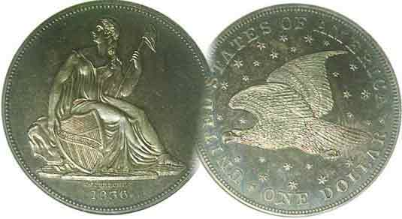
Pres. Steve Kuhl
V .P. Pat James
Sec. Jim Mullaney
Treas. Chuck Goergen
Sgt. in Arms: Jim Sproull
Programs: Pat James
ANA Representative: Jim Barry
Photos: Helen Barry
Publicity: Pat James
Newsletter: Arno Safran
E-Mail: arnosafran@comcast.net
Auctioneer: Jim Sproull
Web site: Susie Nulty (see above.)

2013 Club Meeting Schedule
Volume 12, No. 11 the Stephen James CSRA Coin Club, Founded in 2001 November, 2013
Monthly Newsletter
Our next meeting will be held on Thursday, Nov. 7, 2013 at the Aiken Public Library

Augusta Coin Club Show Set for Nov. 8 & 9 at Patriot’s Park
Jan. 3 Apr. 4 July 11 Oct. 3
Feb. 7 May 2 Aug. 1 Nov. 7
Mar. 7 June 6 Sept. 5 Dec. 5

______________________________________________________________________________________________________

SCNA Convention Puts on Another Fine Show

The fall season is an active one when it comes to area coin shows. Lots of regional shows occur during his period beginning with the late summer BRNA show in Dalton, GA followed by our own club show in early September. The first actual big numismatic event within easy driving distance from the SJ CSRA CC was the just held 41st SCNA Convention in Greenville. In 2012, our state numismatic organization moved the show from the smaller more opulent hall arou7nd the corner from the large TRD Convention Center to a much larger if less attractive hall in order tom accommodate the larger number of dealers wanting to take tables.

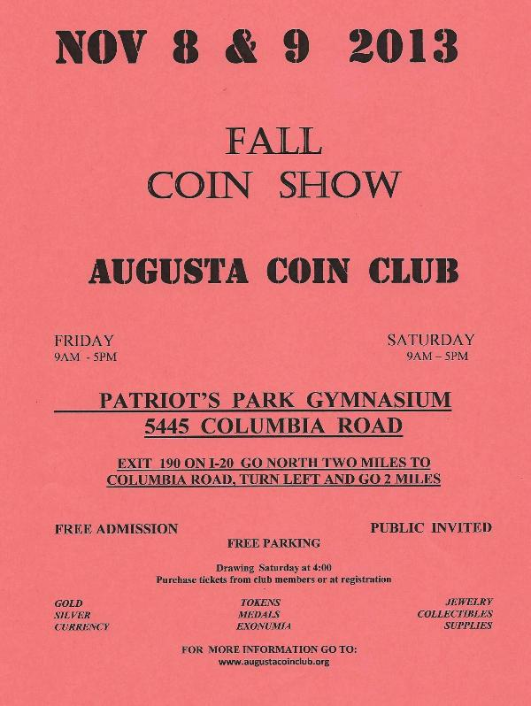
The result both last year and again this year was a larger dealer base. The increase provided a wider range of coins, tokens and paper money collectibles allowing hobbyists from the entry level collector to highly experienced to find numismatic items within their discretionary income. One could purchase an obsolete Latin American Bank note from 10c to a rare US gold piece valued at $10,000. The three-day event also housed a number of outstanding numismatic exhibits by both advanced numismatists and young people and a number of them were outstanding.

On Nov. 1, 2 & 3, the Tennessee State Numismatic Association will be holding a three-day show in Chattanooga and the following weekend, Fri. & Sat. Nov. 8 & 9, our sister club to the west, the Augusta Coin Cub will be holding their fall show at Patriot’s Park in Columbia County, GA.
__________________________________________________________________________________________________________________

Focus is the key to assembling an interesting collection regardless of price or value
By Arno Safran

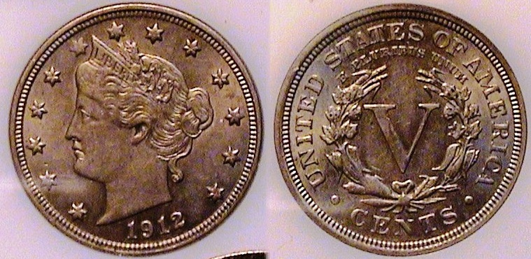

A 1912 Liberty “V” nickel graded AU-55
[Use 3X power glass or magnify page to 200% to view details]

Collecting even common date obsolete US coins in AU or mint-state can be expensive. For young people 18 years or younger, it is virtually impossible yet at the recent SCNA convention held in Greenville, SC there were a number of exhibits that attracted the eye of this attendee that were assembled by young people. One of the displays that caught my attention was an exhibit entitled the “Centennial of a Lost Treasure: The Titanic.” The exhibit featured coins dated 1912, the year the Titanic sank after grazing a huge iceberg in the north Atlantic on its maiden voyage from England to the United States. None of the coins were in AU, let alone mint-state but the exhibitor’s focus was assembling various coins dated 1912 that enabled her to create an interesting display and it received recognition at the show.

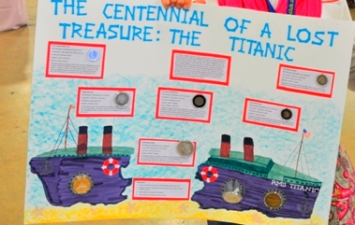

_____________________________________________________________________________________________________________________________
(Continued on page 2, column 1)

Focus is the key to assembling an interesting collection regardless of price or value
(Continued from page 1, column 2)

The` exhibit was put together by Shelby Plooster, a young numismatist who resides in the CSRA and is a member of the Augusta Coin Club.

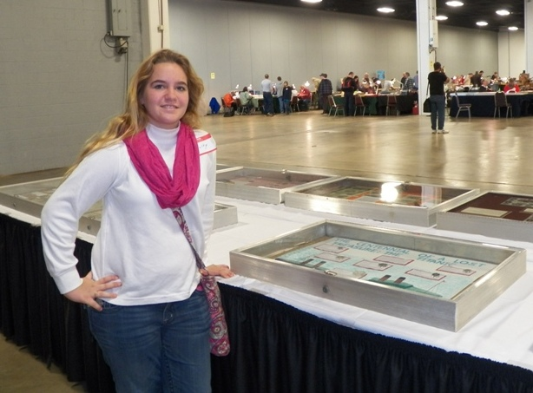

Shelby Plooster standing in front of her Exhibit
At the SCNA Convention held at the TD Convention Center
In Greenville, SC on Oct-25027.
[photo taken by Helen Barry]

The difference between an accumulator and a numismatist is one of focus. The accumulator is one who enjoys acquiring various type coins that he or she may fancy at the time but does not appear to focus on the completion of a group of related coins; in other words a “set. be it short or large a large one. The numismatist on the other hand enjoys the challenge of locating that elusive piece that will fill the final hole of a series or a type set whether it be a that of US war nickels (1942-45) or a more ambitious enterprise such as acquiring one sestertius (a large ancient copper coin) for each of the 12 Caesars of Rome.
Due to the expense of many US coin types, especially in XF or better, the short set may prove to be the only affordable option for the aspiring numismatist. These can take the form of year sets, proof sets, basic type sets of a single denomination, an odd denominational set or a significant date in world history.

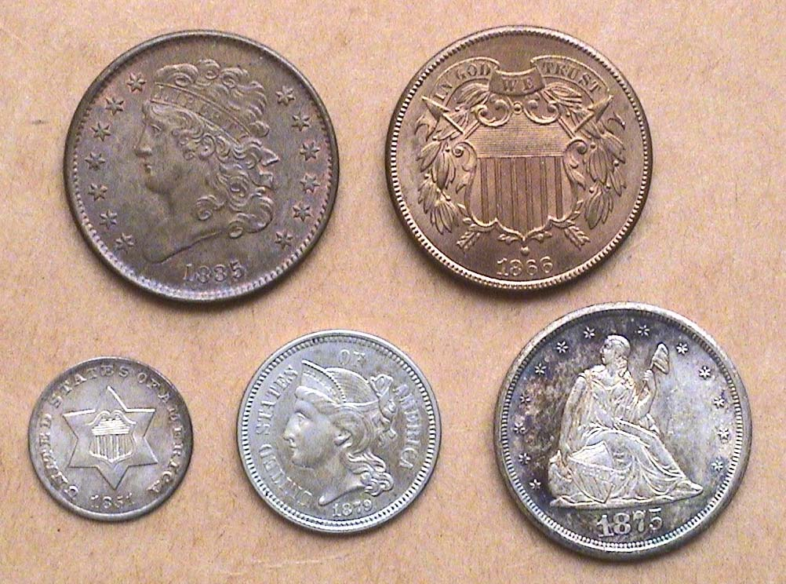

The obverses of an Odd Denominations Type Set
From l to right: top 1835 ½¢, 1866 2¢
Bottom: 1851-O 3¢ silver, 1879 3¢ nickel & 1875cc 20¢
[Magnify page to 200% to see coin details more clearly.]

Kindly Patronize Our Advertisers

