The Stephen James
CSRA Coin Club of Aiken
P.O. Box 11
New Ellenton, SC 29809
Web site: www.sjcsracc.org

The SJ CSRA CC of Aiken, SC meets on the 1st Thursday of the month at the Aiken Public Library

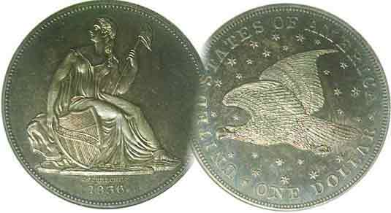
Pres. Willie Simon
V .P. Pat James
Sec. Jim Mullaney
Treas. Chuck Goergen
Sgt. in Arms: Jim Sproull

Programs: Pat James
ANA Representative: Jim Barry
Show Chairman: Steve Kuhl
Photos: Helen Barry
Publicity: Pat James
Newsletter: Arno Safran
E-Mail: arnosafran@comcast.net
Auctioneer: Jim Sproull
Web site: Susie Nulty (see above.)

2014 Club Meeting Schedule
Volume 13, No. 11 the Stephen James CSRA Coin Club, Founded in 2001 November, 2014
Monthly Newsletter
Our next meeting will be held on Thursday, Nov 6, 2014 at the Aiken Public Library

ACC Fall Show at Columbia County Expo Ctr. 11/21 & 22
Jan. 2 Apr. 3 July 3 Oct. 2
Feb. 6 May 1 Aug. 7 Nov. 6
Mar. 6 June 5 Sept. 4 Dec. 4

Augusta Coin Club to hold Fall Show in Grovetown, GA at new Columbia Expo Center
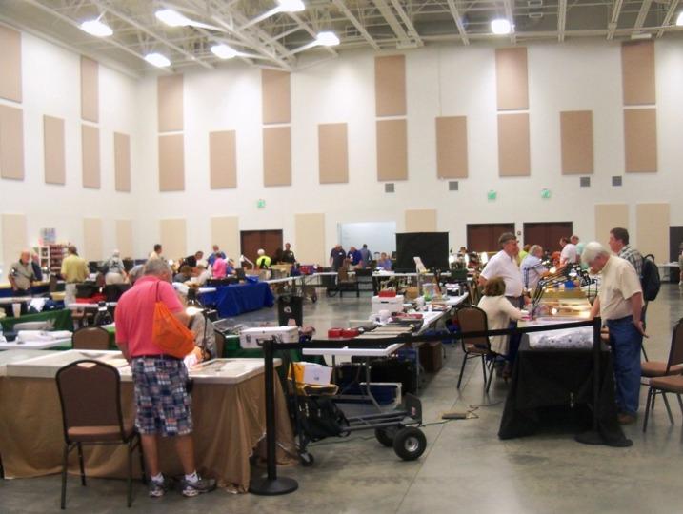

Last May, the Augusta Coin Club moved their show from Patriot’s Park to the recently opened Columbia Expo Center located in Grovetown, GA just off I-20 Interchange 190. To get to the new site from Aiken, make a left at the end of the exit ramp and another left at Gateway Blvd. The Columbia County Exposition Center is on the right near the end of Gateway B’lvd. The new site is not only more accessable than the previous one but is more attractive and better lit. It is near a Wal-Mart super store and several eateries. Dealers polled at the May show were delighted with the attendence which was the best for an ACC show since 2009. As a result, show chairman David Chism is expecting a sell-out by show time which is set for November 21 and 22, a Friday and Saturday, one week before Thanksgiving. The show hours are 9:00 AM to 5:00 PM both days with free Admission to the public and ample free parking adjacent to the facility. There will be five raffle prizes including a gold coin for attendees to consider. These sell for $1.00 per ticket or six for $5.00. The drawing takes place on Saturday afternoon of the show around 4:00 PM but one does not have to be present to win.
____________________________________________________________________________________________________________

Collecting the Coins of 1914, 100 years ago, (excluding gold) By Arno Safran

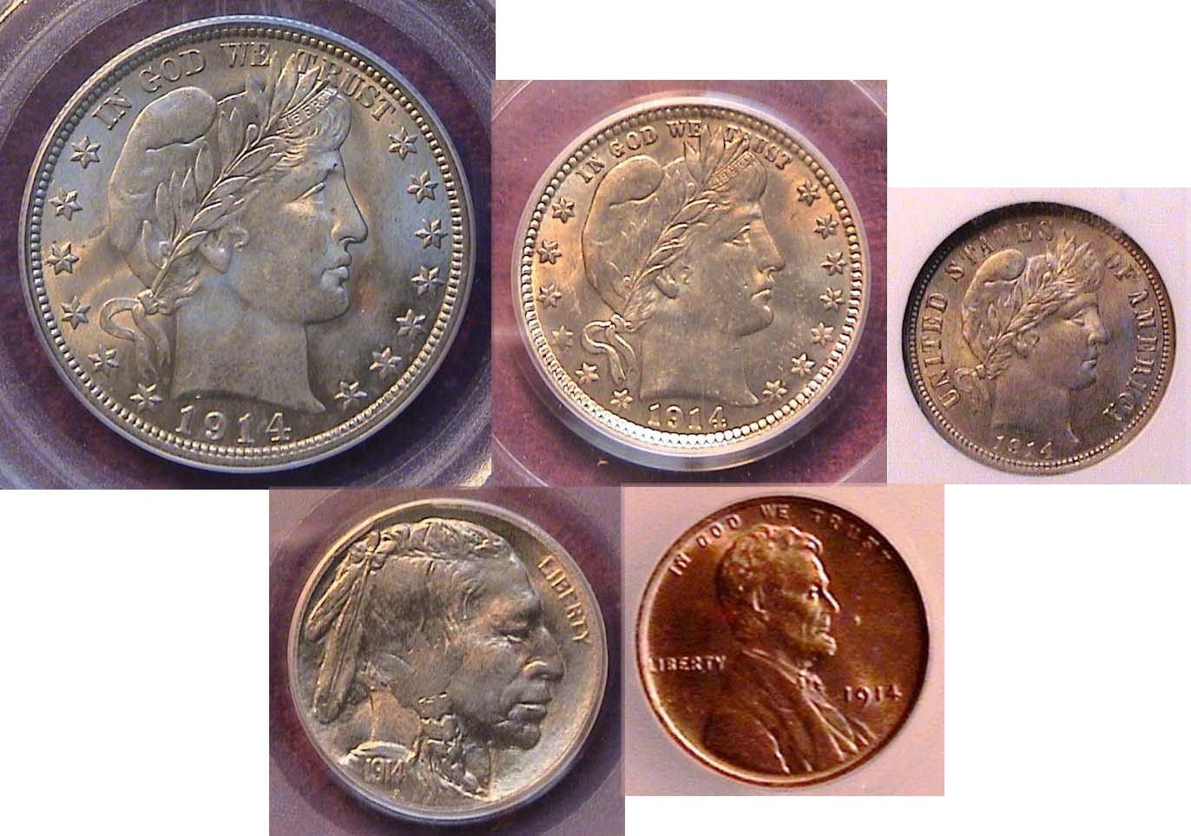

The obverses of a certified uncirculated 1914 US year set (excluding gold) the 50c, 25c & 10c over the 5c & 1c

On July 28, 1914--just over one century ago--Austrian Archduke Ferdinand was assassinated plunging Europe into a war between the Central Powers of Germany and Austria against England, France and Russia. With the war spreading, pressure was being put on the United States to take sides with the result that on August, 19 of that year; President Woodrow Wilson pledged that the United States would remain neutral since many of its citizens represented ethnic backgrounds from the very European countries involved in the conflict.

By 1914, photos of the period show our nation beginning to adjust to our changing technology. The automobile was gradually replacing the horse and buggy and air travel was becoming commercialized.

Our coinage was also undergoing a transformation from the old allegorical stylized designs still being represented by Chief engraver Charles Barber’s Liberty head silver pieces to the portrait coinage of real people featuring Abraham Lincoln on the cent and a composite of three actual Native American chiefs on the 5c nickel.
______________________________________________________________________________________________________________
(Continued on page 2, column 1)
Collecting the US Coins of 1914 (excluding gold)
(Continued from page 1, column 2)

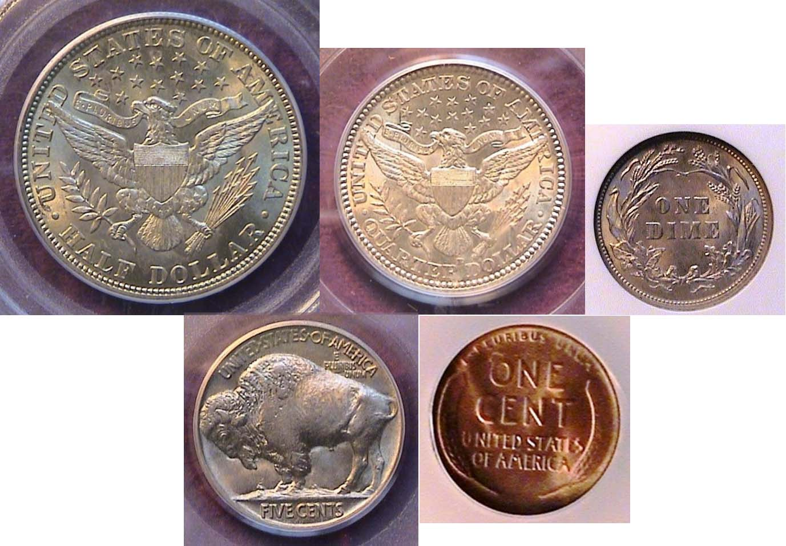

The reverses of a 1914 certified BU year set (excluding gold)

In 1914, there were three US Mints in operation, the Philadelphia Mint (going all the way back to 1793), the San Francisco Mint since 1854 (as a result of the discovery of large gold deposits near Sutter’s Mill, California) and the recently opened Denver Mint in 1906. Long gone were the gold Mints of Dahlonega, GA and Charlotte, NC, (1838-1861*) The Carson City Mint was in operation from 1870-1893) and finally, the New Orleans Mint which opened in 1838 finally closing its doors after 1909.

* In 1861 $1.00 gold pieces were struck in Dahlonega under the auspices of the state of GA and the CFA.

A total of nine different denominations were struck in 1914, the bronze cent, the 5c nickel, the silver dime, quarter and half-dollar and four gold coins; the beautiful $20.00 Saint-Gaudens double eagle and $10 Indian and the $5.00 and $2.50 incuse Indian Head pieces designed by Bela Lyon Pratt. The two smallest gold denominations are modestly priced through MS-62 but for the purpose of this article we will focus on just the non-gold issues, the cent thru the half-dollar.

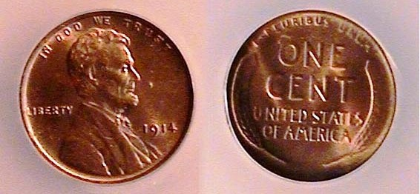

A 1914 –P Lincoln cent graded MS-64 Red by ICG

The collector has three options to acquire a cent dated 1914, but only the Philadelphia Mint issue with a mintage of 75.2 million is moderately priced in uncirculated condition, the low mintage 1914-D being one of the key dates of the series with a mintage of just under 2 million and the 1914-S with only slightly more than 4 million being somewhat costly in mint state. In you are putting together a year set averaging between VF and XF, you would find a nice brown XF-45 1914-P cent not only inexpensive but still fairly attractive. Mint state specimens should grade either full Red or Red-Brown, the latter being less costly.
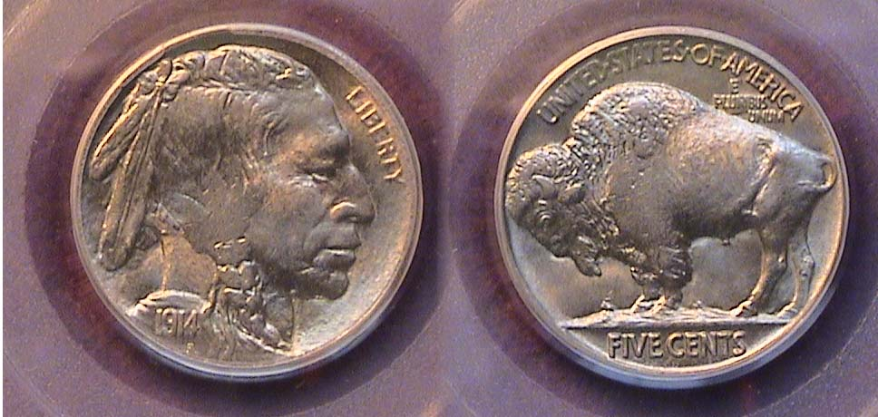

A 1914-P Indian Head Buffalo nickel graded MS-64 by PCGS
[Increase magnification to view details.]

The Buffalo nickel was struck from 1913 thru 1938. In 1934, dealers began stashing away rolls of brand new US coins shortly after they left the mint. Prior to 1934, most of the branch-mint coins, (those struck at the San Francisco and Denver facilities), were produced in very lower numbers with the result that many of the earlier branch-mint dates are scarce to rare in uncirculated condition today. Such is the case with the 1914-D an S nickels. While The Philadelphia Mint struck 21.6 million Buffalo nickels in 1914, the Denver Mint coined only 3.9 million with the San Francisco just 3.4 million. Those attempting to assemble a 1914 year set are advised to acquire a 1914-P nickel due to its fairly low cost grading as high as MS-64.
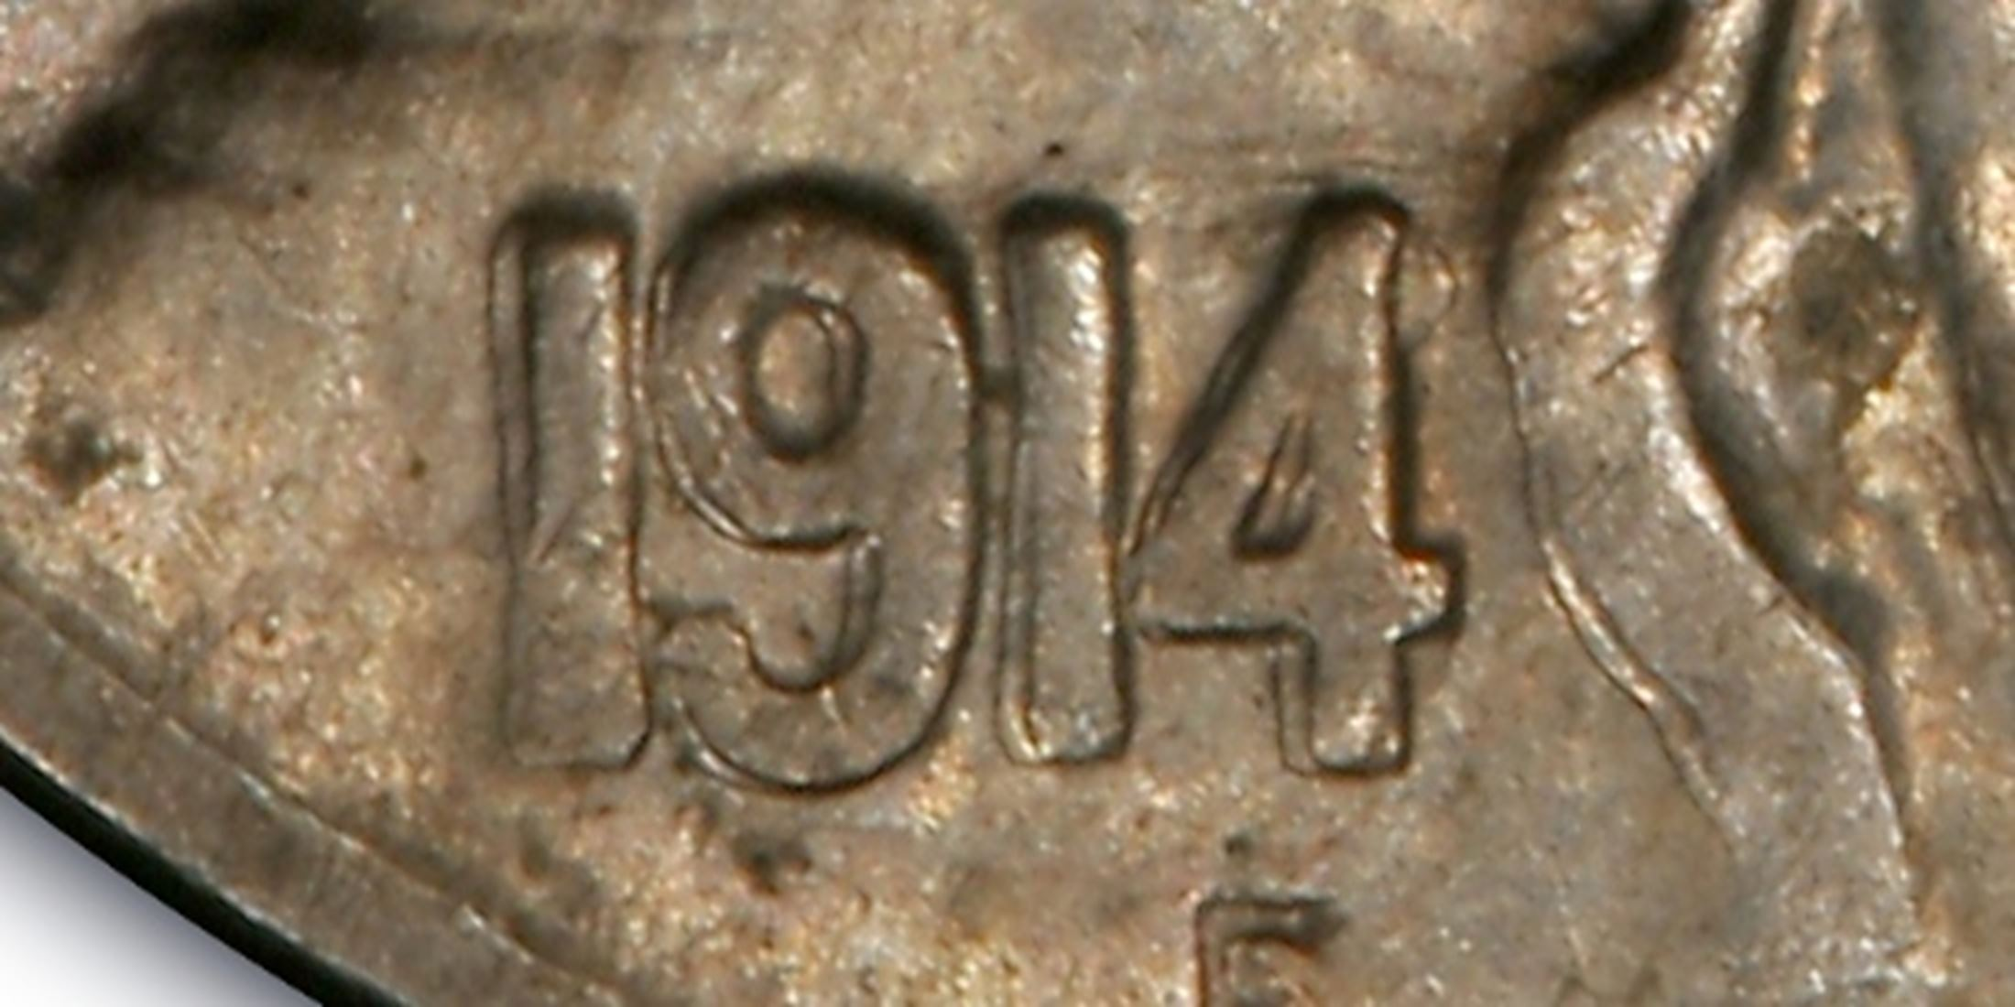
In 1996, noted numismatist Bill Fivaz, a co-author along with J.T. Stanton of the Cherry Picker’s Guide to Rare Die Varieties of United States Coins proposed a contest for collectors to find a new over-date coin. As a result, a 1914/3 Indian Head/ Buffalo nickel was discovered. Since then, a number have been found, one in as high a grade as MS-66.
Increase magnification

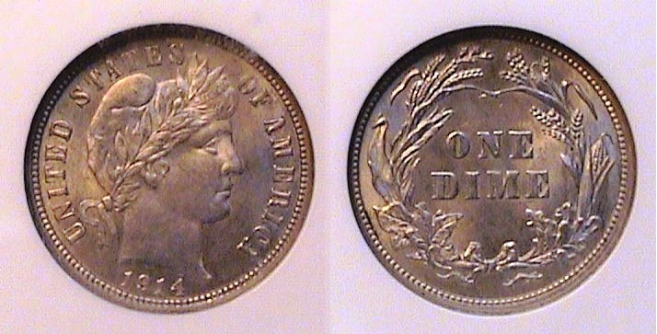

A 1914 Barber dime graded MS-64 by NGC
[Increase magnification to view details.]

In 1914, the Philadelphia Mint struck over 17 million dimes while the Denver Mint produced just fewer than 12 million. Both mint issues are considered common dates in all grades. With the 1914-D dime, the shrewd collector interested in unusual varieties should look for the blundered D mint mark. The 1914-S, with a mintage 2.1 million is far scarcer, especially grading VF-20 and higher and is more expensive in the higher grades. The 1914 P & D issue should not be a problem for the collector to locate. The 1914-P specimen shown above was acquired in August, 2010 at the BRNA show held in Dalton, GA.

The Barber dime is an attractive coin in virtually all grades from Fine-12 thru MS-64. Depending on one’s disposal income a collector could assemble a complete Philadelphia Mint set of Barber dimes from 1892 thru 1916 with only the 1895 being a quasi-key date.
_____________________________________________________________________________
(Continued on page 3, column 1)
Collecting the US Coins of 1914 (excluding gold)
(Continued from previous page)

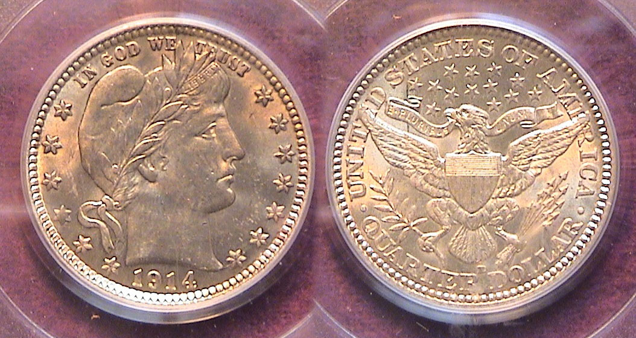

A 1914-D Barber Quarter graded MS-62 by PCGS
{Increase magnification to view details}
Pictured above is a lovely MS-62 example of a 1914-D Barber Liberty Head quarter. The Denver Mint produced a total of 3,046,000 that year, a little less than half the amount of the Philadelphia Mint’s output of 6,224,230 yet the survival rate from each Mint is sufficient to keep the prices moderate up through MS-64. The 1914-S with a mintage of just 264,000 is another story. It had the fourth lowest mintage of the series behind the 1896-S, 1901-S and 1913-S often referred to as the three “stoppers” for collectors desirous of completing the Baber Quarter series (1892-1916).

The 1914-D quarter pictured above was acquired at an Augusta Coin Club show back in November of 1911. It has been observed that some coins graded AU-58 can appear as attractive as MS-63s with a little rub. In recent years the author has observed a number of coins certified MS-62 that has the eye appeal of an MS-63, even a MS-64. Certified coins grading AU-58 can also appear dull and a number of coins grading MS-62 specimens may have tiny detracting marks across its surface. This is why one must grade the coin, not the slab.

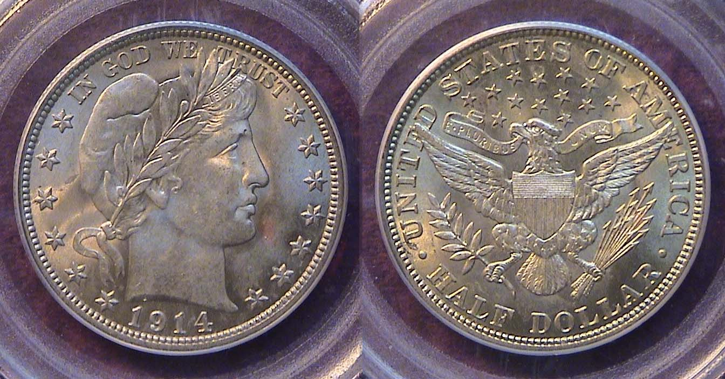

A beautifully toned 1914-P Barber half graded MS-64 by PCGS
{Increase magnification to view details}

The 1914-P Barber half-dollar had the lowest mintage of the 73 dates and mintmarks issued from 1892 through 1915, just 124,230. According to the late David Lawrence, author of The Complete Guide to Barber Halves, the 1914-P issue is scarce from VG thru AU-58, less so in mint-state condition, since during the era of this coin-type, only the wealthy could afford to put an uncirculated specimen away. The 1914-S half had a mintage of 992,000 yet is not considered a scarce date by comparison. No half dollars were coined at the Denver mint in 1914. Despite these facts, the 1914-P is not nearly as difficult to locate above Fine as a number of higher low-mintage coins such as the 1893-S, 1896-S, 1897-O, 1897-S, 1898-O, 1901-S, the key 1904-S and the 1905-O. The key to purchasing a 1914-P half in high grade is selling a number of coins.
Some highlights of 1914

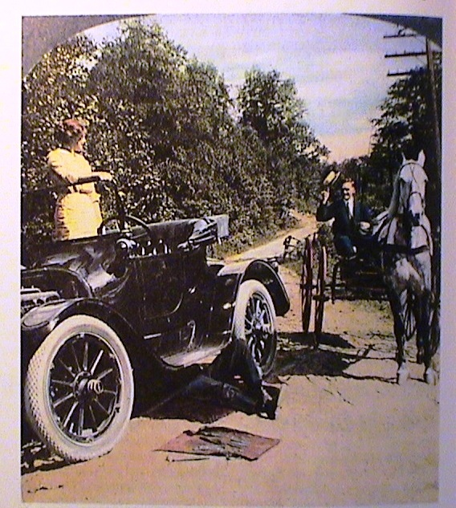

By 1914, the automobile was beginning to overtake
the horse and buggy as a mode of travel

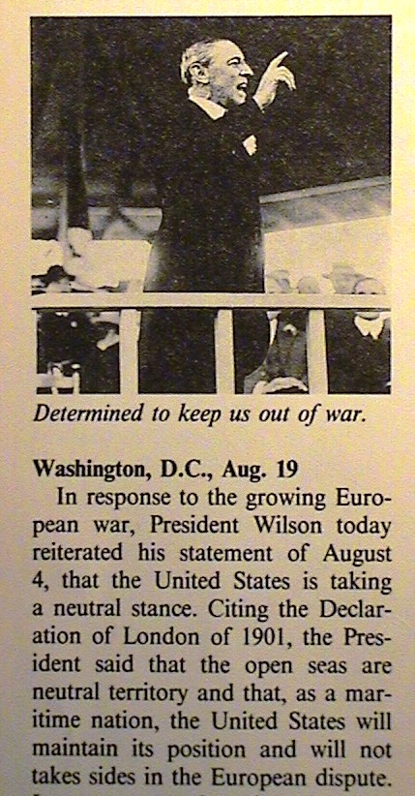
Despite tremendous technical advances with the inventions of the electric light, the telephone and phonograph, also the automobile and airplane among many others introduced during the late 19th and early 20th centuries, by 1914 other parts of the world were breaking apart in armed conflict. It is ironic that exactly 100 years later, the aspects of our civilization are in many ways similar. Miniaturization has given us the compact disc, leading to the MP3, the PC, Desk-top, the cell phone and smart phone plus incredible military technical advances and another president who hoped to avoid war during his tenure.

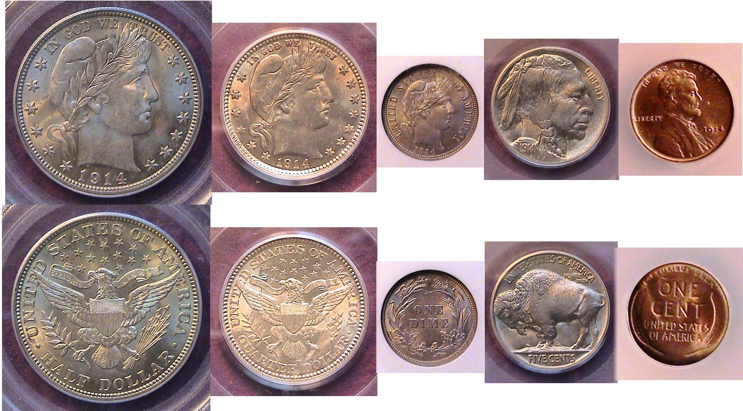

A Certified BU 1914 Year set (excluding gold)
_________________________________________________________________________________________________________________
STEPHEN JAMES CSRA COIN CLUB
Regular Meeting - Aiken County Library
October 2, 2014

President Willie Simon called the meeting to order at 6:45 p.m. Glenn Sanders reported there were 16 members and 2 guests in attendance. Glenn also related information about the upcoming coin shows in the area. He emphasized that if any member has not been to the SCNA state convention, they should make an effort to attend this year from Oct 24-26. Arno Safran provided some information about the Augusta Coin Club Show that is coming up on November 21-22. The minutes were waived, a copy to be put on file. Treasurer Chuck Goergen reported that the October balance was $1925.90. R. J. Vero won the members’ door prize, a Franklin Half Dollar.
President Willie Simon reminded everyone that the club has current Red Books on sale for $10 (four copies remain). Willie also reminded the club that the Augusta Coin Club will meet on October 16. Arno Safran reported that Steve Damron will present a program on the hammered coins from the houses of Normandy through the Tudors that evening at its new location on Telfair Street between 8th & 9th Streets in Augusta.
Willie thanked Steve for his work as bourse chair at last months coin show. The dealers were really pleased. We had 16 dealers at this years show (increase of 5 from last year) including several dealers that had not come to any of our previous shows. Net profits from the show were $457.30. Show income included $1120 from table fees and $923 from drawing tickets. 249 people attended our 2014 show, that was the most in the last four years. Bill Campbell won the first prize drawing, Glenn Sanders won the second prize, and Wayne Harrison won the third prize. Steve thanked the 20 club members who worked at the Coin Show to help make it a success and presented them with a token from Aiken County.
Arno Safran presented a Power Point program of the US Coins of 1860 and the election of Abraham Lincoln. The November program will be on Collecting the coins of the Carson City Mint by member Garry Naples.
There was one Show and Tell presentation by Todd Starbuck. Todd expanded on his Show & Tell from August on 2014 Kennedy half dollars. He displayed his half dollar minted in 3/4 an ounce .9999 fine gold coin that had been graded Proof 69 ultra cameo by NGC as well as examples of each of the varieties of the Kennedy half released so far this year by the mint. Todd also reminded club members that at the end of October the mint would be offering a 4-coin set of half dollars minted in silver.
Willie Simon asked for a show of interest in ordering golf shirts with the Club’s logo. About 10 members out of those present indicated interest. Roger Seitz won the 50/50 - $13.50. Glenn Sanders conducted the club auction. The meeting was adjourned at 8:10 p.m.
Respectfully submitted,
Jim Mullaney, Secretary
Kindly Patronize Our Advertisers

