Pres. Willie Simon
V .P. James Barry
Sec. Helen Barry
Treas. Pat James
Sgt. in Arms: J.J. Engel
Committees:
Auction: J.J. Engel
Programs: James Barry
Newsletter: Arno Safran
The Stephen James
CSRA Coin Club of Aiken
P.O. Box 1739
Aiken, SC 29802
Web site: www.sjcsracc.org
The SJ CSRA CC Now Meets on the 2nd Thursday of the Month at the Cedar Creek Community Center in Aiken, SC

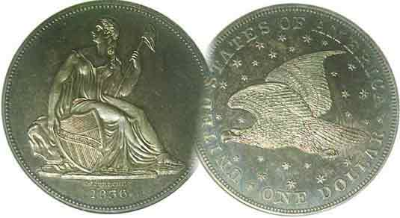

Volume 5, Number 12 the Stephen James CSRA Coin Club Monthly Newsletter December, 2006
Jim Barry talks on Classical Greek Coins
Our Club Dinner is on the 1st Thursday of this month, December 7, 2006 at 6:30 PM
2006 Club Meeting Schedule - 2nd Thursdays at 7 PM
June 8, July 13, Aug. 10, Sep 14,
Oct. 12 Nov. 9, Dinner Meeting, Dec 7

Jim Barry’s Program on Greek Treasures, a Delight

At the Nov. 9 meeting of the Stephen James CSRA Coin Club, Vice President Jim Barry presented a slide program on Treasures of Ancient Greek Coinage. He described the talk as an overview while tying it in with the Greek influence on Roman, English and US coinage. Using a map of Europe and the Mediterranean region, Jim showed the vast region of Classical Greece’s cultural and political influence beginning from around 550 BC to the around 50 BC at the time the Roman empire of Julius Caesar was attaining full grandeur.

Many of the coins displayed figures in high relief akin to tiny circular pieces of sculptured gems. The earliest example displayed a sea turtle with reverse punch that was probably struck around 540 BC. As technology progressed, so did the art of the engraver. Jim showed a variety of coin denominations that included the gold stater and silver pieces from the half drachma to the Tetradrachm; the latter, a large thick coin between the size of our quarter and half dollar. Motifs shown on these coins included animals such as the aforementioned turtle, bees, owls, lions and horses, etc. Other examples displayed portraits of the Greek gods, Zeus, Hera, Athena, Apollo, et al and important emperors and military leaders such as Alexander, the Great. Coins of soldiers in battle were depicted as well. . The club wishes to thank Jim for his presentation.
____________________________________________________________________________________________________________________________

Dinner meeting at EE-Jays Restaurant December 7

The club’s sixth annual pre holiday Christmas dinner party will take place at EE-Jay’s Restaurant on December 7 starting around 6:30 PM Cash Bar with dinner to follow at 7:00 PM. [There will be no regular meeting on the second Thursday in December.] The choice of entrée’s includes Prime Rib, Chicken Monterey and Fried or Broiled Shrimp. As with past holiday events there will be quite a few prizes to go around. Look forward to seeing many of you there.
______________________________________________________________________________________________________________________
(Club News continues on page 4, column 1)
Early Latin American Republican Coinage,
Part II: Central American Republic by Arno Safran

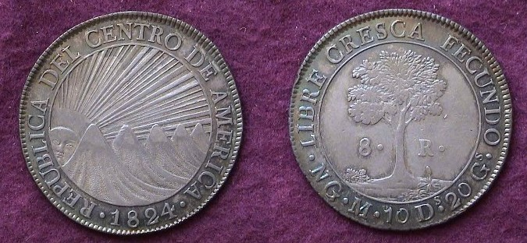

An 1824 8 Reales of the Central American Republic

In 1821, the five provinces south of the Mexican border known today as Central America were declared independent by the governing Captaincy General. In 1822, Mexico’s self proclaimed Emperor Augustin Iturbide I invited these provinces to become part of his federation but El Salvador refused opting instead to become a part of the United States. Iturbide decided to use more persuasive measures, sending an army led by the military governor of Guatemala, Vicente Filisola to invade the tiny province, but before El Salvador could be absorbed, Iturbide was ousted. Filisola reconvened the General Assembly which established a loosely confederated democratic state to be known as the Central American Republic. It consisted of Guatemala, Honduras, El Salvador, Nicaragua and Costa Rica. (Panama was still part of Colombia, South America)

In 1824 the C.A.R. began producing its first silver and gold coins which were struck at the New Guatemala Mint, (Guatemala City today.). For many collectors, the obverse of the dollar sized 8 Reales silver coin showing a rising sun to the left of five volcanoes--its rays extending outward--represents one of the more beautiful designs among world type coins. The surrounding legend is inscribed REPUBLICA DEL CENTRO DE AMERICA. The reverse featured a Ceiba tree with the motto, LIBRE CRESCA FECUNDO, (Liberty increases fertility or growth).
______________________________________________________________________________________________________________
(Continued on page 2, column 1)

The Coinage of the Central American Republic (1824-50)
(Continued from Page 1, column 2)

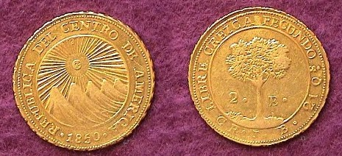

An 1850 CAR 2 Escudo struck at the Costa Rica Mint
(From the author’s collection)
With a reported mintage of just 7,432, this is
considered the most common date for type.

Unlike the USA, the CAR never even achieved the status of a unified government similar to that produced by of our own Articles of Confederation, let alone the Continental Congress after the Revolution. Religious and class strife continually undermined the process finally erupting into a full scale civil war in 1827 with the result that by 1839, the Republic ceased to exit. Despite this, coins from the region would continue to be struck bearing the sun and mountains and Ceiba tree in various denominations through 1850 with the same legend and motto.

The denominations issued during this 27 year period consisted of five silver coins and five gold pieces and were not issued in every year or from one mint. The silver coins included the 8R, 2R, 1R, ½R and tiny ¼R. No 4 Reales were struck. The 8’s are the most numerous with the 1824 being by far the most common. They are moderately priced up thru AU. The coin enjoyed legal tender status here in the USA from 1834 thru 1857. The other silver issues are another matter as far as the collector is concerned. Apparently hoards of the tiny ¼R exist in brilliant uncirculated condition and the 1 Real pieces can be found in problem-free circulated grades but the ½ Real, showing only three volcanoes because of its small size is quite scarce in all grades and the 2 Reales--equal to our quarter-dollar--are rarer still. Of the supposedly collectible dates for this issue; all struck at the Tegucigalpa Mint in Honduras, only the 1831 surfaces from time to time and even then, in low grades or flawed.

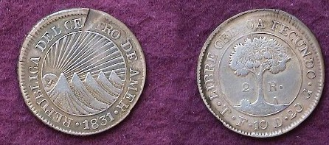

An 1831 CAR 2 Reales struck at the Tegucigalpa Mint in Honduras from the author’s collection. Notice the flan flaw as struck
between 12:00 and 1:00 on the obverse. Despite this, the specimen
is the highest grade example the writer has seen.

The five gold coins struck were the 8 Escudos, 4E, 2E, 1E and ½E. The design was similar with the difference that the sun was centered above the volcanoes, its rays pointed downward as shown above. The 8E’s are around for a price but the 4E’s are quite scarce and expensive. Collectors can still obtain the ½E, 1E and 2E at reasonable prices up to AU. True uncirculated specimens are pricey.

The fineness of the 8 Reales silver issues varied from a high of .903 to a low of .870 weighing between 415 and 416 grains and was considered the least reliable from the USA assayer’s point of view of any of the foreign legal tender coins accepted. Not too many of these pieces circulated here but enough were seen for the US government assayers to consider seriously. The 1 Real was worth 12½¢; the ½R, 6¼¢ but the latter probably was accepted at just 5¢ (at a silver half dime value) assuming one actually surfaced in the early 19th century USA. As for the tiny ¼R, displaying only one volcano, there are no known reports of any actually trading here at the time foreign silver was legal tender in the United States. The coinage of this short-lived Confederation is somewhat challenging to assemble but worth of the effort as it combines history, beauty and rarity.

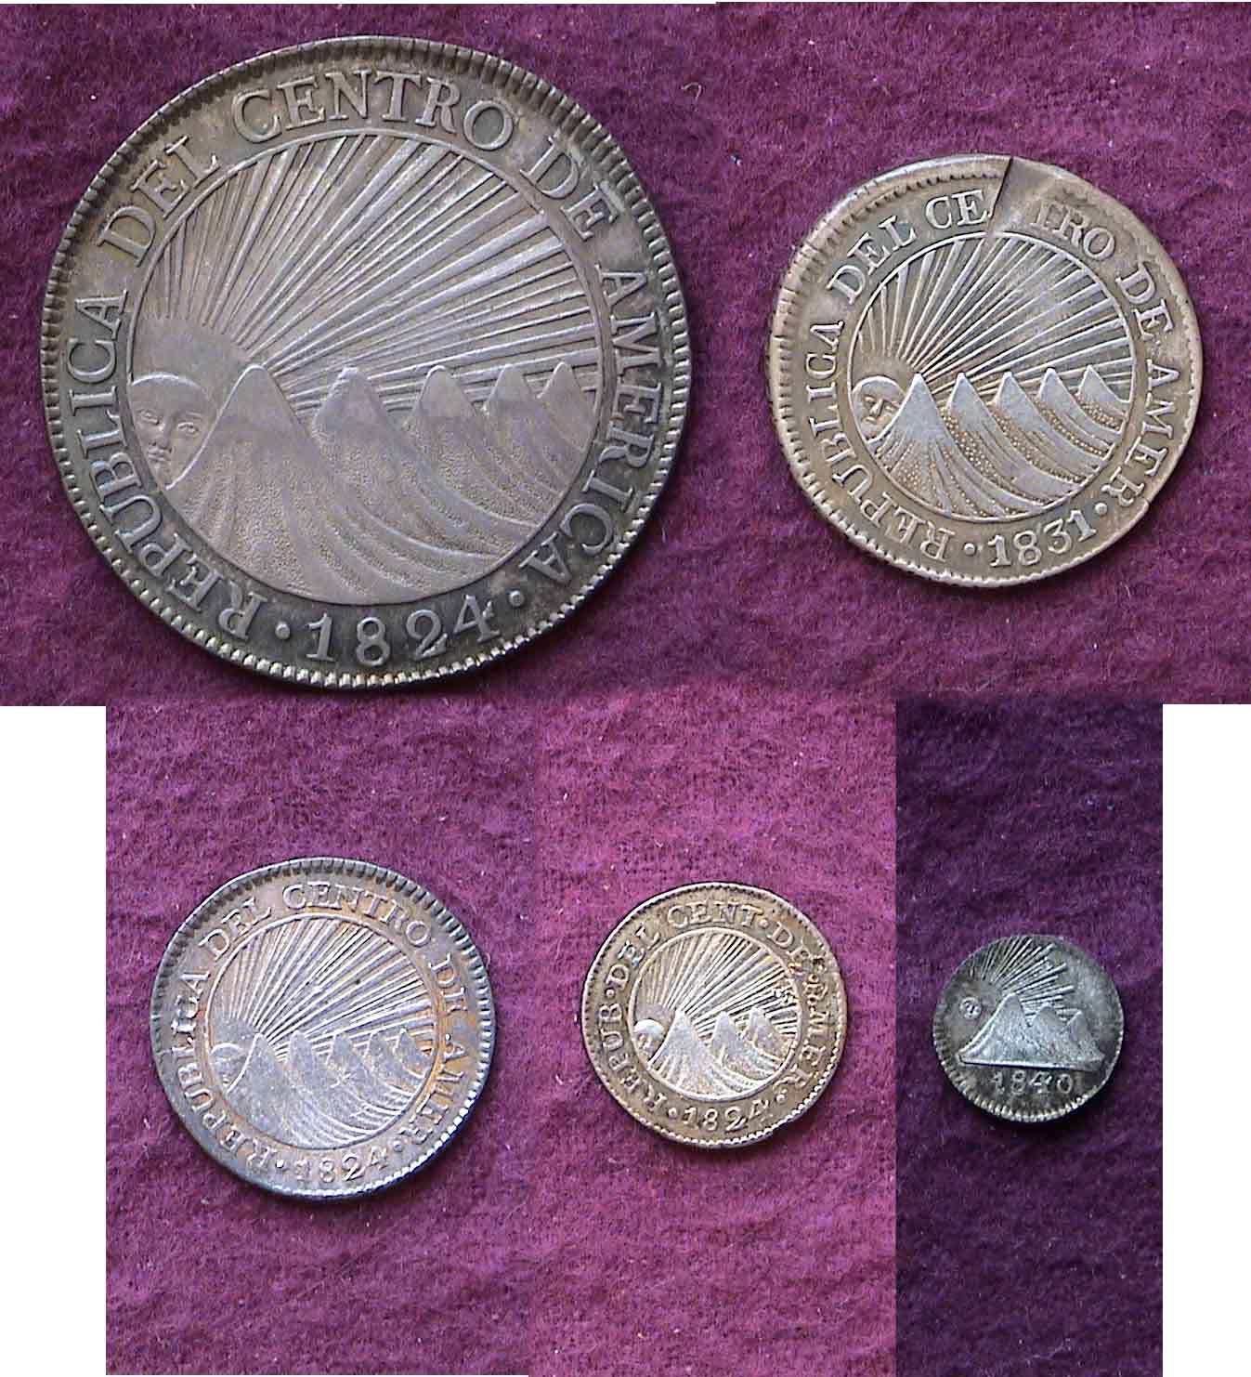

A five piece CAR silver denomination set
from the author’s collection. Magnify up to 200% to see details.

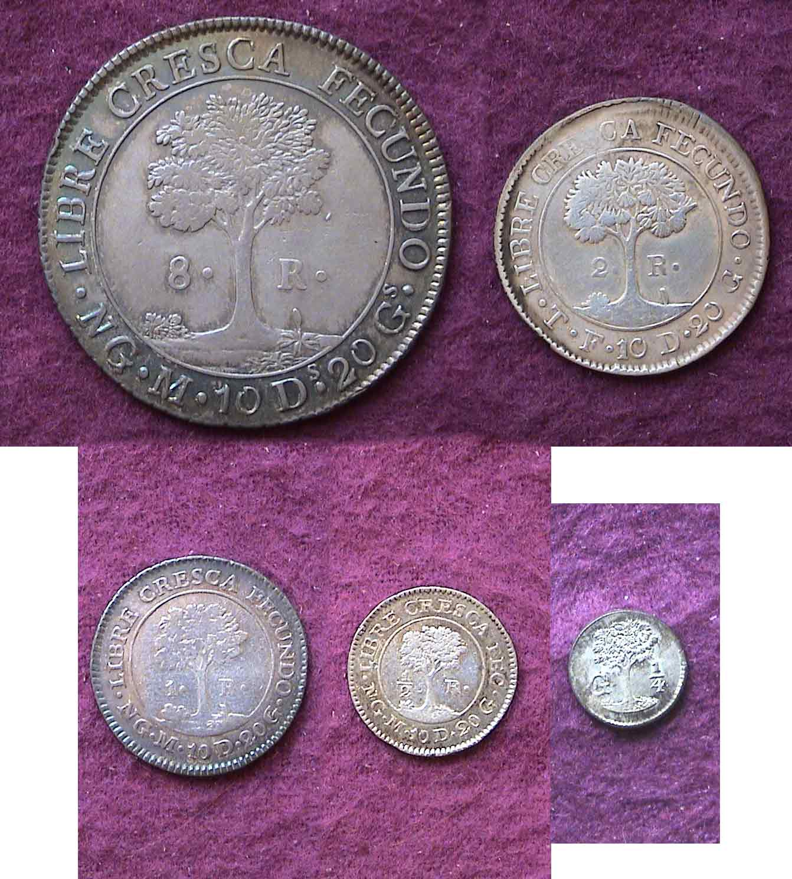

__________________________________________________________________________________________________________________________
TRESORERIE DE NOUMEA
By Bill Myers

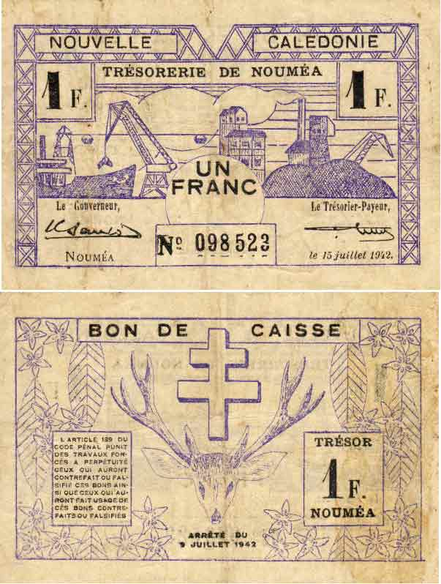

A 1942 New Caledonia 1 franc note face atop back
From the author’s collection

To me, part of being a numismatist is defining a collection and setting out to complete it. There is something about a numismatist that they want one of each type or variety that defines a collection. This is much more then an accumulation or investment, it is a goal and an accomplishment. Arno Safran’s articles and talks have clearly shown the satisfaction of pursuing a collection. You do not have to be wealthy to accomplish this task; you just need time, knowledge and persistence. My advice is to pick an area that interests you, that has defined limits, is obtainable and is within your economic means.

My interest started when I was at a coin show and saw a New Caledonia 2 franc note. It was 110 X 70 mm and was simply printed. The face of the note had a crane loading a ship on the left and a mining scene on the right. On the back of the note were a stag and the Cross of Lorraine. My father had served in New Caledonia during World War II, but unfortunately he did not bring back any numismatic souvenirs from his tour in New Caledonia. I found the note of interest and so I shelled out $5 for the note. Needless to say, my curiosity led me to research my latest acquisition. New Caledonia is a group of Islands in the southwest Pacific Ocean. It was discovered by Captain Cook in 1774 and occupied by France in 1853. The islands are rich in minerals, especially nickel. During World War II France signed an armistice with Germany 22 June 1940. New Caledonia joined the Free French cause in September 1940 rather then become part of Vichy government (occupied France). An American expeditionary force arrived in New Caledonia 10 March 1942 to protect the island and establish an Allied base. The sudden influx of troops stressed the local economy and the circulating currency available was inadequate. One part of the solution was to print local emergency notes. The notes were printed by the “Treasorerie de Noumea” in denominations of 50 centimes and 1, 2, 5 & 20 francs. The 50 centimes has two varieties, one with the issue date of 15 July 1942 and one dated 29 March 1943. The 1 and 2 francs notes have notes with the same issue dates but the 29 March 1943 has thick and thin number varieties. The 5 francs note has only one type, issued 15 June 1943. The 20 francs note has one with issue date of 30 April 1943, and the other simply dated 1943 with “Deuxieme Emission” added on the back. The number of notes issued ranged from 50,000 to 400,000 and the catalog cost in “fine” is from $5-50. Completing this collection would consist of eleven notes and they were obtainable and at a reasonable cost. The hunt was on.

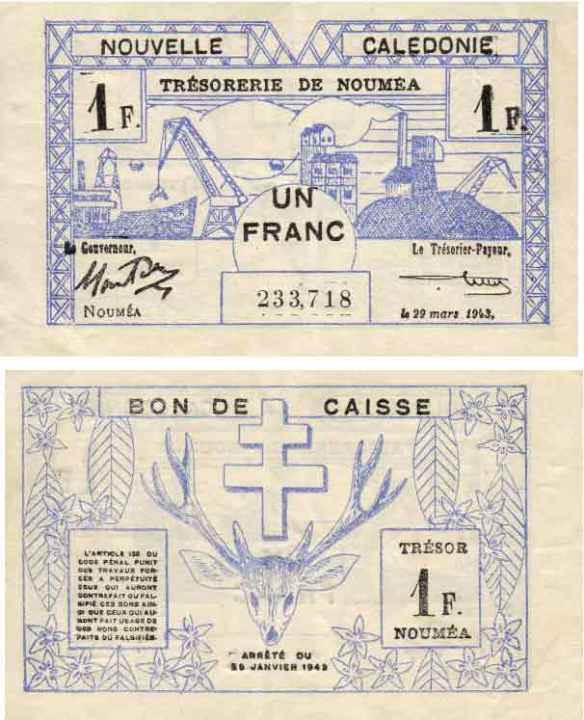

A 1943 New Caledonia 1 franc note from the author’s collection

I purchased notes from mail-order catalogs as well as dealers stock at coin shows. I did not obtain any through on-line auctions (e.g. E-Bay) but certainly that is an available avenue for collectors. The last two notes were obtained from a fellow numismatist that was aware of what I was looking for and found them for me just before I left for Iraq. I found that letting your fellow collectors know what your interests are can greatly expand your search area. It took about a year and a half to obtain all eleven notes and at the total cost of $86, with a range of from $4-20 for each note. The collection will never escalate significantly in value but I have an interesting piece of history and a sense of accomplishment. Now I can direct my attention to other collections as I am always working on several simultaneously. To me this is a significant part of why numismatics interests me.
________________________________________________________________________________________________________________________________
Thanks, Bill for another interesting article, Bill hopes to return in March, ’07 (Ed.)
More Club News
(Continued from page 1, column 1)

There were 21 members and one guest in attendance at the Nov. 9 meeting. President Willie Simon again urged members to submit articles and free ads to the club newsletter. There was a brief discussion on the show and some members discussed the possibility of enlarging the event to a two day affair similar to the Augusta club. One of the difficulties has to do with obtaining a facility that allows overnight security which the Odell Weeks Activity Center is unable to provide. The next coin show has been penciled in for Saturday, September 17 at Odell Weeks. With President Simon’s support and with a promise of more help, JJ Engel will carry on as Bourse chair for another year.

Winner of the silver eagle door prize was new member Mike Dodson. The 50/50 winner was Willie Simon. Congratulations gentlemen. As our next meeting is the special pre-holiday dinner affair at EE-Jay’s, President Willie Simon wished everyone a Happy Thanksgiving, and for those unable to attend the dinner, a very Merry Christmas and Happy New Years in advance. Our next regularly scheduled meeting will fall on Thursday, January 11, 2007 at the Cedar Creek Activity Center.
__________________________________________

Give a Numismatic Gift for Christmas

Essentially, there are two types of hobby orientations: One requires an outlay for the materials to get started while the other by its very nature of acquisition depends on a continual supply of discretionary funds. The hobby of Astronomy belongs to the former camp. Once one obtains the telescope and lenses needed for viewing, the challenge of discovery begins without additional funds. On the other hand, any hobby involving collecting involves the goal of completion which usually requires a considerable number of key acquisitions. In that respect collectors are a curious breed. They derive pleasure from acquisition but in most instances enjoy sharing their knowledge and discoveries with others. As such, many are willing to give as well as receive. With the holidays approaching, the coin collector can suggest a number of numismatic items that would make attractive gifts from stocking fillers to personal mementos of quality. What follows are some suggestions.

Proof Sets: These make for excellent stocking fillers and can represent birth year sets and anniversaries. Ironically, some of the silver sets from the late 1950’s and early 1960’s are far less expensive than many of the more recent ones and also contain the long obsolete Benjamin Franklin half dollar.

Silver Eagles: Many a young collector receiving one of these has become fascinated by the series, now in its 21st year and as they mature, some start collecting the back dates.

¼ oz Gold Eagles: For the woman you love, the size of this coin is just about right to be housed in a pendent attached to a gold chain to be worn as a necklace. Even with today’s gold prices more elevated than they were a few years ago, such a gift might receive a more elevated response.

Modern Commemoratives: If you know someone who collects mementos of a particular famous person, event or geographical location, check out the modern US commemorative series (1982 to date). Included are coins in clad, silver and gold coins representative of the Olympics and other sporting events, famous inventors, statespersons and politicians. Proof issues often make nice gifts and many remain reasonably priced.

Happy Holidays everybody!
__________________________________________________

Kindly Patronize Our Advertisers

