Pres. Steve Kuhl
V .P. James Barry
Sec. Helen Barry
Treas. Sharon Smoot
Sgt. in Arms: Glenn Sanders
The Stephen James
CSRA Coin Club of Aiken
P.O. Box 11
New Ellenton, SC 29809
Web site: www.sjcsracc.org
The SJ CSRA CC now meets on the 1st Tuesday of the month at the Aiken Public Library

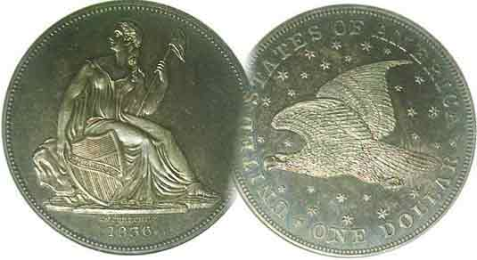
Committees:
Programs: James Barry
Show Chairs: The Barry’s
Newsletter: Arno Safran
E-Mail: arnosafran@comcast.net
Auctioneer: Glenn Sanders

2009 Club Meeting Schedule
Volume 8, Number 12 the Stephen James CSRA Coin Club, Founded in 2001 December, 2009
Monthly Newsletter
We’re Back at the Aiken Public Library
Our next meeting is the first Thursday, Dec. 3, 2009 from 6:00 to 8:45 PM
Club Pre-Christmas Holiday Dinner is Dec. 10 at the Hounds Lake Country Club 6:30 PM
Jan. 5 Apr. 9 July 9 Oct. 8
Feb. 12 May 14 Aug. 13 Nov. 12
Mar. 12 Jun. 11 Sep. 10 Dec. 3* Dec. 10#

____________________________________________________________________________________________________________
* meets at Aiken Public Library, # dinner at Hounds Lake Country Club

It’s Official: Club Returns to Aiken Public Library Dec. 3

December, ’09 will be a “first” and a “second” for the SJ CSRA CC. The “first” for the SJ CSRA CC will be holding twelve regularly scheduled meetings plus a holiday dinner. As there is a $15.00 charge per member to attend the dinner, those attending the Dec. 3 meeting at the library will gain one extra meeting for their $10.00 annual dues. One of the activities that contribute to making our meetings enjoyable is the program portion which offers a wide variety of numismatic topics during the course of a single year.
The “second” will be our meeting twice in one month. The last such occurrence was in March, 2006 under wholly different circumstances. Back then the Library was unable to guarantee us a regular monthly meeting night of the week. On several occasions they would schedule other organizations during our fourth Thursday time slot. This eventually resulted in us being “bumped” for the entire month of February, 2006 with the result that two meetings were held on the first and fifth Thursdays in March of that year. Thanks to the efforts of Willie Simon, the Library has agreed to let us to meet on the first Thursday of the month on a regular basis. For those unfamiliar with the site, the library is located in Aiken at 314 Chesterfield S (Rte. 19) just before it becomes Whiskey Road. The meeting room is on the left as you enter the main entrance of the library and is ours from 6:00 PM until 8:45 PM with the meeting starting time moved back to 6:45 PM.

If you have yet to make a decision on the pre holiday dinner set for Dec. 10 at the Hounds Lake Golf Club, your check of $15 per member or $21 per guest must be received by Dec. 2. The dinner choices are 1) Chicken Picatta, 2) Grilled Salmon or 3) Beef Tips with Mushroom along with a salad, beverage and dessert. As of now 26 persons have signed up.
_________________________________________________________________________________________________________________
(More Club News on page 4, column 1)
From Top to bottom: The US Coins of 1909
By Arno Safran

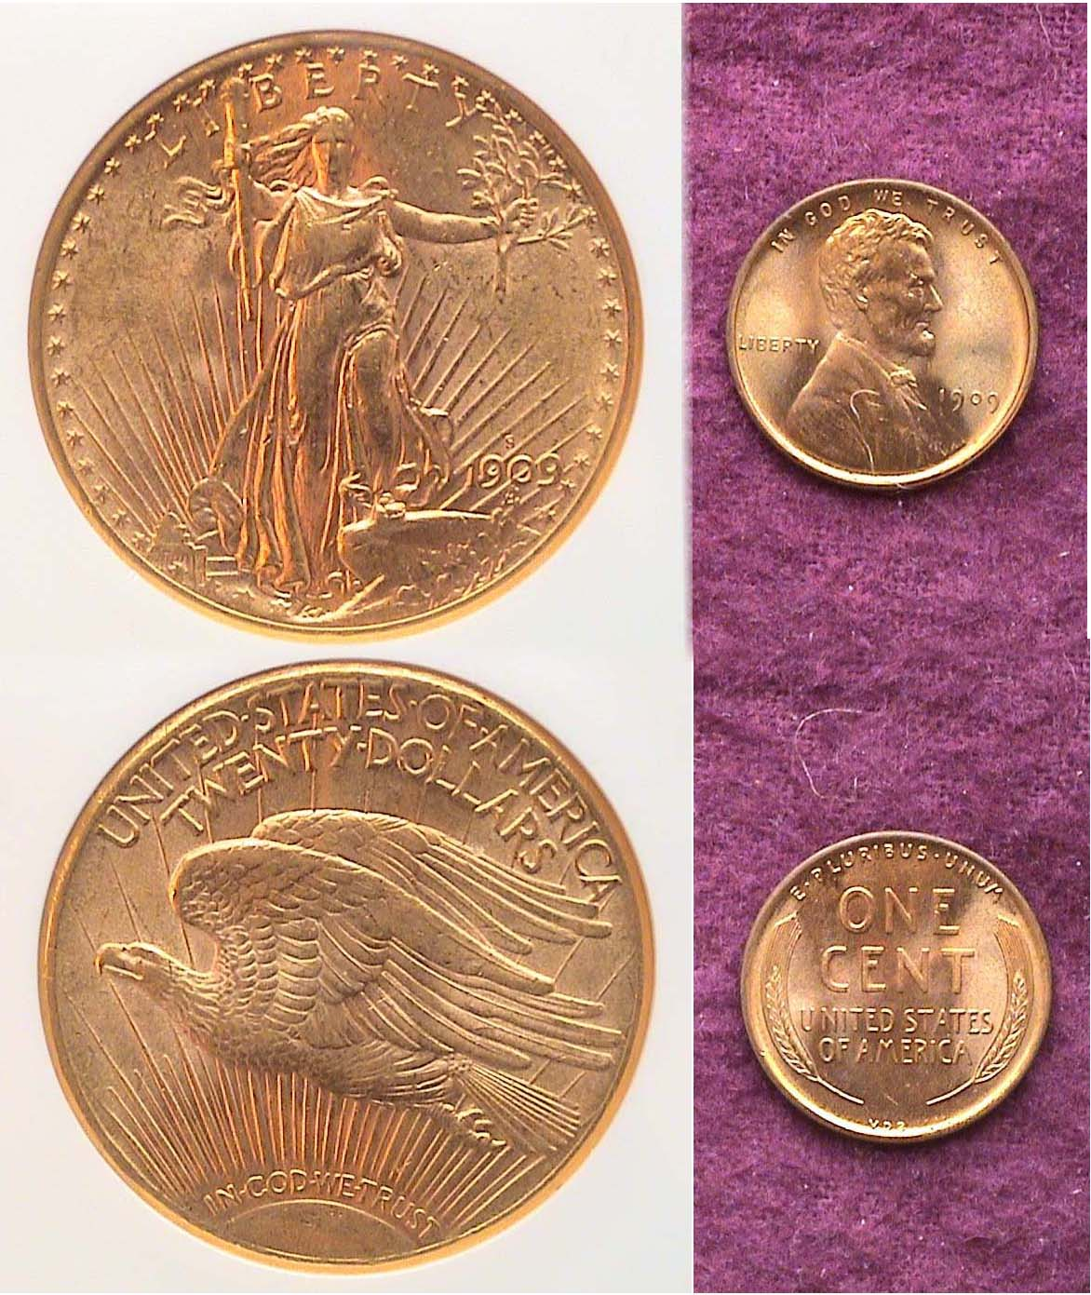

A 1909-S $20 Saint-Gaudens Double Eagle & 1909 VDB Lincoln Cent
[Magnify to 200% to see details.]

100 Years ago our 26th President, Theodore Roosevelt turned over the reigns of governance to his friend and political ally, the rotund William Howard Taft who became 27th President on March 4, 1909. Taft had defeated third time unsuccessful Democratic candidate William Jennings Bryan in the general election the previous November. The population of the United States had reached 90 million and the country was basking in the aftermath of Teddy Roosevelt’s popular policies. Roosevelt had been a champion of a more artistic coinage which had already resulted in the changeover to the beautiful Saint-Gaudens $20 and $10 gold pieces in 1907 and the $5.00 & $2.50 incused Indian Head gold pieces by Bela Lyon Pratt in 1908. Before leaving office Roosevelt asked Victor David Brenner to prepare designs for a new Lincoln Head cent which came into being on August 2, 1909.
_____________________________________________________________________________________________________________________
(Continued on page 2, column 1)
The US Coins of 1909 - 100 Years Ago
(Continued from page 1, column 2)

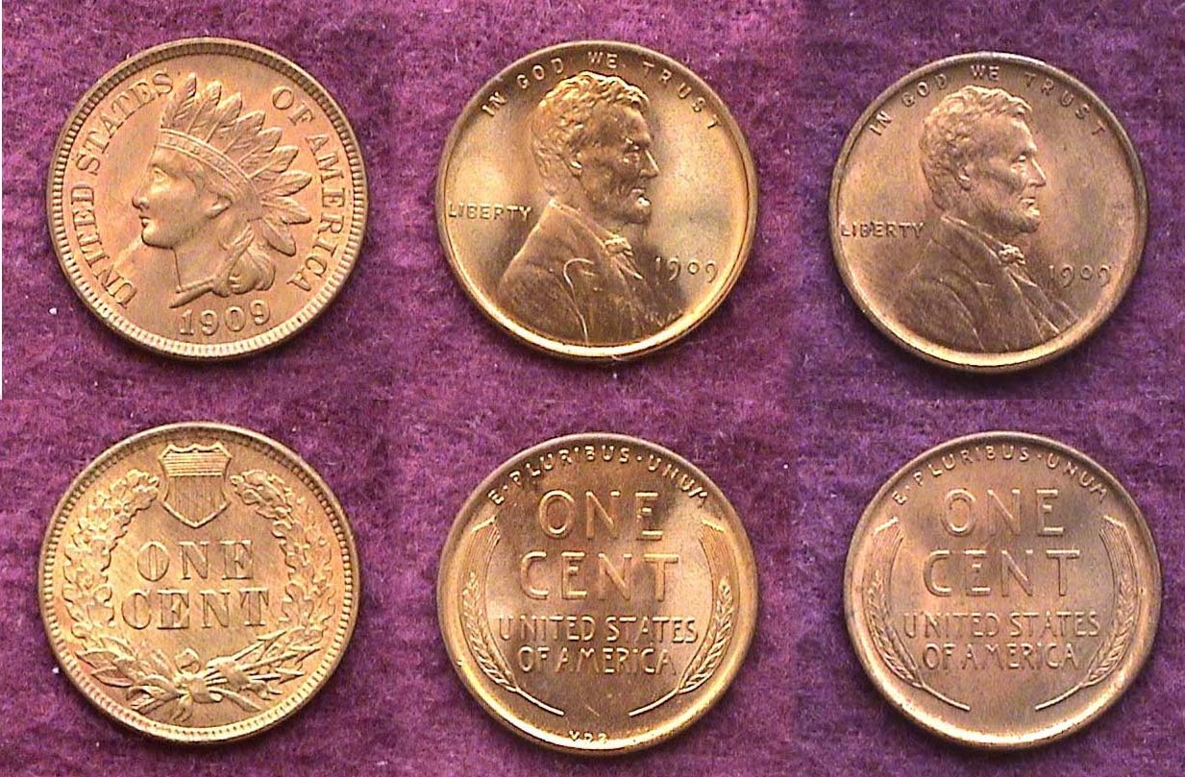

The Cent Types and sub types of 1909
L to R: Indian Head, Lincoln VDB, Lincoln no VDB on rev.
[Magnify to 200% to see details more clearly.]

As with 1907 and 1908, in which both the outgoing old and incoming new gold types were issued, the coinage year of 1909 provided for yet another transitional pairing of types; this time with the cent denomination. In fact, the cents of 1909 in some ways recall the five cent nickels of 1883 when the Mint issued two completely different types; the Shield and the Liberty “no cents” reverse and a second Liberty sub type featuring a “with cents” reverse. In 1909 there was a big hullabaloo over the engraver of the new Lincoln cent’s initials, VDB having been placed on the reverse under the wheat ears. Why persons in power resent those of talent who sign their work on our coinage in some manner of fashion as engravers and artists have done for centuries seems to me somewhat petty, but this apparently is how it has been since the dawn of our republic. At any rate, there was enough political pressure on the Mint to have Victor David Brenner’s initials removed with the result that a second sub-type known as the “No VDB” cent was issued later in 1909 providing for three major varieties for that year.

Beginning in 1908, the San Francisco Mint began striking cents that continued into 1909 on both the outgoing Indian Head and incoming Lincoln cents. They also struck the new cent with the VDB on the reverse but only 484,000 of them were coined before the initials were removed. The purchasing power of a cent in 1909 was about what a quarter is worth today, so not too many 1909-S VDB Lincoln cents were saved in any grade. The latest Red Book lists one grading Good-4 at a retail figure of $750 with a MS-63 priced at $2,300, which does not distinguish between Brown, Red/ Brown or full Red.

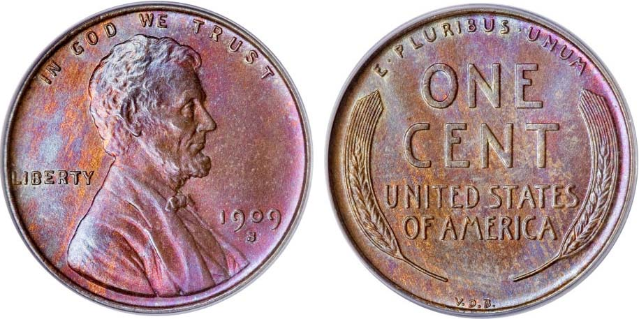

A 1909-S V.D.B. Lincoln Cent graded MS-65-Red-Brown by PCGS
This coin realized $5,462.50 at the Long Beach, CA
Heritage Signature Sale Feb. 4, 2009 [Courtesy of Heritage Auctions Archives]
[Magnify to 500% to see details.]

Most of us could not afford this particular coin no matter how badly we might have wanted it for our collection but it is instructive to surf the Internet in order to see how major auction
companies evaluate and grade coins and what prices they bring for a particular date. Before deciding to use this particular 1909-S V.D.B. Lincoln cent specimen for this article, the author observed a number of examples grading MS-63, MS-64 Red/ Brown and Red and MS-65 up to full Red and found this example to be the most attractive by far. Some of the full Red MS-65’s had blotchy surfaces which in my view netted the coin down to a MS-62 yet the prices realized were within the same $5,000 range as the piece shown.

The 1909-S VDB cent may be one of the most popular key dates in US coinage but even an XF-40 will cost over $1,000, so if one’s aim is to assemble a year set of 1909 coins either including the gold issues or excluding them, it may be more prudent to settle for a full Red 1909-P VDB specimen in MS-63. It is listed in the latest Red book at only $28.00.

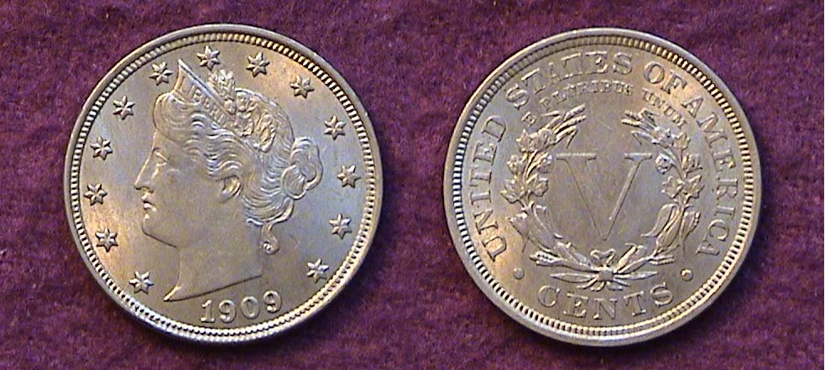

A 1909 Liberty Nickel
[Magnify up to 500% to see details more clearly.]

With 11,585,763 Liberty “V” nickels struck in 1909 the date represents the third lowest mintage for type of its 20th century run. Only the 1912-D (8,474,000) and especially the 1912-S (with just 238,000) are scarcer. In MS-63, the latest Red Book lists the 1909 5¢ at $140, only slightly above common date price. With MS-60’s priced at $95, an AU-58 should sell for around $75 to $85 today, so despite being classified as a “better date”, the date is not all that expensive and if lustrous such as the specimen shown above, would be considered a “best buy”. Five cents had the purchasing power of almost $1.25 in 1909.

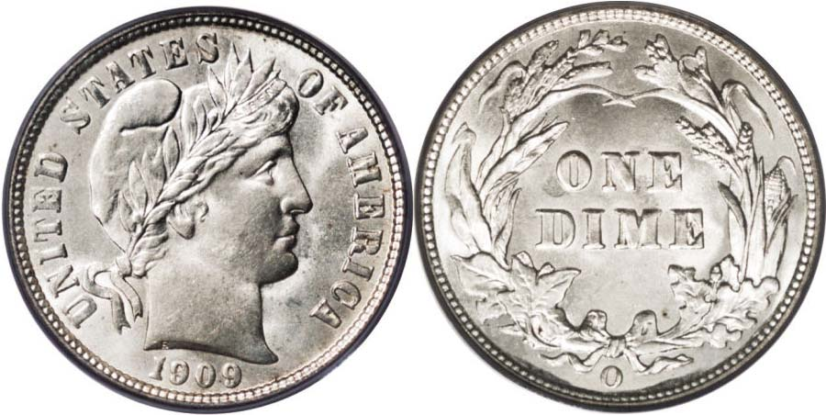

A 1909-O Barber Liberty Head dime graded MS-66 by PCGS
The coin realized $6,325.00 at the Heritage auction
Conducted at the ANA Convention in Milwaukee, WI Aug. 7, 2007
[Courtesy of Heritage Auctions Archives] [Magnify up to 500%]

The significance of the 1909-O dime shown above is not its grade. Yes! It is a magnificent looking coin but virtually none of us reading this can afford such a “gem”. What is significant is that 1909 was the last year the New Orleans Mint was in operation and their coinage output was limited to the three Barber designed Liberty Head silver coins of that period; the dime, quarter and half dollar as well as the extremely low mintage 1909-O $5.00 Indian Head gold half eagle. Over 2 million 1909-O dimes were coined, so if a collector wanted a souvenir from the final year of the New Orleans Mint, try locating one grading AU-58. It should sell for no more than $150 to $175. Of course the 1909-P dime with over 8 million struck would be a lot cheaper; around $95. Ten cents had the purchasing power of just under $2.50 a century ago.
______________________________________________________________________________________________________________________
(Continued on page 3, column 1)
The US Coins of 1909 - 100 Years Ago
(Continued from page 2, column 2)

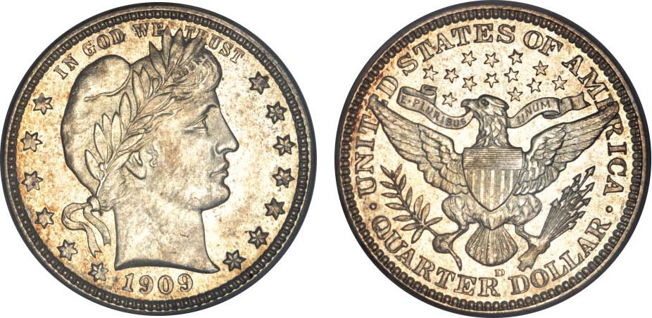

A 1909-D 25¢ graded MS-66 by PCGS
This coin realized $2,530 at the Long Beach, CA Heritage Sale
(Courtesy of Heritage Auctions Archives) [Magnify to 200% to see details]

The 1909-D Barber quarter pictured above is another example of grade rarity triumphing over date rarity. To be sure, it is a sharply struck coin but its slightly mottled toning distracts just enough to net its grade from a MS-66 down to a MS-64 where it would be valued at around $500 or one-fifth of the hammer price. The Denver Mint opened in 1906 and almost from the get-go started producing coins in large mintages. More than 5 million Barber quarters were struck at the Denver facility alone in 1909, so the coin is extremely common. A Choice AU-58 specimen for either the 1909-P or D should sell for around $125 and a MS-63 for $325 and appear almost as attractive.

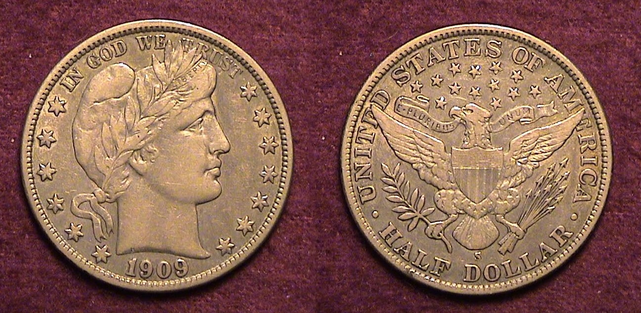

A 1909-S Barber half dollar grading XF-40
[Magnify to 200% to see details.]

The 1909-S Barber half shown above has a mintage of 1,784,000 but is only common as a date below Fine-12 and above AU because mint state examples are available for a price. While half dollars issued since 1941 are seldom seen except in bank rolls, virtually all Barber P, D, O & S half dollar dates entered circulation and were used until they were well worn. 50¢ had the purchasing power of $12.00 back in 1909.

As for the gold coinage of 1909, the date is available for all denominations; the $2.50, $5.00, $10.00 and $20.00 and reasonably priced from AU-58 thru MS-61; the 1909-S $20 Saint being the most common with over 2.7 million struck.

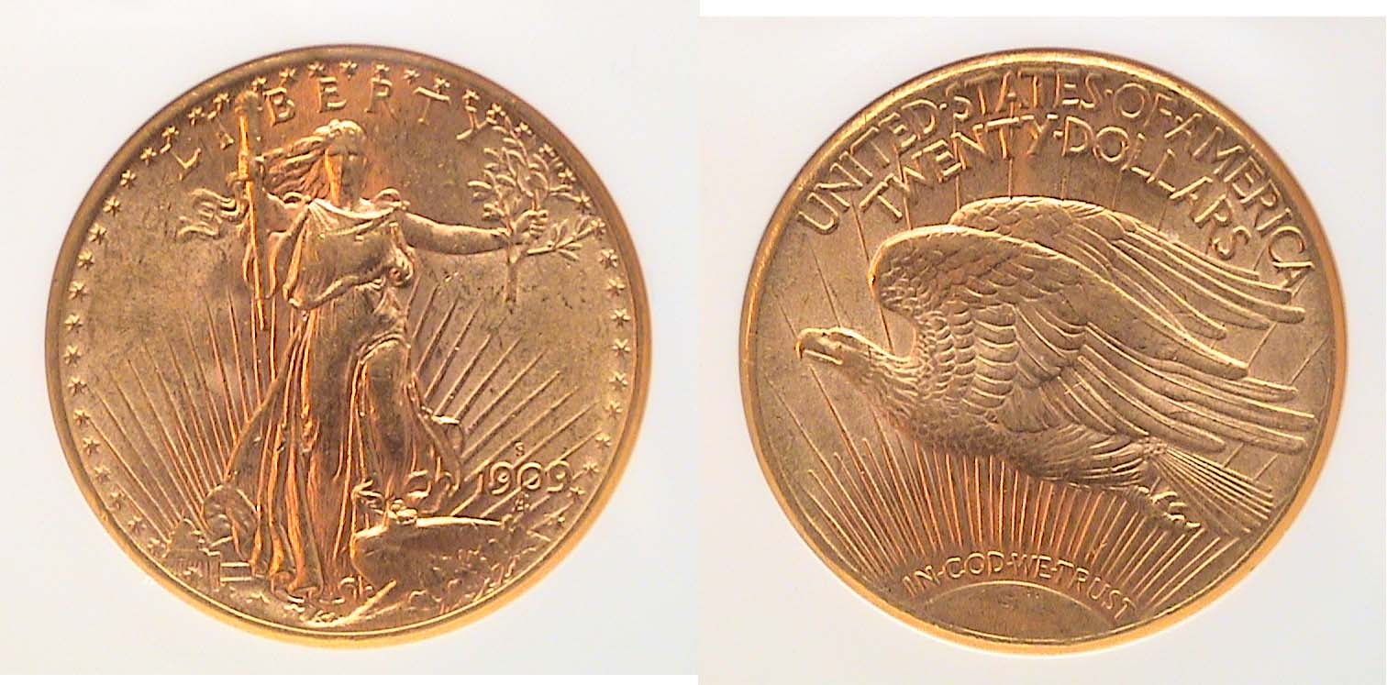

A 1909-S $20.00 Saint-Gaudens certified AU-58 by NGC
___________________________________________________________________________________________________________________

UGANDA CURRENCY
By Bill Myers (Part One: The Coinage)

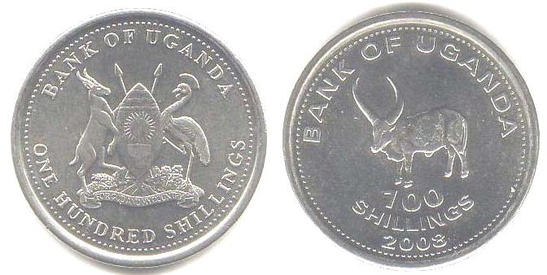

A 2008 100 Shillings coin from Uganda
[Use 3x glass or Magnify to 200% to see details.]

In October 2009 I had the opportunity to travel to Uganda with the U.S. Army as part of Exercise Natural Fire. It was a multi-national exercise to improve the living conditions in Kitgum, in northern Uganda. I was part of the group that delivered medical care over six days to over 6,000 patients. Only basic medical care could be delivered, as we worked out of a clinic building that did not have electricity or running water.

I was pretty much restricted to staying at our base camp during the mission, and to staying at the hotel upon arrival and departure. But I was able to get out once on a shopping excursion and managed to collect some of the current currency of Uganda.

The exchange rate was 1,700-1,800 shillings (sh) to the U.S. dollar. The coins available were 50, 100, 200 and 500 sh. I found it difficult to find nice examples. The coins are stuck in low relief, so the design wears quickly in circulation, and the date is even worn off on some of the coins. I assume the low relief is used to increase the die life and save money. There is a common obverse to all the coins. It has the crest of Uganda surrounded by “Bank of Uganda” and the denomination spelled out. The reverse also has “Bank of Uganda”, the denomination in numerals and the date. In addition, the reverse features the picture of an animal in the center. On the 50 shillings, the head of an antelope is featured. The 100 shillings has an African bull viewed from the side. The 200 shillings has a Cichlid fish and the 500 features the head of a Crested Crane. The Crested Crane is also on the Ugandan crest and the country’s flag. A point of interest is that the 200 shillings coin is actually smaller than the 100 shillings coin.
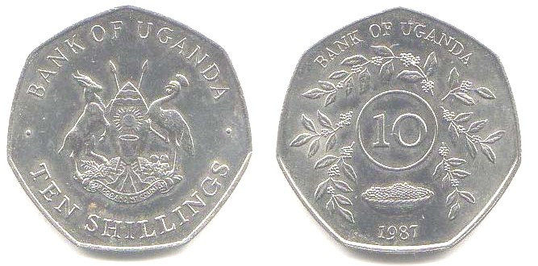

A 1987 10 Shillings coin from Uganda
[Use 3x glass or Magnify to 200% to see details.]

During my one trip to a bank, I obtained a 10 shillings coin. It features branches with leaves around a bowl of fruit. It is dated 1987 and is a one year type coin. It currently has a face value of about ½ a U.S. cent. The coins are composed of nickel-plated steel for the 50 shillings, copper nickel and stainless steel for the 100 shillings, copper nickel for the 200 shillings and nickel brass for the 500 shillings.
______________________________________________________________________________________________________________________
-to be continued-
More Club News
(Continued from page 1, column 1)

It was pitch black and somewhat misty while driving along the unlit roads leading to Cedar Creek on the evening of Thursday, Nov. 12. As a result attendance was down for our final meeting at the Cedar Creek Activity Center. During the SJ CSRA CC’s tenure at this lovely and state of the art facility attendance ranged from a low of 15 to a high of 27 and never approached the 35 or more that used to regularly attend the meetings at the more centrally located Aiken public library. Still, if it weren’t for the Barry’s arranging for this meeting site free of charge during these past 3½ years we may not have survived as a numismatic organization. Treasurer Sharon Smoot reported a record balance for our club; $1,934.27 as of October 31. Considering the state of economy this is extraordinary. Thanks, Sharon.

Show & Tells. Young Numismatist Austin Kuhl brought in a variety of small US banknotes that included the old and new $2.00 bills along with a number of silver certificates. Thank you Austin!

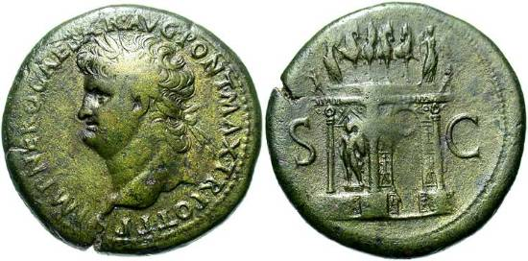

Jim Barry displayed a Roman Sestertius (54-68 AD) depicting Nero as Caesar with Laureate head facing left on the obverse and the Lost Triumphal Arch on the reverse. He explained this piece as an example of Imperial propaganda based on a military campaign Nero claimed to have led although historians take a different view. The coin, struck in brass is 35 mm in diameter (slightly larger than our $20.00 Double eagle).

The Program: Jim Barry ran a DVD featuring Part One of a lecture series on Ancient Rome by Dr. Stephen Tuck, (no relation to Friar.) The speaker spoke of the cultural differences in mores between Ancient Rome and today’s Western Civilization from the perspective of Roman society. The sub-topics included Rome’s need for public display, spectacular entertainment and territorial expansion far beyond the Mediterranean region. The talk was not without interest but perhaps too vast in scope for a 30 minute presentation being limited to just three coins among the variety of Roman artifacts shown. The next program will be a DVD on “Christian Symbols on Byzantine Cons”.

The prize winners at the Nov. 12 meeting were Howard Hillman who won the door prize, Glenn Sanders who took the 50/50 and President Steve Kuhl who was one of the lucky winners of a silver eagle drawing at the SCNA convention held last month in Greenville.
__________________________________________________________________________________________________________________________

Kindly patronize our advertisers
