Pres. Steve Kuhl
V .P. Arno Safran
Sec. Jim Mullaney
Treas. Sharon Smoot
Sgt. in Arms: Glenn Sanders
The Stephen James
CSRA Coin Club of Aiken
P.O. Box 11
New Ellenton, SC 29809
Web site: www.sjcsracc.org
The SJ CSRA CC of Aiken, SC meets on the 1st Thursday of the month at the Aiken Public Library

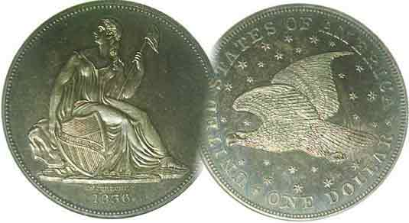
Committees:
Programs: Arno Safran
2010 Show: Jim & Helen Barry
Publicity: Jim Clapp
Newsletter: Arno Safran
E-Mail: arnosafran@comcast.net
Auctioneer: Glenn Sanders

2010 Club Meeting Schedule
Volume 9, Number 12 the Stephen James CSRA Coin Club, Founded in 2001 December, 2010
Monthly Newsletter
Club Ends Year With Many Plusses
Our next get together is the Dinner Meeting Thursday, Dec. 2, 2010 at 6:30 PM

Jan. 7 Apr. 1 July 1 Oct. 7
Feb. 4 May 6 Aug. 5 Nov. 4
Mar. 4 Jun. 3 Sep. 2 Dec. 2

____________________________________________________________________________________________________________

2010 was a good year for the SJ CSRA CC

At the November meeting, President Steve Kuhl reported a treasury balance of $2,384.42. This represents the largest year-end balance since the club was founded in 2001. The year also marked our return to the Aiken Public Library. Despite one or two meetings when attendance was disappointing, overall attendance has increased to an average of 25 members per meeting including guests. Another plus for our club has been the greater involvement of its members in the Show & Tell segment. At the September meeting thirteen members brought in Show & Tell numismatic exhibits although there was only had time for nine. At the November meeting, we had a program yet five members displayed a variety of numismatic items. As Vice President Jim Barry set the tone for our educational programs and they have continued to impress, especially since more of our area citizens and members have been contributing. Xavier Pique, Arno Safran, Walter Kublius and Chuck Goergen have all presented interesting PowerPoint programs along with guest numismatists Robert Moon and Tony Chibbaro. Thanks to the efforts of co-chairs Jim and Helen Barry, along with the many members who assisted them in setting up, operating the welcoming desk and breaking down, we had another successful show in September. Earlier in the year, the club members approved a revision in its by-laws. Finally, we will conclude 2010 with our annual pre-Christmas holiday dinner at the Houndslake Country Club on Thursday December 2, the social get together beginning at 6:30 PM with dinner being served at 7:00 along with a chance for some prizes.

These are the plusses! However, there are some concerns as we plan ahead for 2011. The original Executive Board which did such a tremendous job in organizing the club back in March 2001 have all stepped down. We now have a new Executive Committee but, with 2011 approaching we still do not have a Show Bourse Chairperson. It is a position we must fill soon if the SJ CSRA CC is to continue to grow.
__________________________________________________________________________________________________________________________

The US Coins of 200 Years Ago – 1810
By Arno Safran

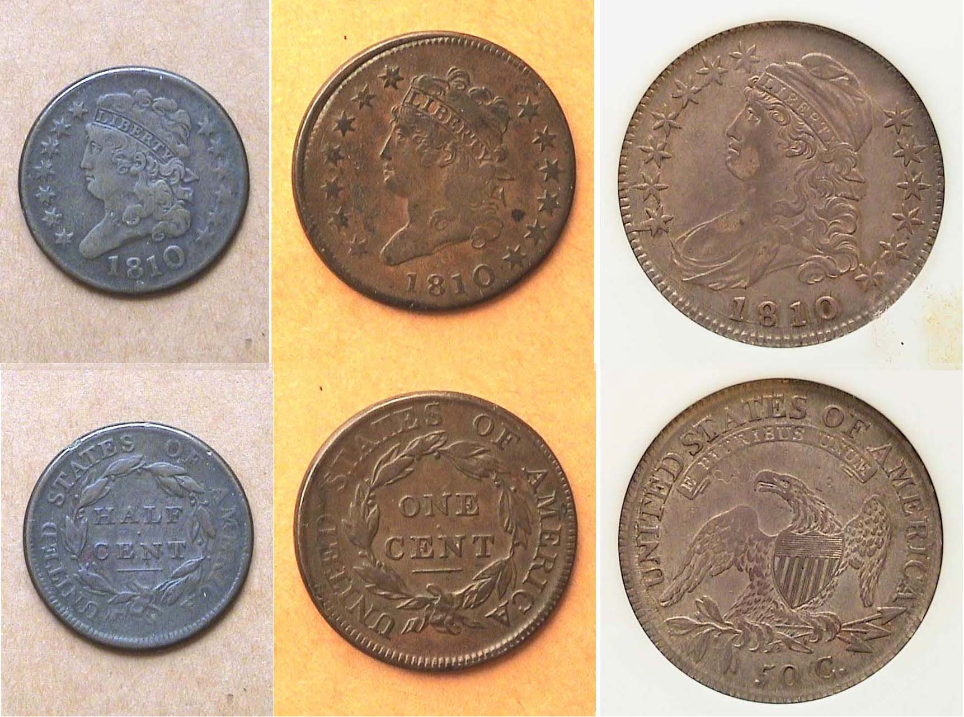

An 1810 US Denomination set (excluding gold)
From Left to right: 1810 ½¢, 1¢ and 50¢ denominations

In the early years of our Republic, our nation’s ability to produce enough coinage to meet the needs of commerce was hampered by the lack of sufficient silver and gold bullion. The planchets needed to strike our copper coins had to be ordered from England, a voyage that took months. The only time all ten authorized US denominations were struck in a single year was in 1796 and this was the high water mark until 1849. Fortunately, there was an abundance of Latin American silver coinage from the Real (12½¢) through the 8 Reales ($1.00) that circulated here. These supplemented what our Mint could produce on a yearly basis. Between 1807 and 1825, the US Mint seldom struck more than four denominations as a number of them had been suspended. For most of this period, only one gold denomination was issued; the $5.00 half eagle. (Survivors are all rare and costly today). Excluding gold, only three denominations were struck in 1810, the coins that are shown above, the ½¢, 1¢ and 50¢. They are still reasonably priced in Fine-12 to VF-30.
_____________________________________________________________________________________________________________________________
(Continued on page 2, column 2)

Collecting the US Coinage of 1810: 200 years ago
(Continued from page 1, column 2)

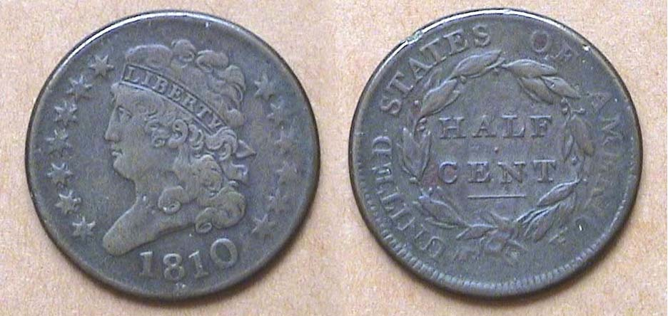

An 1810 Classic Head ½¢ grading Fine-12
[Use 3X glass or magnify to 200%]

The 1810 Classic Head type half cent had a reported mintage of 215,000, a huge drop from the 1,154,572 given for the previous year. Due to the extensive circulation of the Spanish Real, worth 12½¢, the half cent saw lots of circulation in making change for the slightly larger than dime-sized silver coin. In 1810, a half cent could be used towards the purchase of a number of items from buttons to books and other goods that were priced from around 2½¢s or more. As a date, the 1810 is considered one of the scarcer ones of the Classic Head series (1809-1836) and is somewhat pricy in the higher grades. It is challenging to find one in problem-free condition. The specimen shown above was graded Fine and purchased in January of 1986 for a paltry $25. The small rim bump at 11:00 on the reverse may have accounted for the low price I paid back then but overall, the coin is attractive for grade. The 2010 Red Book lists it at $120 in Fine-12. In VF-20 it is priced closer to $250 and in XF-40, around $550 but the date is not seen with any frequency.

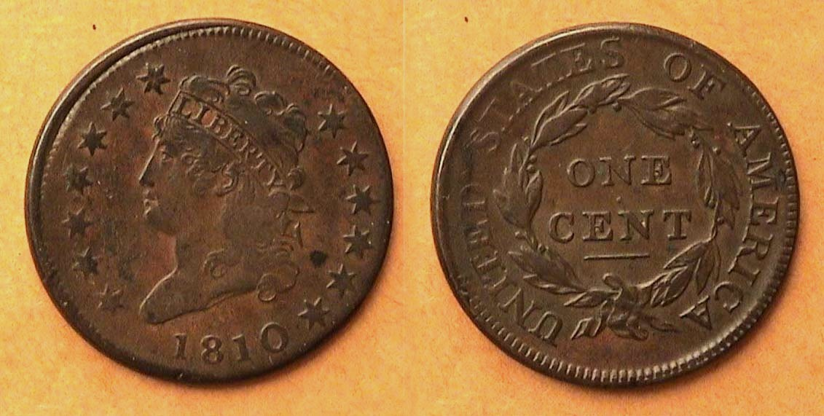

An 1810 Classic Head Large Cent, S-283 R2 VF-30
[Use 3X glass or magnify to 200%]

As a collector, I have long regarded the Classic Head cent design by John Reich to be the most artistic and attractive of all cent types to date. Regrettably, the copper used for striking these coins during the type’s seven-year consecutive run (1808-1814) was well below the standard of those that preceded and followed. After the long sea voyage from England to America many of the planchets arrived dark and porous from being housed in kegs stored inside the damp holds of ships with the result that even some higher grade specimens can be found charcoal colored, stained and corroded.

The reported mintage for cents dated 1810 was 1,458,500 and while the date is considered common for type, finding a chocolate-brown problem-free specimen is a challenge. The author was shown the above specimen at a coin club meeting back in 1989 by a reliable dealer who graded the piece VF-30. It was sold for $235. The latest Red Book lists a VF-20 specimen at $600 and an XF-40 at a whopping $1,550. You may draw your own conclusion as to what a VF-30 1810 Classic Head cent might sell for today.
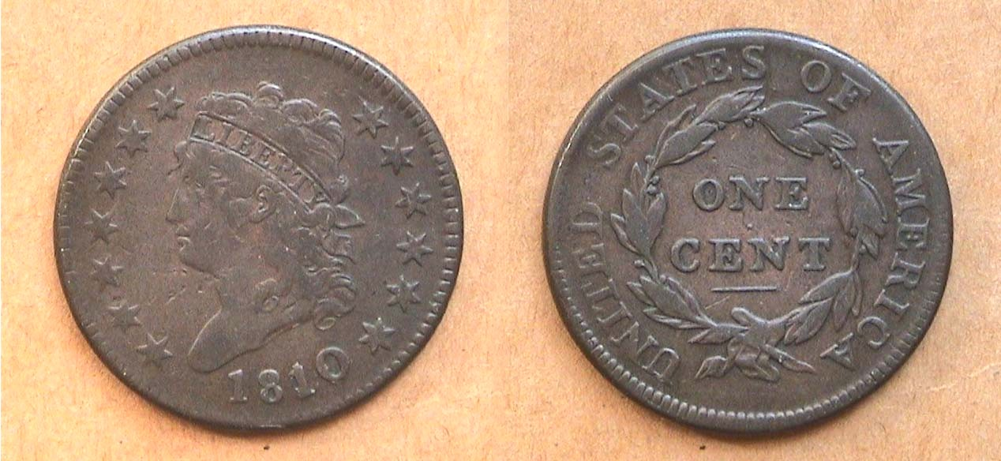

An 1810/09 Classic Head Large Cent, S-281 R1 VF-20
[Use 3X glass or magnify to 200%]
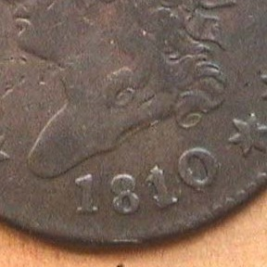
For those who enjoy collecting coins with overdates, 1810 offers an 1810/09 cent variety that is popular with large cent collectors. Fortunately, it is regarded as a fairly common die variety and priced similarly to the 1810 normal date.

In 1810, the only silver denomination coined was the half dollar. The dollar had been suspended after 1804; the half-dime after 1805, the quarter after 1807 and between 1809 and 1820, the dime was coined only in 1811 and 1814. Most of our circulating silver coinage was supported by large numbers of Latin American colonials minted at the various Mints south of the border. These included the ½ Real (6¼¢), the Real (12½¢) and 2 Reales (25¢; AKA 2 bits) Only the Hispanic 4 Reales, (with the value of 50¢) were in short supply but as the Bust half dollar was our largest circulating coin, these weren’t needed.

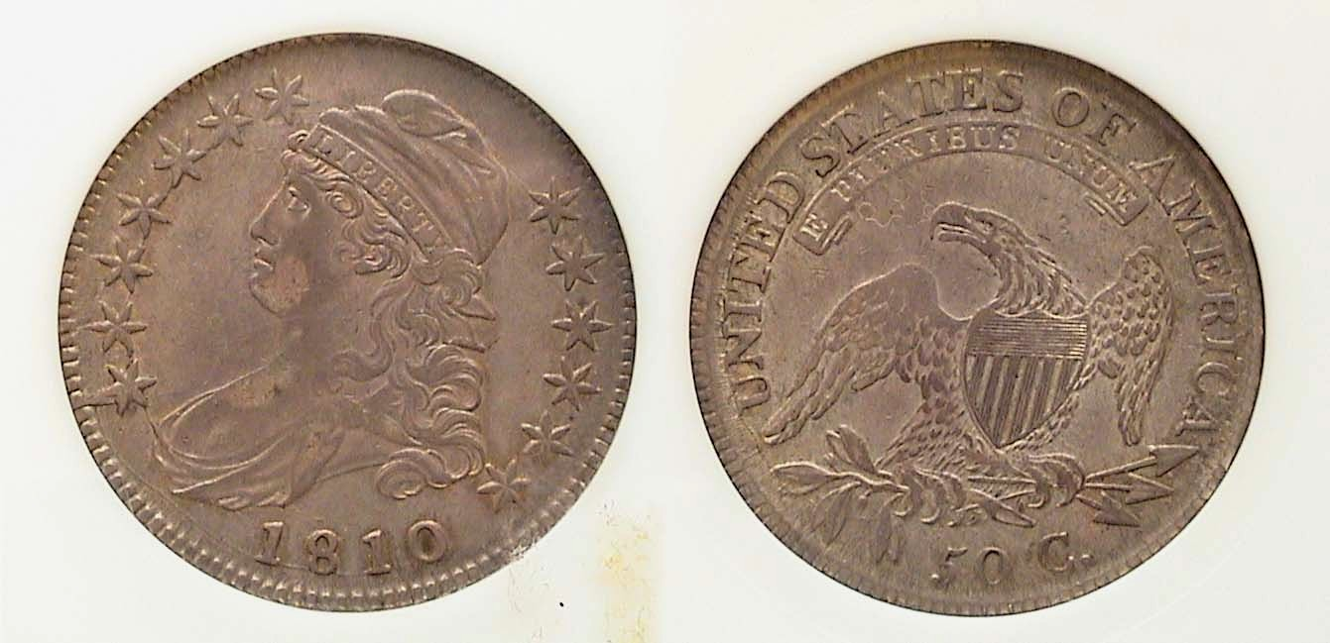
An 1810 Capped Bust Half Dollar. O-101, R1
The coin was graded AU-50 by NGC [Magnify to 200%]

The reported mintage for the 1810 half-dollar was 1,276,276. Since 50¢ had the purchasing power of $9.00 back then it could acquire many goods. As our largest silver denomination, the Bust half was ostensibly used as specie to back large business transactions and many were stored in the vaults of the numerous State and local banks. Because of this, a large number of these Capped Bust lettered edge halves survive in XF to BU. (The series was issued from 1807 through 1836.) Until 2000, most dates were relatively inexpensive up through XF-45 but with the tremendous influx of type collectors during the first five years of the 21st century, even the most common dates sell for $90 in VF-20 and $175 in EX-40 now. An 1810 50¢ in XF-40 is listed in the 2010 Red Book at $275, in VF, $170.

In 1810, the population of the United States was 7,300.000 million. James Madison; author of the US Constitution was serving the nation as our fourth President, having succeeded the author of our Declaration of Independence, Thomas Jefferson the previous year. The country was in good hands but ominous war clouds were looming.
_____________________________________________________________________________________________________________________
Club News

President Steve Kuhl called the Nov. 4 meeting to order at 6:45 PM. Sgt. in Arms Glenn Sanders reported that there were 24 members and 1 guest present. He also announced upcoming shows in Columbia, Chattanooga and Augusta. Jim Barry announced that President Steve Kuhl was one of the raffle prize winners at the recently held SCNA coin show held in Greenville. He was presented with an uncut uncirculated sheet of State of South Carolina Revenue Bond Scrip printed in 1873.

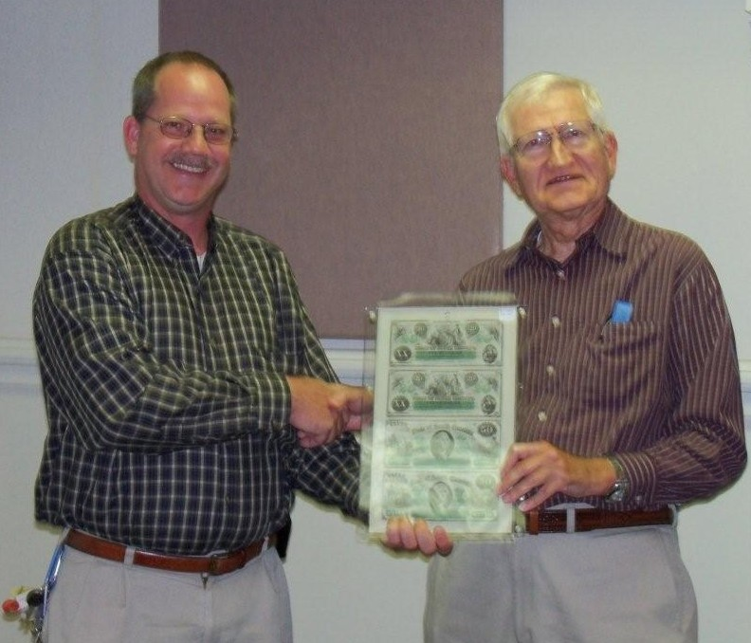

President Steve Kuhl receiving uncut 1873 State of SC Bond Scrip from SCNA Immediate Past President Jim Barry
[Photo, courtesy of Helen Barry]

Jim Barry also mentioned that so far, no one has yet come forward to serve as Show chairperson. He and his wife Helen announced back in April that they would be stepping down after doing the Sept. 11, 2010 show. Our next show is tentatively scheduled for Sat. Sept. 10. The clock is ticking.

Member Rick Owen donated a NGC Grading book to the Aiken Public Library; a $10.00 value. Thank you, Rick! Helen Barry reminded members to make their reservations for the Club’s pre Christmas holiday dinner by the 23rd of November. So far around 30 members and guests signed up.

The Show and Tell Session that preceded the program produced five interesting displays. Austin Kuhl displayed German notgeld from the inflationary period of 1822 and 1823. They were valued at $100,000 marks but couldn’t buy much.

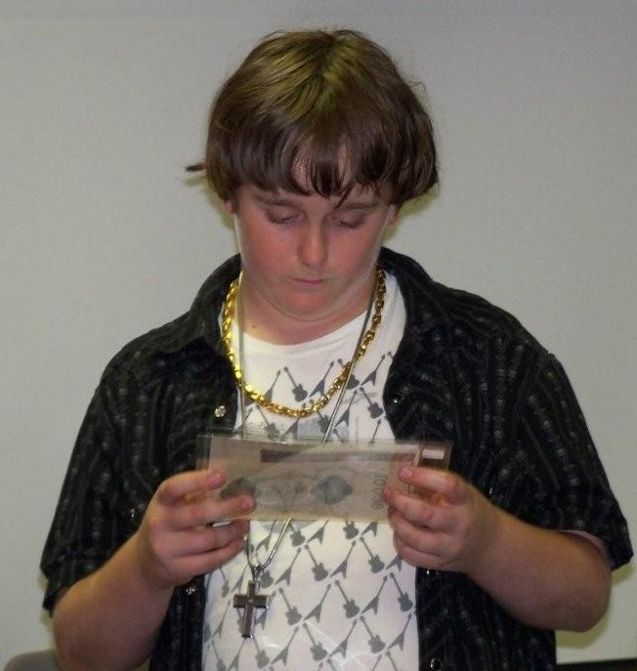
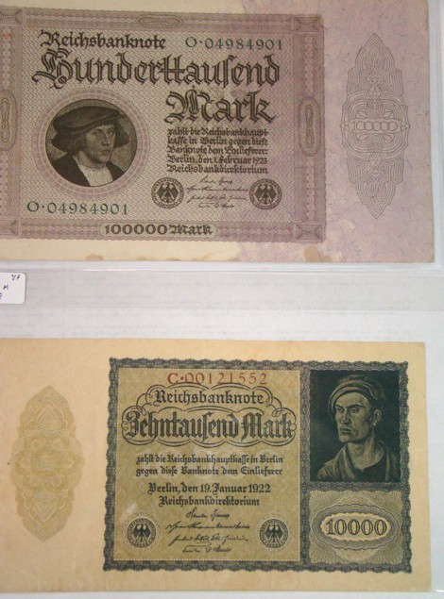
Austin Kuhl with notgeld, left; close-ups at right
Photos by Helen Barry and Jim Mullaney [Use 3X glass or magnify to 200%]

Rick Owen brought in a popular key date 1909-S VDB Lincoln cent housed in a NGC-63 holder and it was a beauty.

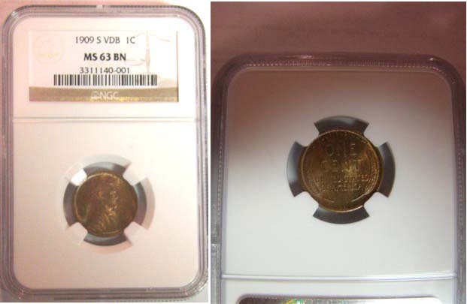

At left, a 1909-S VDB 1¢ obverse and at right, the reverse enlarged
Photo, courtesy of Jim Mullaney

Jim Barry displayed a cast copper coin from the Japanese Feudal period (1400 – 1853).

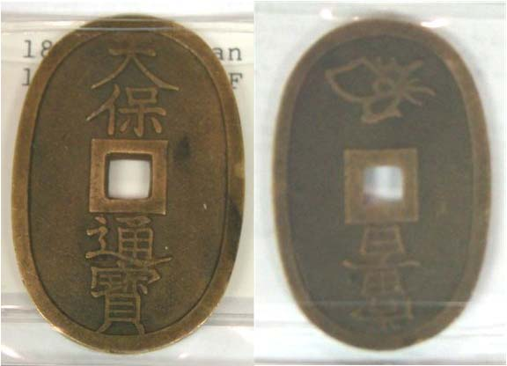

Japanese Feudal Period cast coin
[Use 3X glass or magnify to 200%]
Photo, courtesy of Jim Mullaney

Roger Worpell displayed his impressive collection of British Crowns going back to George II spanning the years from 1720 to 1982.
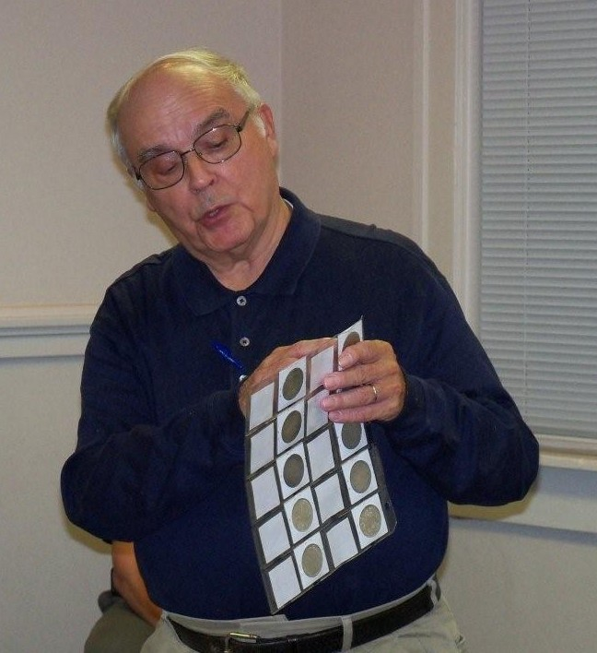
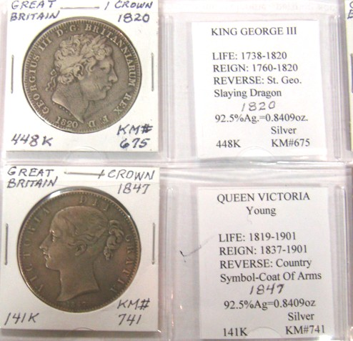
At left, Roger Worpell holding loose leaf sheet with collection of British silver crowns. At right are the obverses of King George III and the young Queen Victoria.
[Use 3X glass or magnify to 200%]
Photo, courtesy of Jim Mullaney

President Steve Kuhl also showed his prize winning sheet of South Carolina Revenue bond scrip in the denominations of $20.00 and $50.00 notes won at the recently held SCNA show raffle drawing. Congratulation, Steve!
_______________________________________________________________________________________________________________
(Continued on page 4, column 1)

Show & Tells
(continued from previous page)

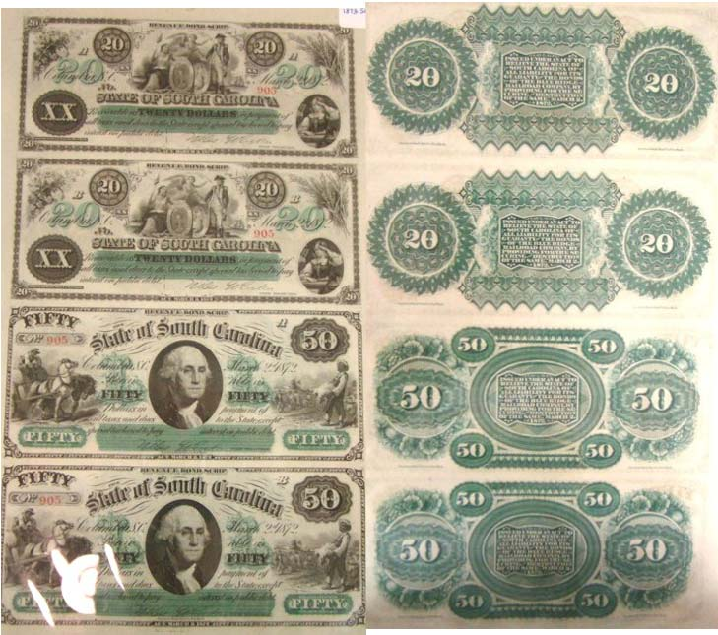

An uncut sheet of SC Revenue Bond Scrip in the denominations of $20.00 and $50.00 won by our club President Steve Kuhl
At the SCNA Convention, October 30, 2010
[Use 3X glass or magnify to 200%]
Photo, courtesy of Jim Mullaney
___________________________________________________________________________________________________________

The Program

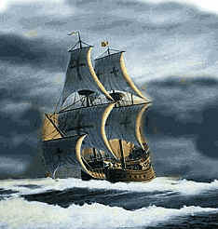
Our speaker for the Nov. 4 meeting was member Chuck Goergen. Chuck gave a PowerPoint presentation entitled, “Spanish colonial cobs and the Treasure ship Nuestra Senora de Atocha”. The Atocha was the “caboose” of the 28 ship Spanish fleet. It was one of the eight ships of that convoy that went aground and sunk off the Dry Tortugas and the Florida keys when a hurricane engulfed them on September 5, 1622. What made the Atocha so special was its valuable cargo that included gold doubloons and silver cobs, (AKA pieces of Eight). Chuck mentioned that 264 people died and yet miraculously five survived but the wreck was scattered and difficult to find due to another hurricane that hit the area a month later. Chuck reported that the Spanish were never able to salvage the treasure. The treasure remained lost until Mel Fisher and his salvage crew recovered much of it in 1985.

Chuck discussed the types of numismatic items that were hoisted up from the bottom of the sea These included around 100,000 shield type cobs and 1,000 ingots the size of bread loaves.
Chuck presented a history of the various Latin American mints that were operating in the Western hemisphere during the early 17th century; the Spanish coat of arms and the various types and styles of coins produced. This was a fascinating program. Thank you Chuck.
___________________________________________________________________________________________________________________

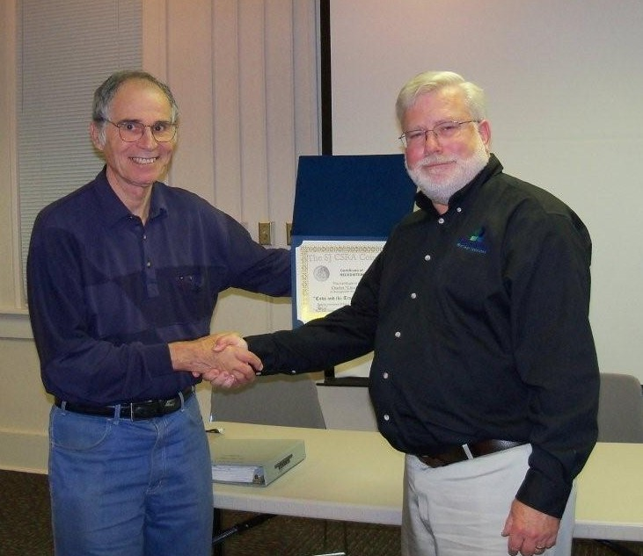
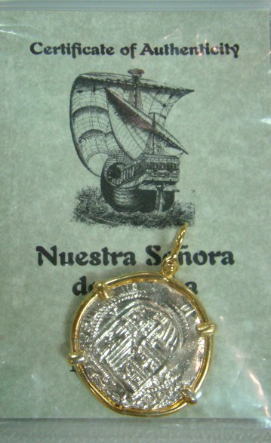
Arno Safran presenting Chuck Goergen Authenticity Certificate
With Educational Award at Nov. 4 meeting
{Photo, courtesy of Helen Barry)

In other club news Jim Barry announced he will be teaching a course on Ancient Greek Coinage and History sponsored by the USC Aiken. The four week course will run on Wednesdays Jan. 26 thru Feb. 16, 2011 at the Cedar Creek Community Center, Aiken starting at 3:00 PM. Please contact Laura Anderson at USCA, 803-641-3563 for further information. The Prizewinners at the Nov. 4 meeting were Helen Barry, Todd Starbuck and Glenn Sanders. Glenn won the 50/50 drawing - ($24.00) and Helen won the door prize. Todd returned from the northland to pick up his prize won at an earlier meeting. Congratulations winners! Our next get together is the Dec. 2 dinner meeting at the Hounds Lake Country Club. Our first official meeting of the new year will be on Thurs, Jan. 6, 2011. To all reading this, the editor hopes that everyone had a wonderful Thanksgiving and wishes you all a very Merry Christmas holiday season and a Happy New Year.
___________________________________________________________________________________________________________________________

