Pres. Steve Kuhl
V .P. Pat James
Sec. Jim Mullaney
Treas. Sharon Smoot
Sgt. in Arms: Glenn Sanders
The Stephen James
CSRA Coin Club of Aiken
P.O. Box 11
New Ellenton, SC 29809
Web site: www.sjcsracc.org
The SJ CSRA CC of Aiken, SC meets on the 1st Thursday of the month at the Aiken Public Library

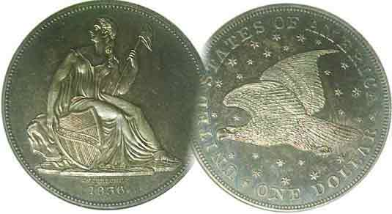
Programs: Pat James
Show: by Committee
ANA Representative: Jim Barry
Publicity: Jim Clapp
Newsletter: Arno Safran
E-Mail: arnosafran@comcast.net
Auctioneer: Glenn Sanders
Web site: Susie Nulty (see above.)

2011 Club Meeting Schedule
Volume 10, Number 12 the Stephen James CSRA Coin Club, Founded in 2001 December, 2011
Monthly Newsletter
Successful Show, Programs & Show & Tells 2011 Highlights
Our next meeting is on Thursday, December 1, 2011 at Hounds lake Golf Club

Jan. 6 Apr. 7 July 7 Oct. 6
Feb. 3 May 5 Aug. 4 Nov. 3
Mar. 3 Jun. 2 Sep. 1 Dec. 1, (dinner)

______________________________________________________________________________________________________

Successful Show, Interesting Show & Tells and Enjoyable programs Highlight 2011 Club Activities

As we approach the end of 2011 our coin club can now look back with pride on almost a decade of impressive numismatic activity. Some coin clubs have no concept of Roberts Rules of Order nor any sincere interest in numismatic education but seem to exist from month to month for the sole purpose of auctioning off mostly common coins, Mint and Proof Sets or low grade type. While our club holds a monthly auction run by our redoubtable auctioneer Glenn Sanders, the executive committee encourages members to bring in numismatic items from their collection and share their latest acquisitions. This has had the effect of widening the scope of numismatic knowledge for those who attend regularly. As a result, we have been exposed to a variety of scarcer US coins as well as some amazing foreign and ancient coins, tokens, medals and banknotes. Through the efforts of program chairs, Jim Barry, Arno Safran and Pat James, and the many members who have given numismatic presentations (in addition to our guest speakers and borrowed DVDs or tape), members have experienced a numismatic program at every meeting during the 10 year span.

Our final meeting of 2011 will take place at the Hounds Lake Golf Club where we will meet for dinner, discuss plans for next year’s meetings and even partake of some Show & Tells. There will even be some door prizes awarded to members and guests and based on past dinners at this facility, everyone can look forward to a tasty meal.

Our first meeting after the holidays will be Thursday, January 5. Unfortunately, the date falls during the week of the Annual Florida United Numismatists (FUN) Show in Orlando (Jan. 5-8, 2012). For those who have never made it down to FUN (about a 7 hour drive from Aiken), the Show boasts the largest bourse in the United States. It has often been said, if you cannot find what you are looking for at FUN, it probably no longer exists.
_____________________________________________________________________________________________________________________
(More Club News continues on page 3, column 2)

1853: An Amazing US Coinage Year: 158 Years Ago
By Arno Safran

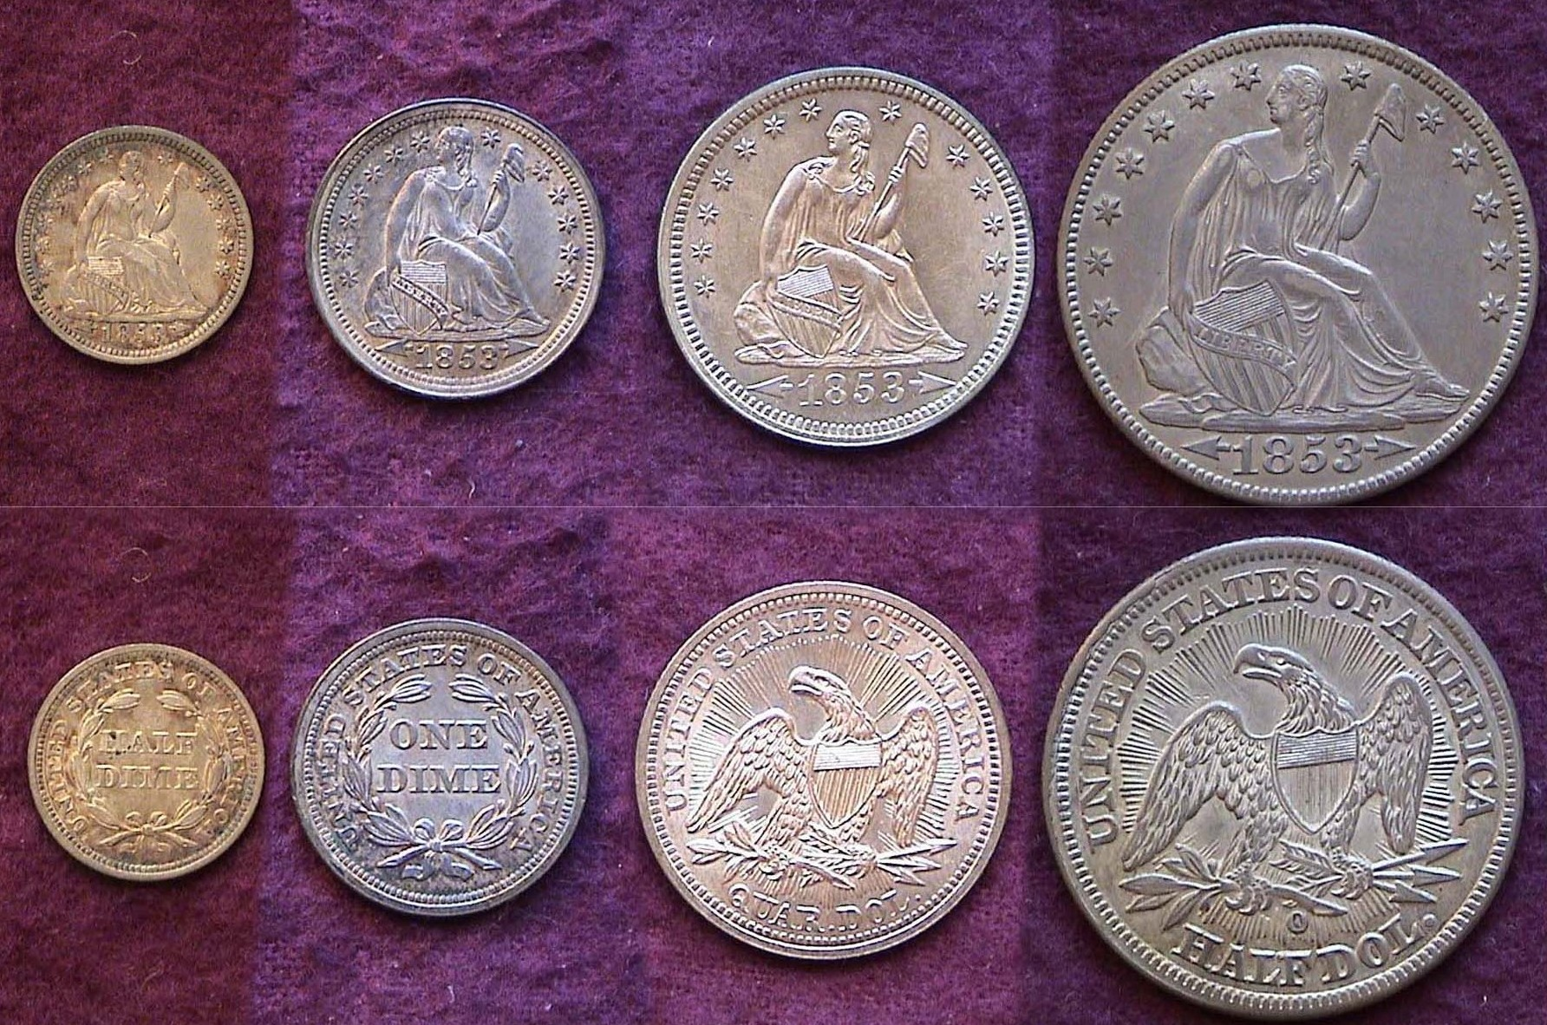

A set of 1853 arrows (and rays) Liberty Seated silver coins
Shown from left to right are the half dime, dime, quarter and half dollar
[Magnify to 200% to see details.]

Imagine a situation where our newly minted coins are being hoarded, then sold to bullion dealers practically as soon as they left the Mint. Why would such a thing happen? It couldn’t possibly occur today because none of our circulating coins are struck in silver, but after vast discoveries of gold in California around the mid 19th century, the price of silver rose in relation to gold adversely affecting commerce in the eastern states. As a result, the Philadelphia Mint began reducing its output of silver coinage, especially in the larger denominations. In 1850, the P Mint produced only 190,800 quarters, 227,000 half dollars and just 7,500 silver dollars but that only added to the problem. What little output left the Mint was immediately sold to the bullion dealers and melted for their silver content over the face value of the coins. Finally in 1853, Congress acted on the suggestion by Mint Director George N. Eckert to reduce the weight of the silver coins just enough to make it unprofitable for dealers in bullion to benefit from it. The bill was passed on February 21 and signed into law by President Franklin Pierce.
____________________________________________________________________________________________________________________
(Continued on page 2, column 1)
The Coins of 1853 (Continued from page 1, column 2)

With the bill signed into law, Mint Director Eckert instructed Chief engraver James Barton Longacre to have an arrow placed on each side of the 1853 date on the 5¢, 10¢, 25¢ and 50¢ denominations as a means of communicating to the public the lower silver weight therein. The quarter and half dollar were to receive rays emanating outward from the eagle on the reverse thereby adding special emphasis to the change. With so few silver dollars being coined, (only 46,110 were struck in 1853), it was decided not to alter the weight on the dollar coin.

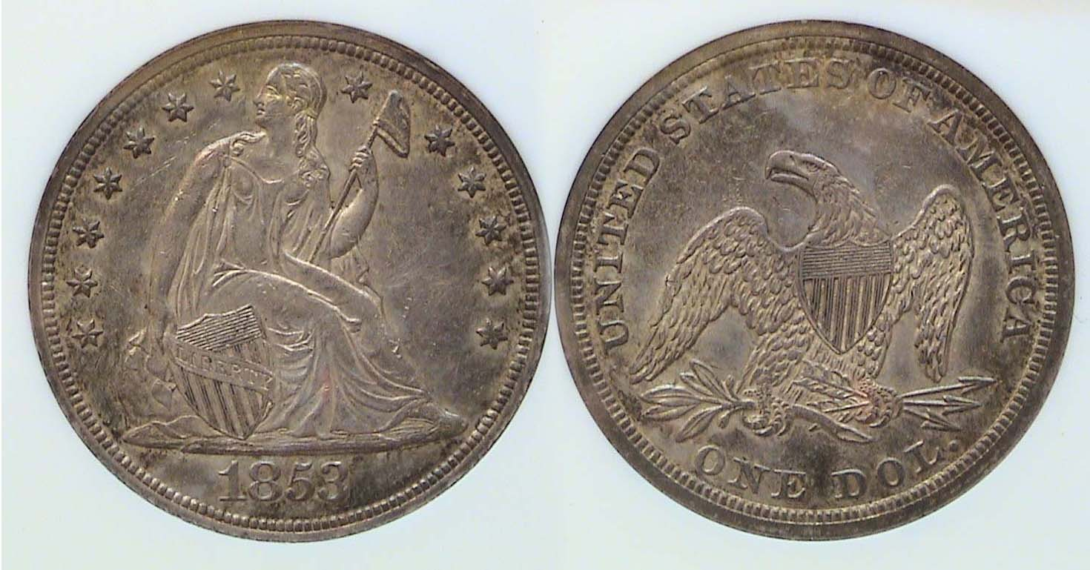

An 1853 Liberty Seated $1.00 graded AU-58 by NGC
This was the only Liberty Seated denomination unaffected by the Coinage Act of 1853. [Magnify to 200% to see details.]

In that same year the Mint struck record numbers of the newer reduced weight silver coins and they circulated. The coin hoarding and melting ended and commerce was restored to its pre Gold Rush levels. While not nearly as controversial as the recent “bailout” of Wall Street and Banking system, the money crisis of 1853 was a serious issue at the time.

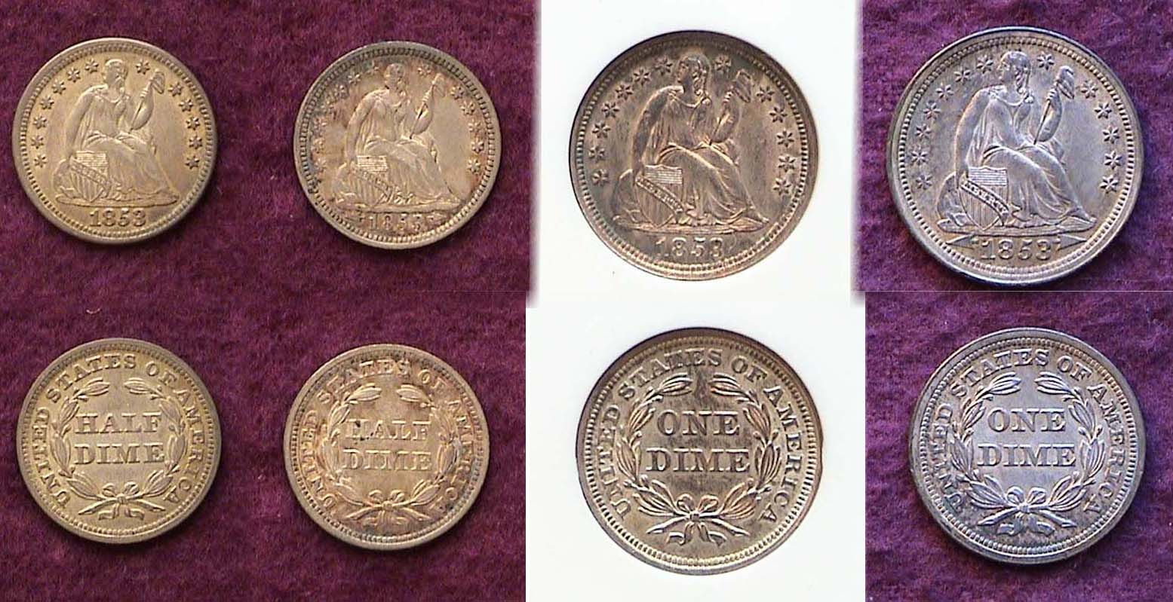

1853 no arrows and with arrows half dimes and dimes
(When printed, the coins are approximately actual size if not in exact scale.)
[Magnify to 200% to observe details more clearly]

From the collector’s perspective the Coinage Act of 1853 inadvertently provided some special challenges as those coins struck before the changeover are considerably scarcer. The 1853 no arrows quarter is very scarce but the 1853-O no arrows or rays half dollar with only three known survivors--none higher than VF--is considered uncollectible even to the manor born. On the other hand, with a little perseverance, one can locate the 1853 no arrows half dime and dime in XF-45 or better at a higher cost but still affordable. Each represents a good bargain as the mintage for the 1853-P no arrows half dime was 135,000 compared with 13,210,020 for the with arrows issue. The 1853-P no arrows dime is even scarcer with only 95,000 struck compared with 12,078,010 for the 1853-P with arrows version.

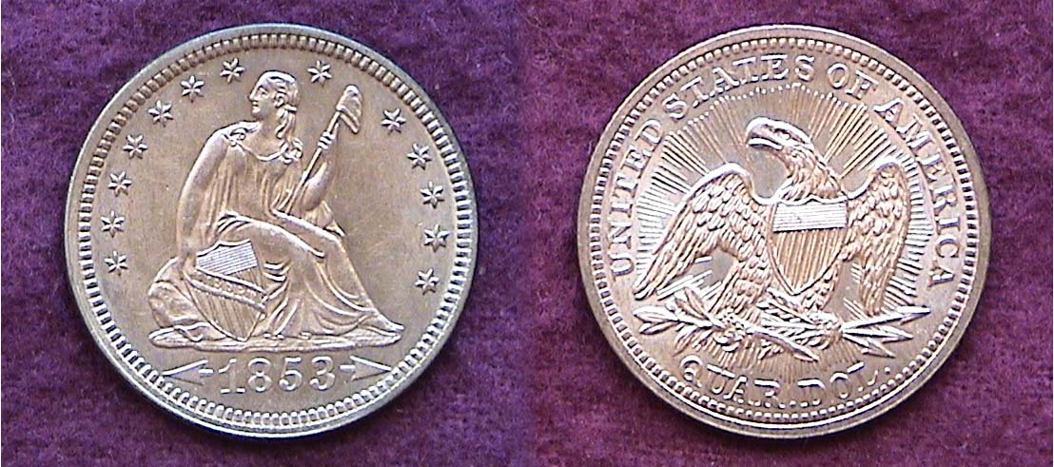

Shown above is the majestic 1853 arrows and rays quarter dollar.
[Magnify to 200% to see details.]

The 1853 with arrows and rays quarter is one of our most beautiful coins especially grading AU-58 or higher. The magnificent rays emanating outward from the eagle on the reverse was a master stroke by engraver James Barton Longacre. Despite its enormous mintage, over 15 million, the high water mark for the 25¢ denomination at the time of issue, the sub-type has always been in strong demand because it is a one year type and is more expensive than other dates with far lower mintages. In 1854, the new Mint Director, James Ross Snowden decided to have the rays on the reverses of the quarter and half dollar removed. No reason for this is known but it is conceivable that he wanted all four denominations; (the half dime through the half dollar) to appear consistent by just showing the arrows alongside the date and nothing else.

The earlier 1853 no arrows quarter is another story and therein lies the tale. During almost two months before the coinage Act of 1853 went into effect some 44,200 were reported minted but many may have been melted for their higher bullion value. By contrast 15,210,020 of the lighter weight silver 1853 arrows and rays quarters were struck at the Philadelphia Mint alone. At a major show in the early 1990’s the writer was once offered an 1853 no arrows Liberty Seated quarter housed in a PCGS-holder grading MS-62; the price, a whopping $2,900. The dealer was an honorable man and allowed me to take it home and keep it for a while but after almost two weeks, regrettably I had to return it because it was beyond my discretionary income. Big mistake! Sometimes one has to find a way. The 1853 no arrows is a rare coin and while it may surface from time to time, I have yet to come across a more attractive example at even twice the original asking price of “the one that got away”.

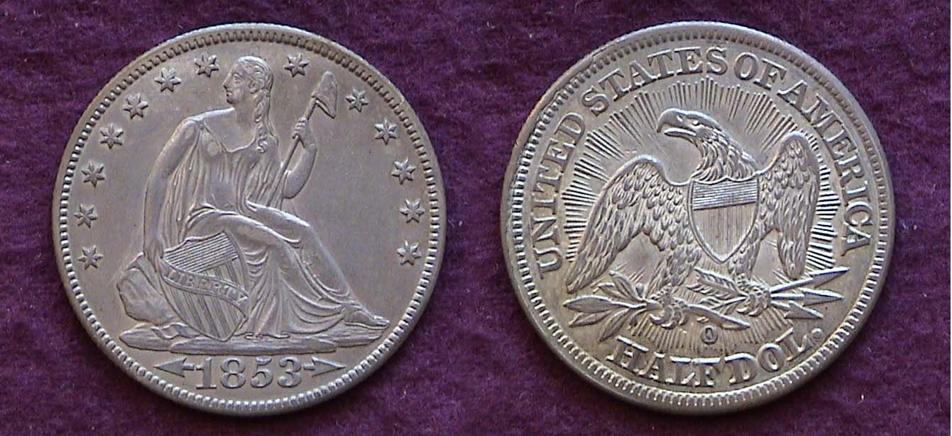

An 1853-O Liberty Seated 50¢ with arrows and rays grading AU-50
1,328,000 were minted. [Magnify to 200% to observe details more clearly]

The 1853-O arrows and rays half dollar with a mintage of 1.3 million surfaces less often than the 1853-P (3.5 million) but is priced only slightly higher. Still, the date is common enough. With its appealing design and as a one year type coin it is priced higher than a number of dates with lower mintages.
_________________________________________________________________________________________________________
(Continued on page 3, column 1)
The Coins of 1853: The Minor Coinage
(Continued from page 2, column 2)

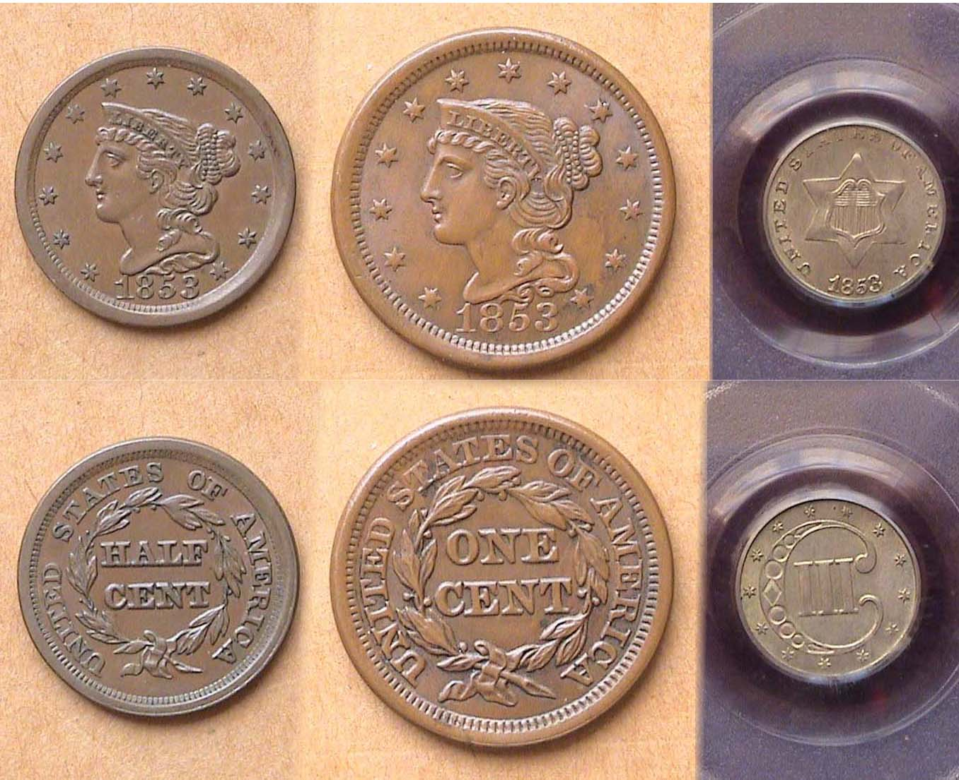

An 1853 ½¢, 1¢ copper and 3¢ silver piece
[Magnify to 200% to observe details especially on the 3¢ coin.]

There was of course the minor coinage of 1853; the ½¢ and 1¢, both with the late date Mature Head Braided Hair Coronet stylized design accompanied by the awkward tiny three cent silver piece. The last named was authorized in 1851 to make it easier to pay for a first class postage stamp which had been reduced from 5¢ to 3¢. It had a composition of .750 silver and .250 copper as opposed to the normal .900 fine silver bonded to .100 copper in our standard silver issues. [A coin that contains 75% silver as opposed to 90% will still qualify as a legitimate silver issue unlike billon which is a coin having a silver content of 50% or less.]

In addition to all of the foregoing, there were five gold denominations struck in 1853. These included a second $1.00 denomination (first issued in 1849), the $2.50 quarter eagle; $5.00 half eagle, $10.00 eagle and $20.00 double eagle. The P Mint lower denominations are affordable up to AU but the $10s and $20s are priced high and most lack eye appeal below AU-58.

Excluding gold and the no arrows silver subtypes, the collector--over time--should be able to assemble an 1853 set of the eight denominations that include the ½¢, 1¢, 3¢ silver, with arrows half dime, dime, quarter, half dollar and no arrows silver dollar.

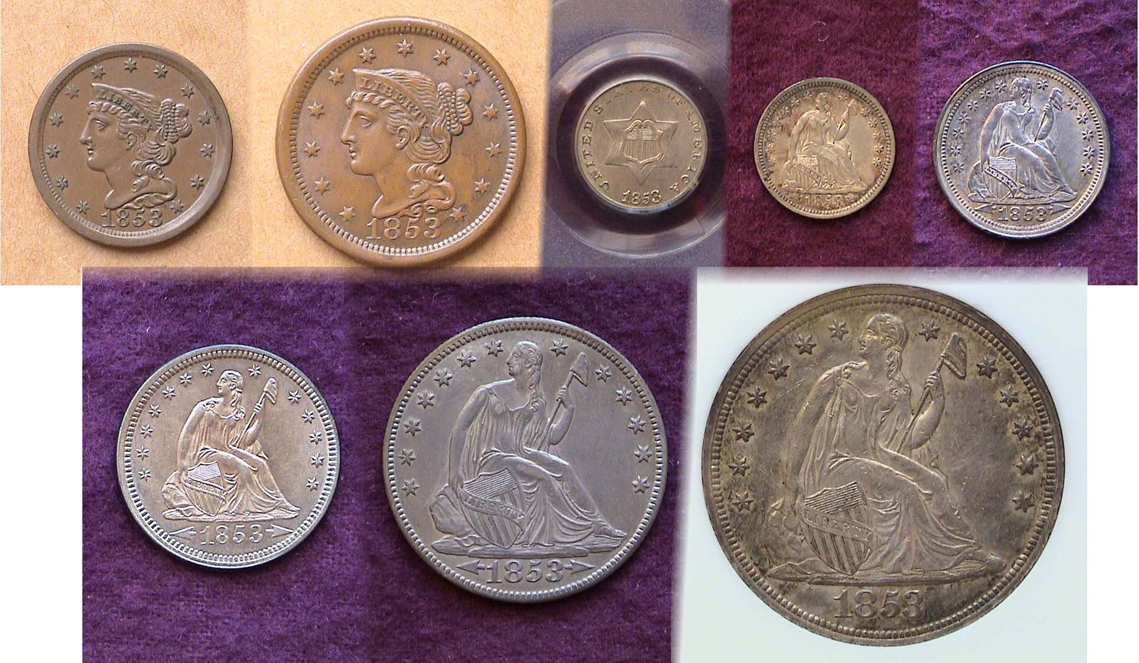

The eight regular denominations struck in 1853 (excluding gold) shown slightly reduced to fit on page. [Magnify to 200% to see details.]
______________________________________________________________________________________________________________

_

Club News

In the absence of President Steve Kuhl, (who had a death in the family) VP Pat James presided over the Nov. 3 meeting. Twenty members were present which included three new members, Dexter Lumpkin, David & Linda Amey. Welcome! As both the Treasurer and Sgt. in Arms were also unable to attend, the usual drawings for the door prize and the 50/50 were suspended. Members were reminded about the upcoming Christmas Party scheduled for Thursday, December 1 with and the November 21 deadline to make their choices from the menu and remit payment to the SJ CSRA Coin Club to member Helen Barry. Pat mentioned that due to the success of the club show, the club will contribute $12.00 to the cost of each member’s dinner. Pat also reminded those in attendance about the upcoming Augusta Coin Club Show to be held Nov. 11 & 12 at Patriot’s Park in Columbia County, GA.

Workers who helped out at the club’s Sept. 10 show were presented with thank you gifts of a numismatic nature. Those who were unable to make the meeting will receive their gifts of appreciation at the Christmas Party on Dec. 1.

Thee were three Show and Tell presenters. Dick Lasure displayed two US commemorative coins that were not representative of the half dollar denomination. These were the beautiful 1893 Queen Isabella quarter and 1900 Lafayette $1.00. Jim Barry presented everyone present a neat token advertising the recently held SC Numismatic Association Convention held in Greenville the previous weekend. He then displayed a 3¢ nickel piece and an ancient silver coin; the latter being a tetradrachm of Nicomedes II Epiphanes, King of Bithynia from 149 to around 127 BC. Jim provided some additional background on the coin:

*The tetradrachm (4 drachms) was a silver coin issued by various Greek mints from 600BE to 200AD when the area was under Roman rule.

Nicomedes II Epiphanes (Greek: Νικομήδης Β' ὁ Ἐπιφανής) was the king of Bithynia from 149 to c. 127 BC. He was fourth in descent from Nicomedes I. Nicomedes II was the son and successor of Prusias II and Apame IV. His parents were related, as they were uncle and niece, as well as maternal half-cousins.
He was so popular with the people that his father sent him to Rome to limit his influence. However in Rome, he also gained favor from the Roman Senate, forcing Prusias to send an emissary with secret orders to assassinate him. But the emissary revealed the plot, and persuaded the prince to rebel against his father. Supported by Attalus II Philadelphus, king of Pergamon, he was completely successful, and ordered his father to be put to death at Nicomedia. During his long reign Nicomedes adhered steadily to the Roman alliance, and assisted them against Eumenes III of Pergamon. He was succeeded by his son Nicomedes III.

Member Rick Owen followed sharing his latest wonderful coin acquisitions won at auction. These included two Indian Head cents, dated 1859 and 1881, a 1901 Liberty nickel, a 1902 BU Barber dime, a blazing 1917 Type I Standing Liberty Quarter certified MS-66 and wonder of wonders., the key to the business strike portion of the Morgan dollar set, an 1893-S.
_______________________________________________________________________________________________________________________
(Continued on page 4, column 1)

Club News

(Continued from the previous page)

For the program Vice President James ran a video entitled “A History of Money” lent to the club by Xavier Pique, Treasurer of the Augusta Coin Club. Secretary Jim Mullaney made “Herculean efforts” to get the video equipment up and running (it turned out there was a problem with the cable connection). The first half of the program was shown which the members found very interesting. The second half will be presented at the January 5, 2012 meeting.

In the absence of auctioneer Glenn Sanders, member Roger Worpell ran the auction, which was larger than usual and enjoyed some extensive bidding action. (Pat James and Helen Barry served as Bids recorder and lot interpreters as required)

Club Photos from the Nov. 3 meeting

(Courtesy of Helen Barry)

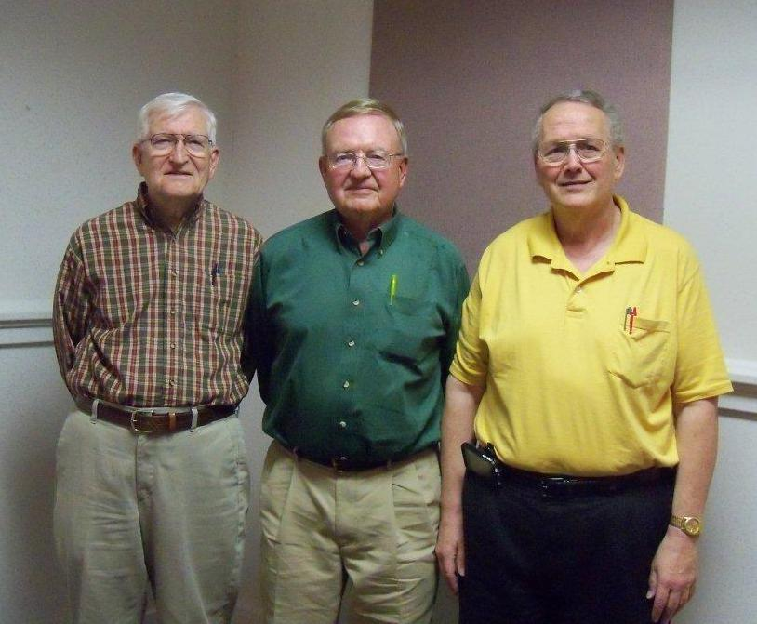

Show and Tell Presenters

From Left to right; Jim Barry, Dick Lasure and Rick Owen

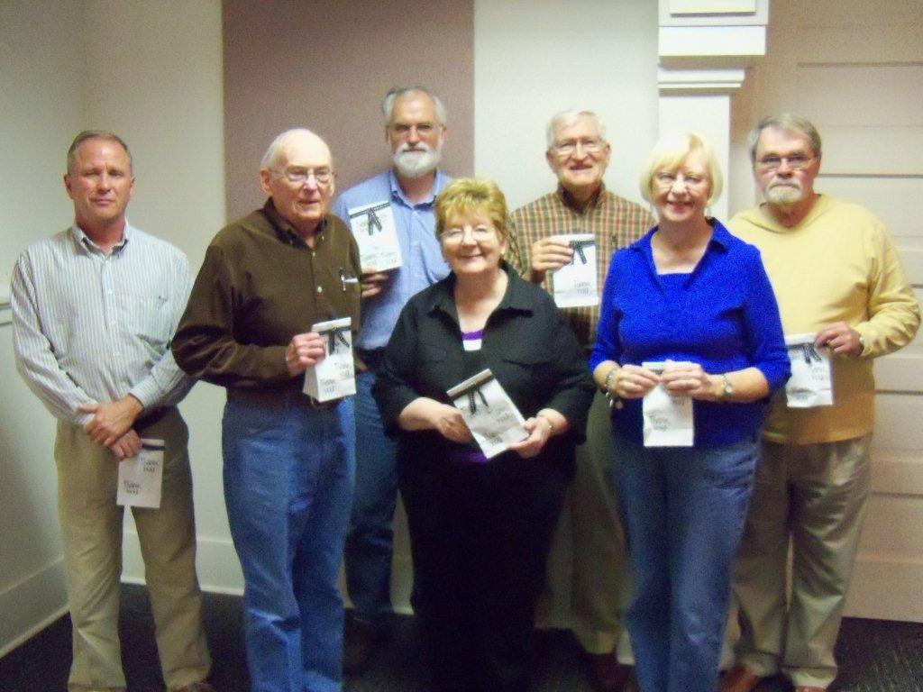

Members receiving "thank you" awards for volunteering at the coin show: Willie Simon, Jim Jewett, Jim Mullaney, Pat James, Jim Barry, Helen Barry, and Jim Clapp.

Those members unable to attend will receive their gifts of appreciation at the Christmas party on Dec. 1.
____________________________________________________________________________________________________________________
(The editor wishes to thank VP Pat James for supplying him with the information for November 3 meeting.)
For Christmas, Start a young family member on the Road to Coin Collecting by placing an obsolete type coin in the Christmas stocking

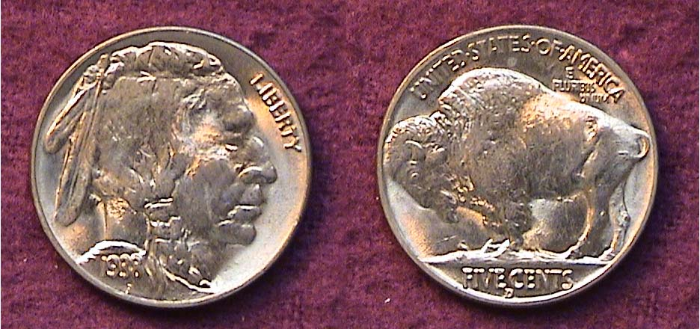

A Gem BU 1938-D Indian Head-Buffalo nickel

Most obsolete US type coins are expensive today, so is t any wonder, few youngsters opt to collect coins when they can spend time on computerized games. There are still some US type cons out there that are affordable in Mint state. They’re not rare but can have the same mystique Barber coinage had on us when we were kids. For starters there’s the 1938-D Buffalo nickel, arguably the best struck date of the entire series (1913-1938). Then there’s the Mercury dime. Any date from 1941 thru 45 is still cheap in MS-63. Another is the Franklin Half; a large .900 fine silver coin that represents to today’s youth what Barber halves did for many of us during the 1950’s and '’60s. Why not consider dropping one of those in a youth’s stocking this Christmas?
______________________________________________________________________________________________________________

Kindly Patronize our Advertisers

