The Stephen James
CSRA Coin Club of Aiken
P.O. Box 11
New Ellenton, SC 29809
Web site: www.sjcsracc.org
The SJ CSRA CC of Aiken, SC meets on the 1st Thursday of the month at the Aiken Public Library

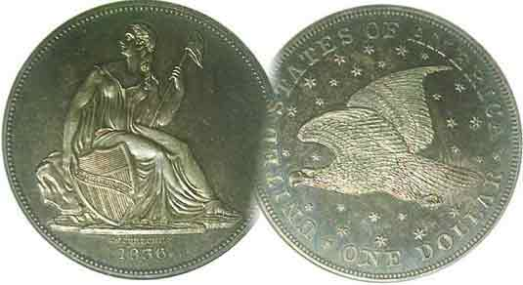
Pres. Steve Kuhl
V .P. Pat James
Sec. Jim Mullaney
Treas. Chuck Goergen
Sgt. in Arms: Glenn Sanders
Programs: Pat James
ANA Representative: Jim Barry
Photos: Helen Barry
Publicity: Pat James
Newsletter: Arno Safran
E-Mail: arnosafran@comcast.net
Auctioneer: Glenn Sanders
Web site: Susie Nulty (see above.)

2012 Club Meeting Schedule
Volume 11, No. 12 the Stephen James CSRA Coin Club, Founded in 2001 December, 2012
Monthly Newsletter
Dinner Meeting Set- 6:30 start, West side Bowery
Our next meeting will be on Thursday, Dec. 6, 2012 at the West Side Bowery in Aiken

Jan. 5 Apr. 5 July 5 Oct. 4
Feb. 2 May 3 Aug. 2 Nov. 8
Mar. 1 Jun. 7 Sept. 6 Dec. 6

______________________________________________________________________________________________________

Frustrated with the high cost of US large cents,
Try collecting Hard Times Tokens: (Article 2)

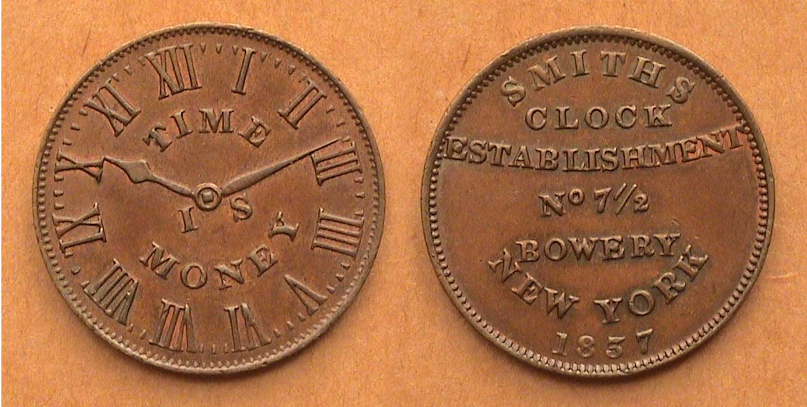

An 1837 Hard Times Token, HT-314, (Low 135). Smith’s Clock
[Use 3-x glass to magnify page to 150% to view details.]

With Hanukkah, Christmas, Yuletide and New Year’s Day not far off, the Smith’s Clock token shown above serves as a reminder that the time between now and the period of giving and sharing is becoming shorter and as the obverse suggests, “Time is Money”. The Hard Times tokens series was struck between 1832 and 1834 and can be divided principally between those who had a political axe to grind and merchants who wanted the public to purchase their goods. Most HTs were struck in copper about the size of our large cent, c. 27 to 29 mm in diameter. The commercial pieces are called “store cards” and many had the value of one-cent towards an item sold by the issuing merchant. The store cards are interesting because they often portray the image of an item being sold such as a watch, an umbrella, a boot, a brush, a piece of machinery for example, or a building where the manufacturing was taking place. As such, the store card tokens provide a great deal of variety while drawing the collector into the commercial lifestyle of the period.

The Smith’s Clock Establishment was located at 7½, the Bowery located on the third floor at the corner of Division Street in Lower Manhattan (in New York City). Five different varieties of this token were issued, all dated 1837.
_____________________________________________________________________________________________________________

Collecting the US Coins of 1922
90 Years Ago By Arno Safran

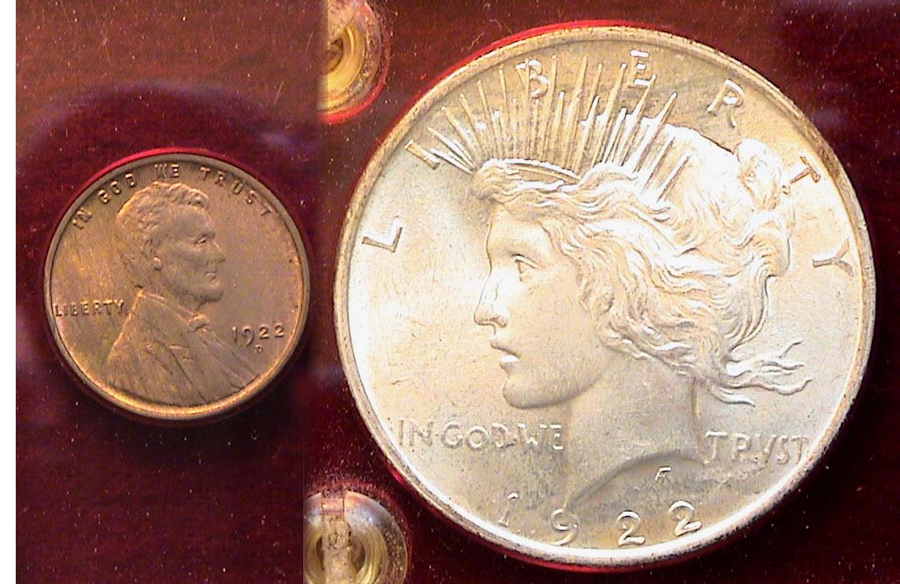

The obverses of a 1922 Year set (excluding gold)
[Use 3-x glass to magnify page to 150% to view details.]

If one excludes the 1922 Saint-Gaudens $20.00 double eagle the collector needs just two denomominations to complete a year set, the Lincoln cent and the Peace dollar. Why were so few denominations produced in 1922? We often think of the “Roaring Twenties” as a decade of fun and frolic when most everyone appeared to be making “whoopee” as well as money on the stock market, fully employed and happy. Nevertheless, the first decade after the end of World War I did not start out that way. In 1921, the country found itself in a steep economic downturn and as a result, the US Mint found that it did not need to produce any nickels, dimes, quarters or half dollars. As for the gold issues, no $2.50 quarter eagles, $5.00 half eagles or $10.00 eagles were issued either; just the $20.00 Saint-Gaudens double eagle. Furthermore, the Lincoln cent was struck only at the Denver Mint that year, the first time since 1815 that no cents were produced at the Philadelphia Mint facility.

One would think that as a coin year, 1922 would be very dull as far as the collector is concerned but nothing could be farther from the truth. In actuality, two unusual versions were created from some of the 1922-D Lincoln cent dies, one scarce and one quite rare, and therein lies the tale of the three 1922 cent varieties, the 1922–D, the “weak D”, (once referred to as the “broken D”) and the 1922 “Plain”, (AKA “No D”).
_________________________________________________________________________________________________________________________
(Continued on page 2, column 1).

Collecting the US Coins of 1922: 90 Years ago
(Continued from page 1, column 2)

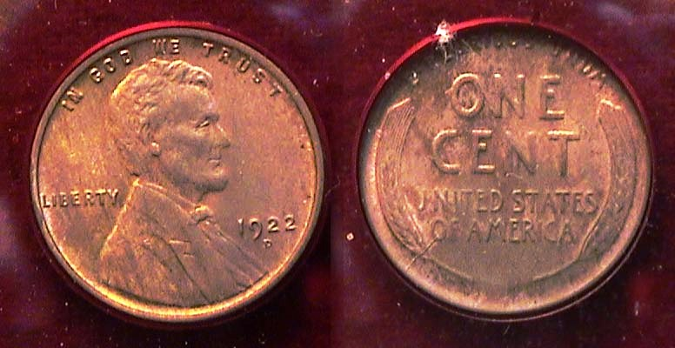

A 1922-D Lincoln Wheat back cent
[Use 3-x glass to magnify page to 200% to view details.]

Between 1909 and 1922, the yearly mintages for the Lincoln cents were mostly in the double-digit millions, (i.e., 10,000,000 or more). The reported mintage for the 1922-D Lincoln cent was 7,160,000. While this may seem considerable compared with early to mid 19th century cent coinage, the 1922-D Lincoln cent received one of the smallest mintages from any one Mint since the series’ inception, ranking the date the tenth lowest up to that point in time behind the 1913-S, 1910-S, 1915-S, 1912-S, 1914-S, 1911-S, 1909-S, 1914-D and finally, the 1909-S VDB. As a result, the date has considerable value. It is listed in the 2013 Red Book at $20.00 in Good-4 and rises gradually to $27.00 in VF-20 before taking off to $40.00 in XF-40, $75.00 in AU 50 and $110 in MS-60, about the grade of the coin shown above. The author acquired the specimen back in 1986 at a local NJ coin shop and the price was considerably lower then, $20.00. As a “better date”, the value of the 1922-D cent has risen ten times in the past 26 years compared with the more common date Lincoln cents.

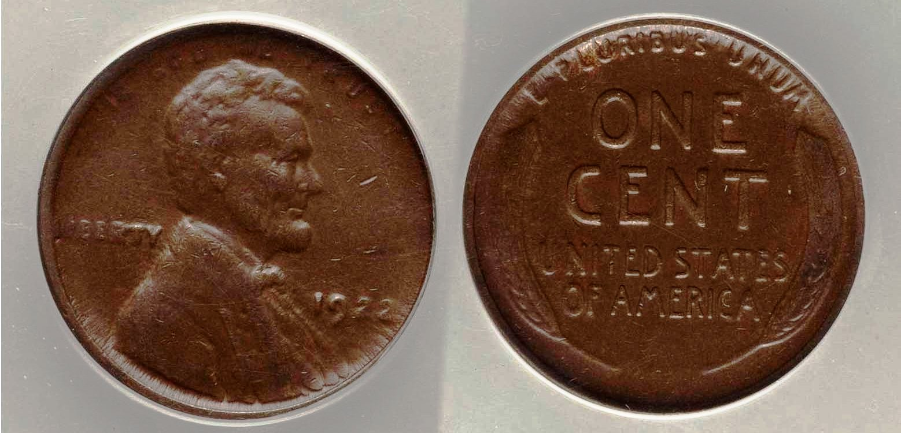

A 1922- “weak D” variety Lincoln 1c graded AU-50 by ANACS
[Use 3-x glass or magnify page up to 500% to view details]
(Courtesy of Heritage Auction Galleries)

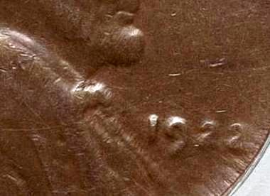
Most collectors of Lincoln Wheat-back cents seek such key dates as the 1909-S VDB or 1914-D but back in the 1930s thru 1959, young collectors also sought the 1922 “Broken D” (today known as the “weak D”) variety. The cause of this anomaly may have been due to grease intermingling with the D-punch on some of the dies used to strike the coin. If one examines the detail of the area just below the date you may be able to make out the D mintmark. It appears barely visible directly below the 9 and first 2.

“D” barely showing under date

How much would the 1922 “Weak D” cent be worth today? The coin realized $373.50 at a Heritage auction in 2011.

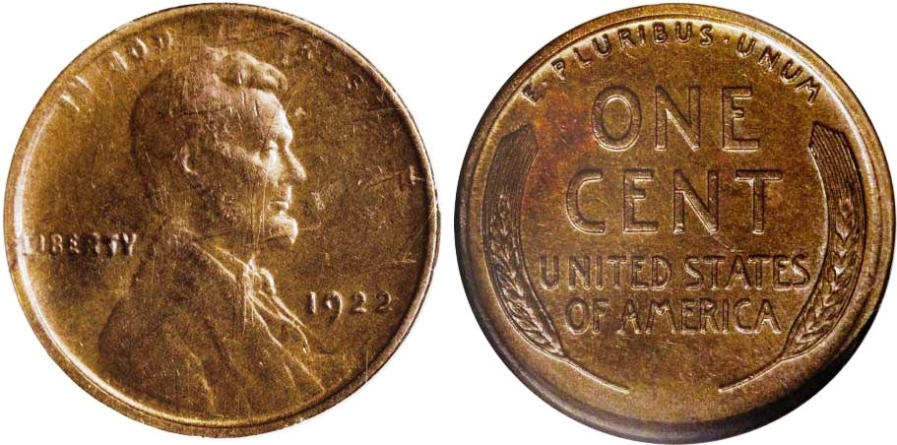

A 1922- “Plain “ (or no D”) variety Lincoln 1c graded AU-53 by NGC
[Use 3-x glass or magnify page up to 500% to view details]
(Courtesy of Heritage Auction Galleries)

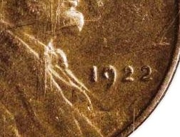
Far scarcer is the 1922 “Plain” no mintmark 1¢ specimen, which is quite costly in all grades. The coin shown above realized a whopping $5,195 back in May-June, 2007 at the Long Beach, CA auction held by Heritage. According to the 2013 Red Book, the buyer did remarkably well as it is listed at $6,250 in AU-50, a slightly lower grade than the example shown.

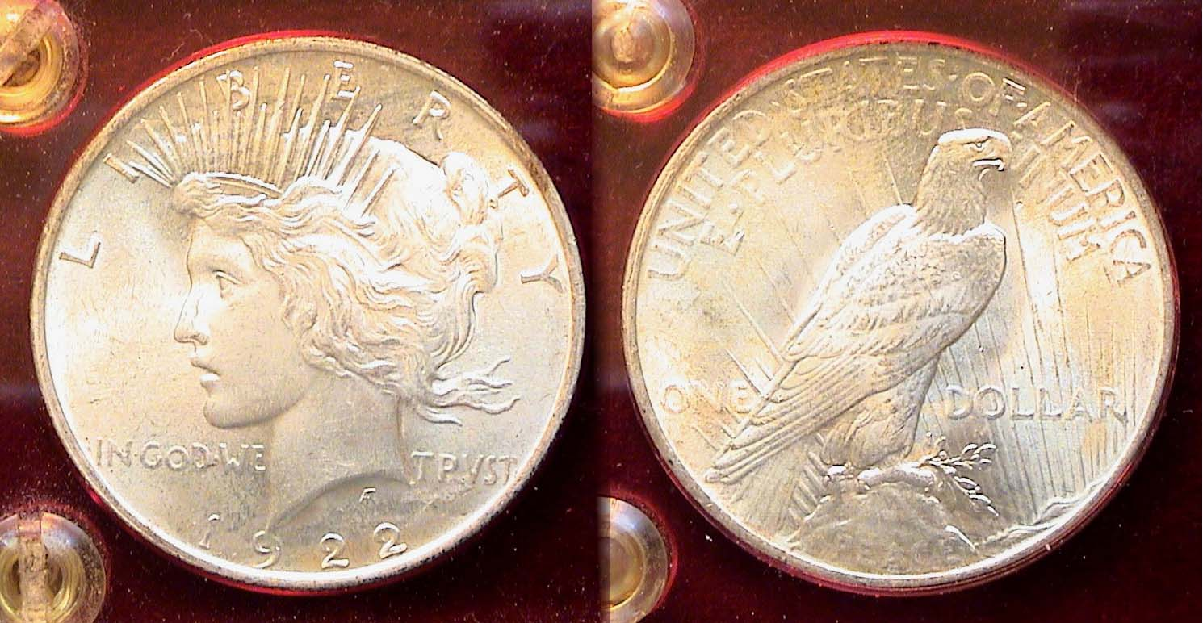

A Brilliant Uncirculated 1922 Peace dollar
[Use 3-x glass to magnify page to 200% to view details.]

The Peace dollar designed by medalist Anthony de Francisci was first struck at the Philadelphia Mint in 1921. This occurred after the largest outpouring of Morgan dollars ever produced in any single year. The grand total from all three Mints was 89,730,000. On the other hand, only slightly more than one million 1921 Peace dollars were made with most specimens appearing weakly struck and lackluster. Because of its lower mintage, the date is valued today at $450 in MS-63 and $750 in MS-64 according to the 2013 Red book. In 1922 however, the Peace dollar was struck at all three mints and in prodigious mintages, again as 84,275,000 rolled off the Mint presses for the second highest in US history. As a result, the collector can acquire an attractive uncirculated specimen grading as high as MS-64 for around $65.00 to $75.00 (or for $40 to $50 after melt.) While the Peace dollar series has never commanded the popularity of the Morgan dollar, the attractive design type exhibits a more serene Miss Liberty on the obverse and arguably, a more elegantly refined eagle on the reverse.

There is one other US coin denomination that was struck in 1922 and that was the $20.00 gold Saint-Gaudens designed Striding Liberty Double eagle. It was produced at both the Philadelphia and San Francisco Mints; 1,375,500 in Phili, and oddly 2,658,000 at San Francisco, almost twice as many, but despite the disproportionate mintages between the two, the Philadelphia Mint issue is less expensive in AU-50 or higher.
______________________________________________________________________________________________________________________
(Continued on page 3, column 1)

Collecting the US Coins of 1922: 90 Years ago
(Continued from the previous page)

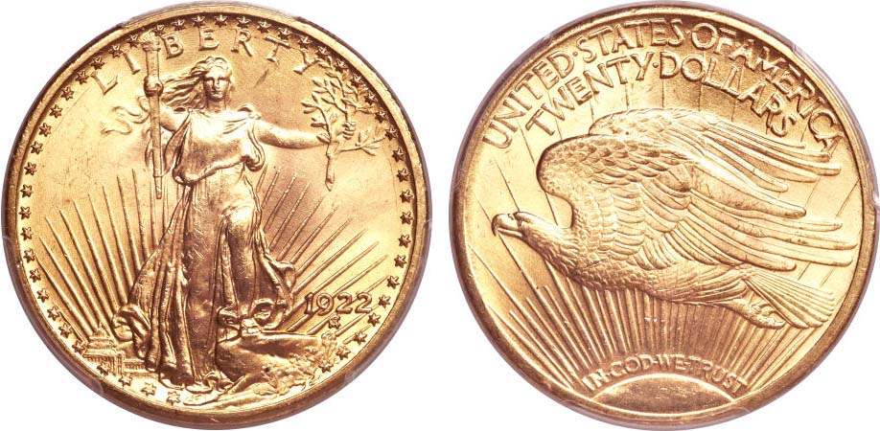

A 1922 Saint-Gaudens $20.00 Double Eagle graded MS-65 by PCGS
[Use 3-x glass to magnify page to 200% to view details.]
The coin realized $3,290 at the Long Beach, CA Sale conducted by Heritage Auction on Sept 6, 2012
(Courtesy of Heritage Auctions Archives)

The beautiful 1922 $20.00 Saint-Gaudens double eagle shown above cost a lot of money to the winning bidder but one does not have to pay that much to acquire an attractive example of a 1922 $20.00 gold piece since some certified MS-62 graded coins can appear almost as nice for under $2,000. While that figure may still seem like a lot of money, consider that the current average price of an ounce of gold has been around $1,700 or above for the past two months. With the so-called “Fiscal cliff” issue still unsettled as this is being written, gold is unlikely to move very much lower for a while. A double eagle contains 90% of an ounce of gold. At $1,700, the base value of the denomination regardless of the grade would be $1,530. According to the Heritage Auctions Archives web site, recent sales of 1922 Saint-Gaudens double eagles certified MS-62 have been hammered down at a high of $1,939 (This includes the 15% interest charged by the auction company.)

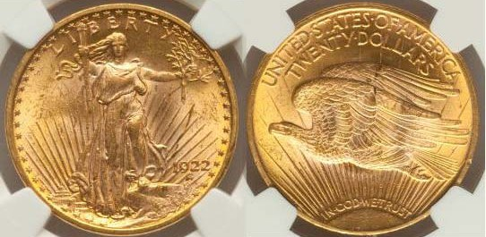

A 1922 Saint-Gaudens $20.00 graded MS-62 by NGC in CAC holder
[Use 3-x glass to magnify page to 200% to view details.]
(Courtesy of Heritage Auctions Archives)

When one compares the MS-62 example with the MS-65 atop the page, the differences increase only at the higher magnification but at actual size and under no more than 3X power magnification the MS-62 specimen still remains an attractive coin yet should cost only $400 above melt. Looking at the situation in this light, such a coin is affordable as long as gold does not drastically drop, (which does not seem to be likely in the near future.) Under these conditions, the total cost of an uncirculated 1922-year set that would include a 1922-D cent grading MS-60, 1922-P Peace dollar grading MS-64 and a 1922 Saint-Gaudens grading MS-62 should not exceed a net value of $550.00 after melt, arguably, a good investment!
___________________________________________________________________________________________________________________________s

Whirligig
By Bill Myers

I was recently going through a junk box and came across a 31 mm copper coin that was so worn that almost none of the original image was visible. The edges had been beveled and it had two large holes in the center of it. It appeared that the only value it had was the copper it contained. Normally I would have thrown it back into the box, but I remembered an article on Page 25 of the November Numismatist. It was entitled “Multi-purpose coins: Whirligigs and Crimpers”.

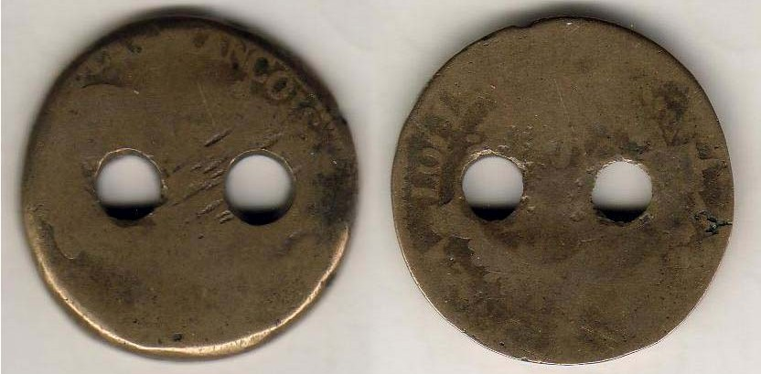

A well-worn two sided copper whirligig, (c. 31 mm in diameter)
From the Bill Myers numismatic oddities collection

The article had a picture of a coin with two holes in it and noted it was a whirligig (a child’s toy). I put a string through the holes, tied it in a loop, put in between my fingers, and spun the coin around. I then pulled on the string, the coin spun around, and as I pulled it back and forth, the coin kept spinning making a whirring sound.

The coin has seen a lot of wear so it appears to have provided hours of enjoyment to a child or children. I remember playing with a whirligig as a child but I think it was made out of a button and not a coin. If it was a coin, I am sure I still have it somewhere in my collection today.

This is another example of how important numismatic knowledge is. If I had not read the article, I would not have been able to find an interesting, though not valuable, numismatic item.

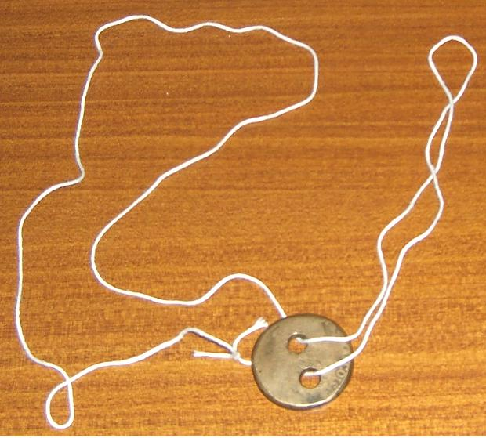

__________________________________________________________________________________________________________________________
Thanks, Bill for another little “gem” from the world of Exonumia. This “toy” could make nice stocking filler for some child at Christmas. ED.

Club News

Our next meeting will beheld at the West Side Bowery located in the Alley at 151 Bee Lane in Aiken, SC 29801. Their phone is (803)-648-2900 should anyone need to call beforehand.

At the Nov. 8 meeting, VP Pat James presided in the absence of President Steve Kuhl. Sgt. in Arms Glenn Sanders announced that 20 members were present and reported on upcoming coin shows in Augusta, Columbia and Charlotte. Treasurer Chuck Goergen reported a balance of $2,730.78. Thank you, Pat, Glenn and Chuck. In other business, the SJ CSRA CC Board approved a donation to the Aiken Public Library.

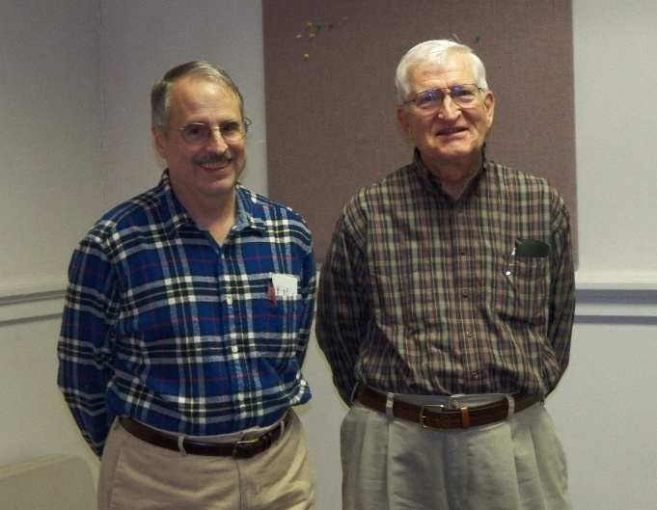
There were two Show & Tells. Andrew Goslin brought in three obsolete US coins from his father-in-law’s collection, an 1834 lettered edge Capped Bust Half dollar, also an 1855 with arrows Lib. Std. 50¢ and a 1943 Canadian Bronze cent. Jim Barry displayed a second century BC Greek tetradrachm issued by Demetrius I from the Seleucid Kingdom. Portrayed on the silver quarter-sized coin was Demetrius on the obverse and Tychy holding a cornucopia on the reverse. American (Traditional)

Show & Tellers at the Nov. 15, 2012 meeting
Andrew Goslin at left, and Jim Barry at right
[Photo taken by Helen Barry]

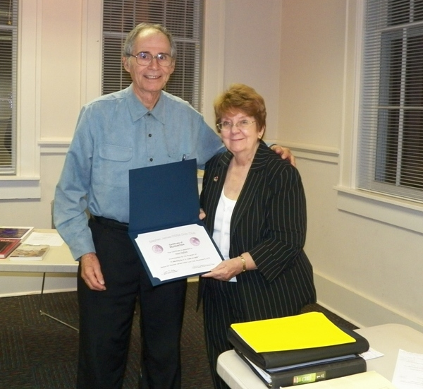
The program featured a PowerPoint presentation by Arno Safran on “The US Coinage of 1850”. Arno displayed coins from his collection that included the half cent thru the silver dollar. He also showed examples of the gold coins of 1850 (the $1.00 thru the $20.00 double eagle), courtesy of Heritage Auctions Archives intermingling them with the political, social and economic crisis the nation was experiencing a decade before the Civil War.
Arno receiving certificate of appreciation
from Programs Chairperson & VP Pat James
[Photo taken by Helen Barry]

Winner of both the door prize and 50/50 drawing at the Nov. 8 meeting was Dick Smoot. Congratulations, Dick! As this is our final newsletter of 2012, the editor would like to wish his fellow members, all those associated with the SJ CSRA CC a very Merry Christmas, and to those who celebrate the Festival of Lights a very Happy Hanukkah.
___________________________________________________________________________________________________________________________

Kindly Patronize our Dealers

