The Stephen James
CSRA Coin Club of Aiken
P.O. Box 11
New Ellenton, SC 29809
Web site: www.sjcsracc.org
The SJ CSRA CC of Aiken, SC meets on the 1st Thursday of the month at the Aiken Public Library

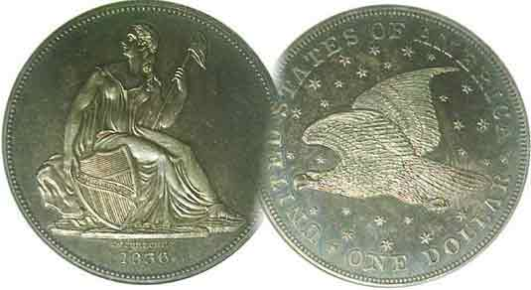
Pres. Steve Kuhl
V .P. Pat James
Sec. Jim Mullaney
Treas. Chuck Goergen
Sgt. in Arms: Jim Sproull
Programs: Pat James
ANA Representative: Jim Barry
Photos: Helen Barry
Publicity: Pat James
Newsletter: Arno Safran
E-Mail: arnosafran@comcast.net
Auctioneer: Jim Sproull
Web site: Susie Nulty (see above.)

2013 Club Meeting Schedule
Volume 12, No. 12 the Stephen James CSRA Coin Club, Founded in 2001 December, 2013
Monthly Newsletter
Our next meeting will be held on Thursday, Dec 5, 2013 at the Knights of Columbus

SJ CSRA CC pre Holiday dinner Meeting Dec. 5
Jan. 3 Apr. 4 July 11 Oct. 3
Feb. 7 May 2 Aug. 1 Nov. 7
Mar. 7 June 6 Sept. 5 Dec. 5

______________________________________________________________________________________________________

Newsletter Completes 12 Years with this issue

The Stephen James CSRA Coin Club was founded in March 2001 and held its first meeting in April of that year in the Aiken Public Library. The first issue of the club newsletter was published in January 2002 and featured an article on the Internet as a new source for adding coins to one’s collection.

As Vol. 1, No. 1 went to press; gold was trading at around $279.00 an ounce with silver at $4.66 an ounce. At the 2002 FUN Show in Orlando, FL, one could still acquire an early date US type, coin at anywhere from one-half to one-fourth the price they are today. By 2008, many of these lower mintage coins had disappeared from dealers’ stocks and when a replacement was found, it more often than not, lacked the eye appeal of the former piece, this despite being graded the same by one of the four major certification parties. What caused this?
The drop off in the availability of attractive US type coins, including many of the more common dates, can be attributed to the tripling of the collector base by the so-called “baby boomers” who became attracted to coin collecting upon the introduction of the statehood quarters program begun in 1999.

On Oct. 9, 2007, the Stock Market reached a then record high of $14,164.53 but with the start of the great Recession not long after, their values began an extended period of steady decline. It would bottom out at $6,547.05, on March 9, 2009. Gold, which had begun to rise in 2006, really took off in late 2008 eventually peaking around $1,800 in July 2011. From 2009 thru 2011, the US type coin market stagnated because collector want lists could not be filled along with the greater amount of cash being used for strictly bullion purchases. When gold began to level off and gradually drop to below $1,300, by 2013, type coins began to reappear in dealers’ cases at slightly lower prices. This resulted in collectors becoming more active. Now may be a good time to add an attractive type coin to your collection or focus on building a short set of topical coins.
_______________________________________________________________________________________________________________________

Building a 1917 US Type set
By Arno Safran

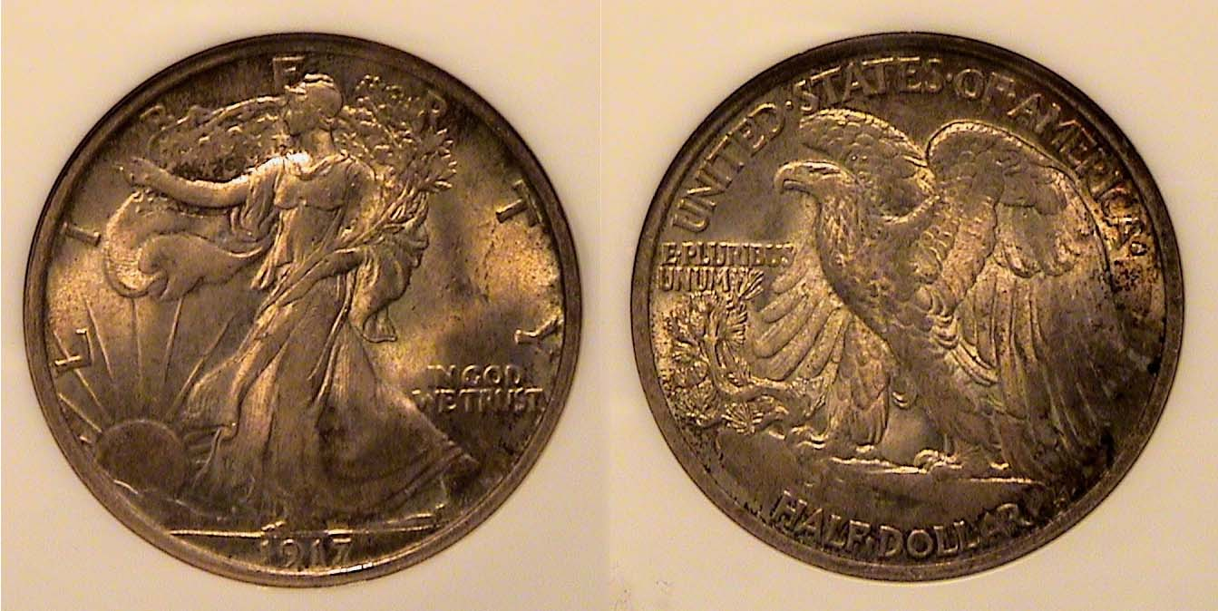

A richly toned 1917 Walking Liberty Half-dollar
[Use 3x magnifying glass or enlarge page to 150%]

Back in April of 2011, I came across a richly toned 1917 Walking Liberty half-dollar at the Blue Ridge Numismatic Association show. Graded MS-63 by NGC, it was a vast improvement over a “raw” AU specimen I had once owned. I decided on re-building a complete denominational set of 1917 coins. The following criteria were established for the now 95-year-old set. All the coins had to be certified by one of the four established certification companies, PCGS, NGC, ANACS or ICG. They all had to be graded at least AU-58 or better and they should have eye appeal. Only five denominations were required, the copper cent, 5c nickel, silver dime, quarter and half dollar but six coins were needed because two sub-types of the Standing Liberty quarter were coined that year. No US gold coins were produced in 1917 (although I probably would have excluded them due to their expense.) Of the three Mints, Philadelphia, San Francisco and Denver, the Philadelphia Mint issues were by far the most common and the least expensive, also the best struck.

To make matters easier, I had acquired both 1917-P quarter sub-types years ago “raw” and decided to have them certified. As it turned out, representatives from two of the four grading companies would be on hand for submissions at an upcoming Georgia Numismatic Assoc. show. There, I also looked forward to finding some the other denominations because all 1917-P issues were extremely common. When I got to the show, I submitted the quarters for certification but to my surprise, I found none of the others in the grades I was seeking.
__________________________________________________________________________________________________________________________
(Continued on page 2, column 1)
Building a 1917 US Type set
(Continued from page 1, column 2)

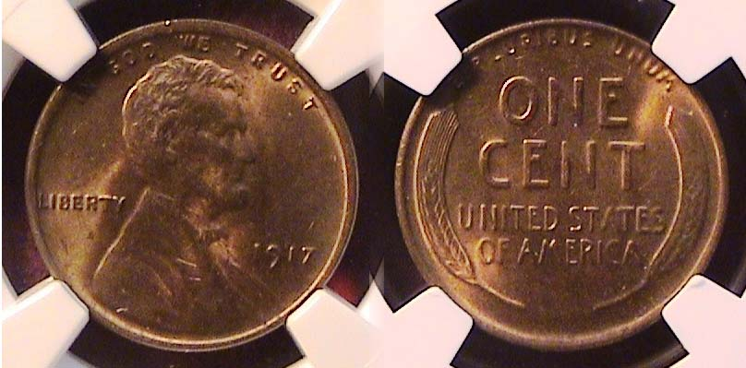

A 1917-P Lincoln cent graded MS-64 RB by NGC
[Use 3x magnifying glass or enlarge page to 200%]

The recorded mintage for the 1917-P Lincoln cent was 196,429,785 hardly a scarce, let alone a rare date. In MS-63, it is listed at just $32 in the 2014 Red Book, The odd thing is that the 1909-S VDB cent, one of the most popular sought after rarities, listed in the same source at $2,000 in MS-63, seems to come up for auction more regularly than a BU 1917-P surfaces at a club, state or regional show.

When seeking early date Lincoln cents, one usually tries to find a brilliant uncirculated specimen with full “red” color. Despite the mintage, such coins are scarce to rare today and expensive. The MS-64 Red-Brown example shown above was finally acquired at the Blue Ridge Numismatic Assoc. show in August of 2013. Upon magnification one can observe that the coin is fairly well struck, having even coppery color with enough red for it to be considered natural and attractive.

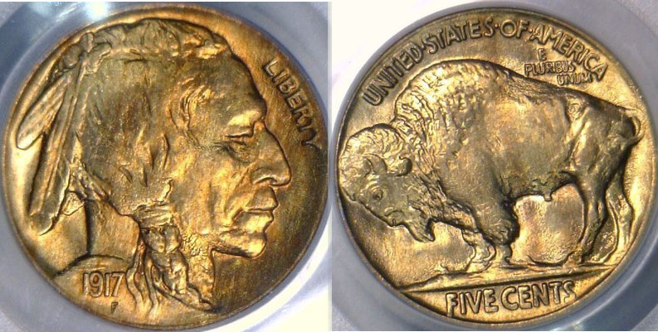

A 1917 Indian Head/ Buffalo nickel graded mS-65 by PCGS
[Use 3x magnifying glass or enlarge page to 200%]

The Indian Head Buffalo nickel (1913-1938-D) designed by James Earle Fraser has been dubbed “the most American of coins”. During its quarter century run the denomination was the workhorse the economy and thus, saw heavy circulation. With a few exceptions such as the 1918-P, 1921-P and 1924-P, most Philadelphia Mint issues are extremely common and inexpensive allowing one to assemble a complete uncirculated date set from 1913-P thru 1937-P, adding the 1938-D issue for completion.

With a mintage of 51,424,019, the 1917 P Buffalo nickel is not considered a scarce coin. One would think there are plenty of mint state survivors available but today, attractive BU examples appear to surface with far less frequency. According to numismatic scholar, David Lange, author of the complete Guide to Buffalo nickels, in 1917 “the obverse design was strengthened in the lines of the Indian’s garment which appear above the date.” He also mentions that with the US entering WWI that year, there were major shortages of our minor coinage possibly resulting in fewer mint state survivors. The coin pictured above was located on a dealer’s web site and acquired in June of this year, The dealer is known for having an excellent eye for attractive coins within grade. While pricey, this MS-65 specimen, with its exquisite russet toning, is in every way a true “Gem.
.
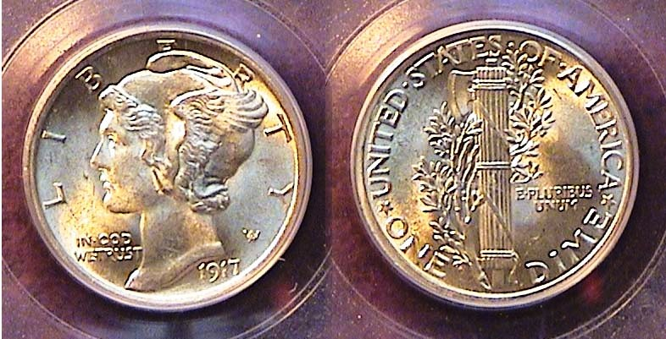

A 1917 Mercury dime graded MS-64 Full Bands by PCGS
[Use 3x magnifying glass or enlarge page to 200%]

The Winged Liberty (Mercury) dime was struck from 1916 thru 1945. Most of the dates from 1934 on are available from all three Mints in MS-60 thru MS-65. As for the early dates, many of the branch mint issues are scarce to rare in high grade but those struck at the Philadelphia Mint with the exception of 1921, 1930 and 1931 are considered generally common and supposedly available and moderately priced up thru MS-64.
The mintage for the 1917-P Mercury dime was 52,230,000. The date comes well struck, with many specimens showing fully split bands on the reverse, (the two horizontal lines crossing the center of the fasces.) In recent years, a large number of the 1917s grading MS-63 or better have apparently found new homes possibly due to the many new entrants into coin collecting. As a result, the date was not easy to locate in the grade desired. The coin pictured above was finally acquired at the BRNA Show held in Dalton, GA in August 2013.

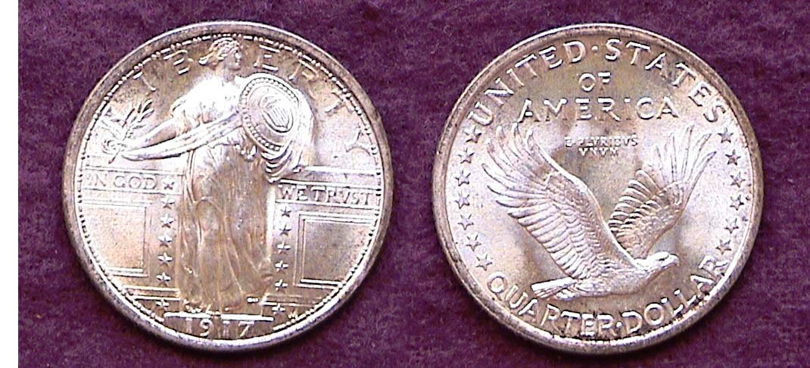

A 1917-P Standing Liberty Quarter Type I graded MS-64 by ICG
[Use 3x magnifying glass or enlarge page to 200%]

The Standing Liberty Quarter designed by Hermon MacNeil was struck from 1916 thru 1930. The 1916, with only 52,000 made, is considered the “key” to the set but the 1917-P Type I with a mintage of 8,7400,000 (shown directly above), while not absolutely identical to the 1916 design, is close enough to allow most collectors the opportunity to acquire a Type I example at modest price up through MS-64.

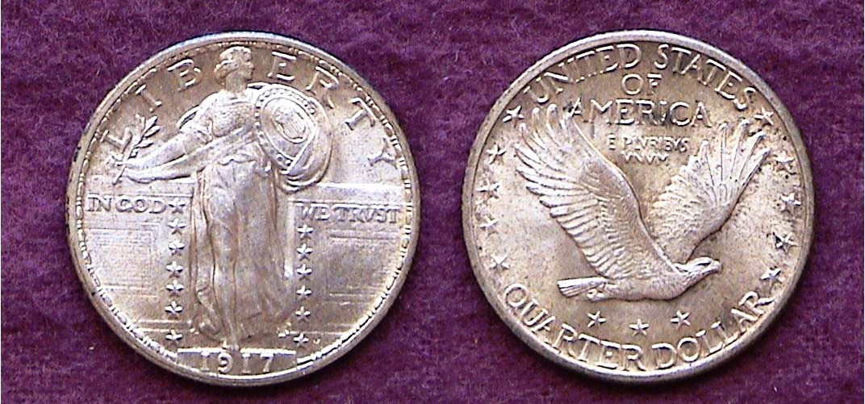

A 1917-P Standing Liberty Quarter Type II graded MS-65 by ICG
[Use 3x magnifying glass or enlarge page to 200%]

The Type II variety of the Standing Liberty quarter shows several changes from the Type I version. On the obverse, Miss Liberty’s head and coif have been reshaped and her garment of chainmail now covers her breast. On the reverse, the eagle has been raised with three stars added beneath and five stars placed on either side. The size of the motto has been enlarged.
________________________________________________________________________________________________________________
(Continued on page 3, column 1)
Building a 1917 US Type set
(Continued from the previous page)

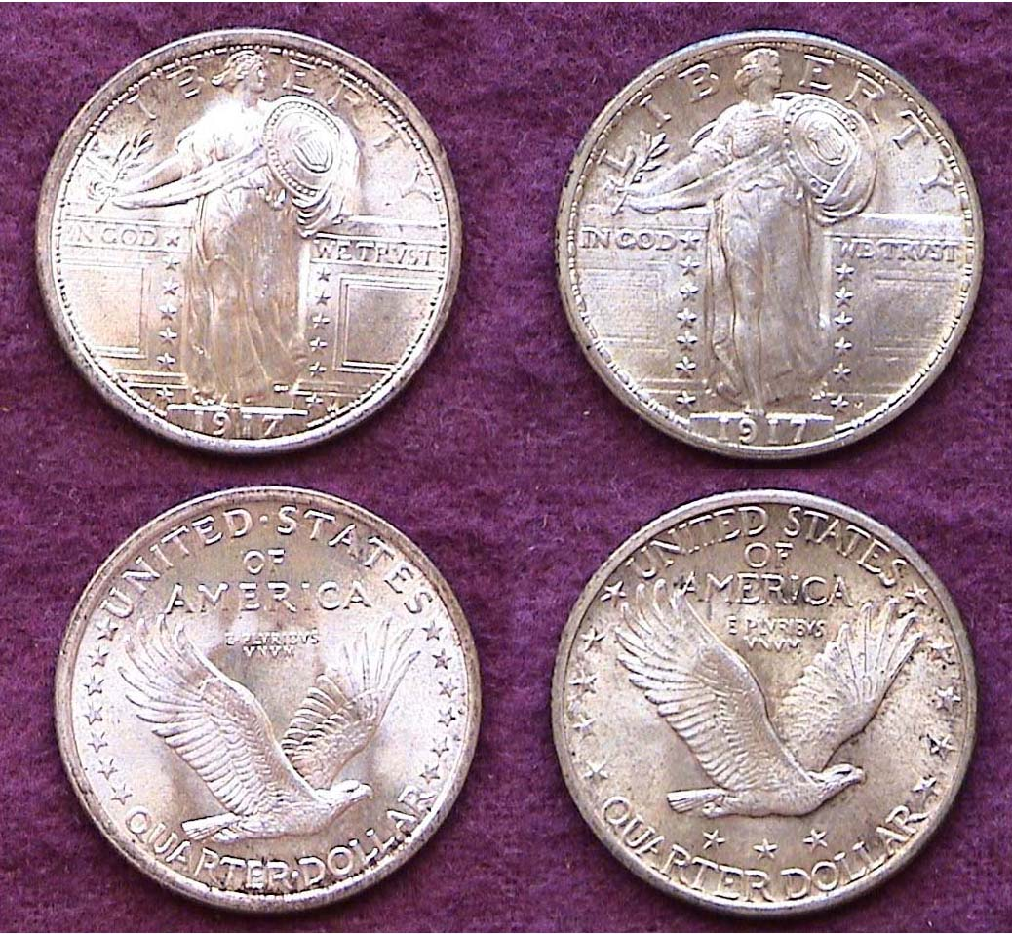

The 1917 Type 1 (left & Type 2 right) SL Quarters side by side
Seen together, one can easily observe the changes
[Use 3x magnifying glass or enlarge page to 200%]

In addition to the foregoing changes noted on the previous page, Miss Liberty’s Shield was subtly altered in the Type II version with fewer, if larger stars placed around the circumference and replaced by a neater, more circular shroud at the bottom.

It was quite customary to see modifications occur after a new design type was released. Most of the time the changes were made to improve the Mint’s effectiveness in bringing out more of the coin’s details or allow the coins to stack properly for insertion into bank rolls. Unfortunately, in most cases these alterations came at the expense of the coin’s aesthetic appeal as with the Gobrecht’s original 1836 Liberty Seated design or the Shield nickel of 1867 when the rays on the reverse were removed. In the case of the 1917 quarter sub-types the jury is still out as to which sub-type is the more attractive.

The mintage for the 1917-P Type II Standing Liberty quarter was 13,880,000, around five million more than the Type I and is priced slightly lower than the Type I in the same grades.

A richly toned 1917 Walking Liberty Half dollar
Graded MS-63 by NGC [Use 3x magnifying glass or enlarge page to 150%]

The Walking Liberty half-dollar designed by Adolf Weinman is arguably our most beautiful silver coin. It was struck from 1916 thru 1947 although not in every year. During the so-called “Roaring Twenties” the mintages were low with the San Francisco Mint striking the lion’s share of Walking Liberty halves. No half dollar coins were struck at all in 1922, 1924, 1925 and 1926 or in 1930, 1931 and 1932; the latter three years occurring in the depths of the Great Depression. Between 1920 and 1933, the denomination was struck at Philadelphia only in 1920 and 1921 and in Denver in 1920, 1921 and 1929.
With exception of the 1920-P, all these coins are expensive.

In 1934, dealers began putting away rolls of WL halves and while some of the branch mint issues are still scarce in MS-63 or better, virtually all of the Philadelphia Mint issues remain available at very moderate prices thru MS-64. During the 1930s the vending machine industry was already in high gear but virtually none provided a slot for the half dollar denomination. That fact plus the large size of the coin discouraged most of the public from using the fifty-cent piece in circulation which us another reason why so many of the later dates, especially those from the 1940s are inexpensive today.

Among the early dates, the 1916-P & D along with the 1917-P, 1918-S and 1920-P are fairly common and inexpensive, the 1917, especially so with a mintage of 12,292,000. The 1917 also comes with a sharper strike than the 1916 and is moderately priced thru MS-64. In 1916 and the first part of 1917, the D & S Mintmarks were placed on the obverse under the date. In the latter part of 1917, the mint mark was moved to the reverse near the rim on the lower left side of the eagle. All 1917 branch mint issues are scarce and expensive however.

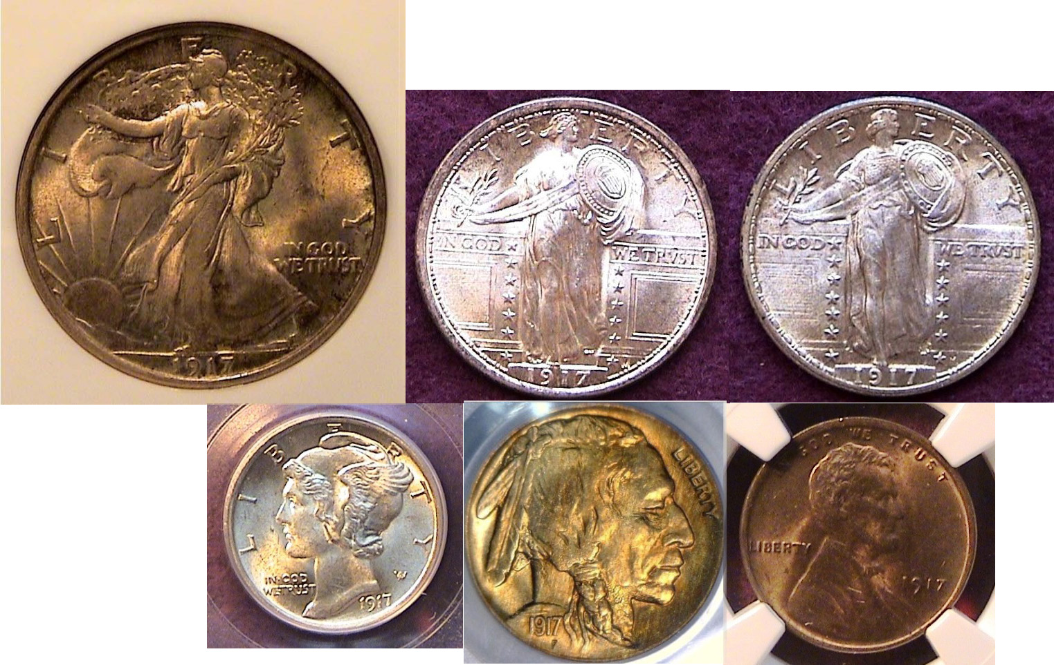

The obverses of a certified BU 1917 year set

With a certain amount of study, observation and focus, one can assemble a 1917 year set grading BU at a moderate price. While not “rare”, the satisfaction for the collector comes from 1) the attractiveness of all of the coin designs, 2) the balanced appearance of the set and 3) completeness.

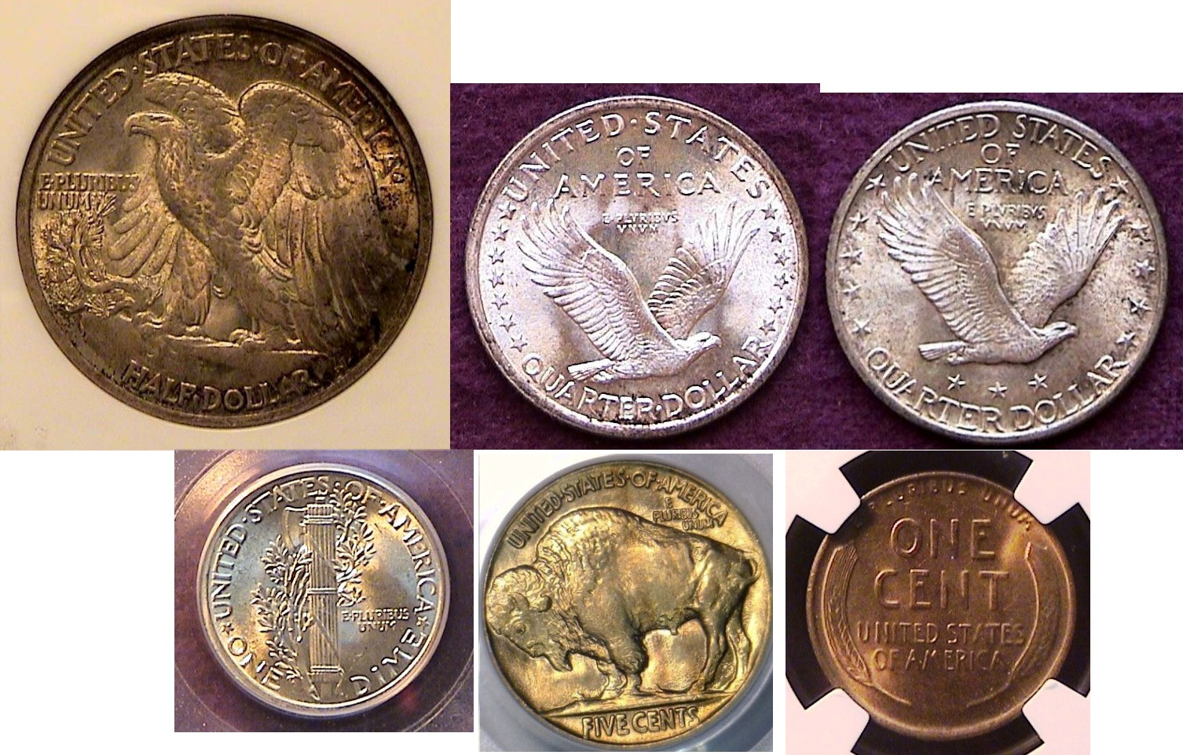

The reverses of a certified BU 1917 Year Set
__________________________________________________________________

STEPHEN JAMES CSRA COIN CLUB
Regular Meeting
Aiken County Library
November 7, 2013

Steve Kuhl called the regular meeting of the club to order at 6:45 p.m. Sgt. In Arms Jim Sproull reported that there were 27 members present (26 adults, 1 junior). There were also 5 guests, Douglas Pryor, Robbie Ogden, Mrs. Black, RJ Vero, and Brandon Chaney (15 regular members needed to conduct the business of the club.) Jim also announced information concerning several upcoming coin shows in the vicinity, especially the Show for the Augusta Coin Club.
Chuck Goergen won the door prize, a Franklin Half Dollar. A motion was made by Mac Smith, seconded by Pat James, and passed to dispense with the reading of the October minutes. The treasurer’s report was presented. The February balance was $2415.13. James Black joined our club immediately prior to the meeting. The club still has one copy of the 2014 Redbook for sale for $8.
Steve Kuhl described the plans for the club’s Holiday Dinner. We’re having it Dec 5 at the Knights of Columbus, 1003 Spalding Drive. Entrees will be steak or chicken. Price is $11 for club members and $24 for non-members. There will be a cash bar. .Jim Barry reminded the board that the annual audit of the club’s financial records was overdue by several months. Chuck Goergen stated that he and Roger Worpell would make completing the audit a higher priority.
Show & Tells were presented by Jim Barry, Chuck Goergen, and Arno Safran. Jim shared an ancient coin that was struck after the Battle of Philippi in 42 BC. Chuck shared a coin struck under Ptolemy II that he obtained since his recent program on ancient coinage. The coin had a small ∆ behind the ear of Ptolemy I on the obverse. Arno shared a complete set of 1953 coins from all three mints in BU condition.
The program was on Southern Currency, Banks and Bonds, by Garry Naples.
Respectfully submitted,
Jim Mullaney, Secretary

Show & Tell brought in by Chuck Goergen

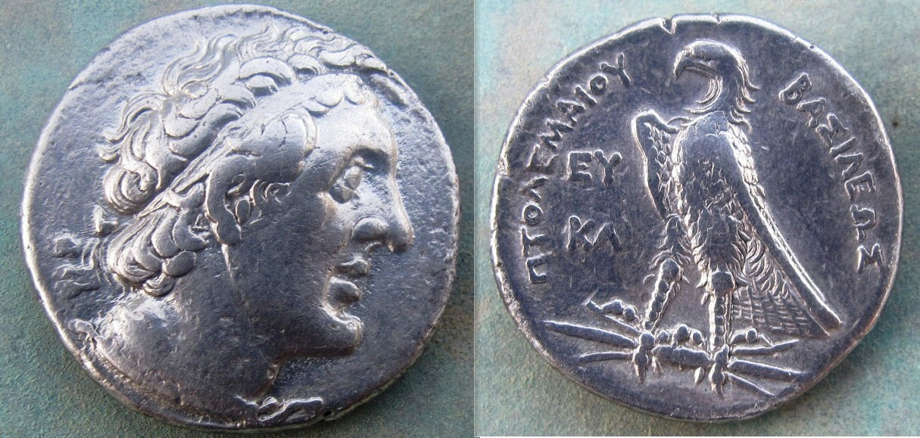

Ptolemy II Philadelphus 285-246 BC delta on obv. & rev.
[Use 3x magnifying glass or enlarge page to 200%]

Update on Helen Barry

Member Helen Barry is undergoing excellent care and tests at University Hospital in Augusta. We are hoping for a desired diagnosis and a full recovery.

Kindly Patronize Our Advertisers

