The Stephen James
CSRA Coin Club of Aiken
P.O. Box 11
New Ellenton, SC 29809
Web site: www.sjcsracc.org

The SJ CSRA CC of Aiken, SC meets on the 1st Thursday of the month at the Aiken Public Library

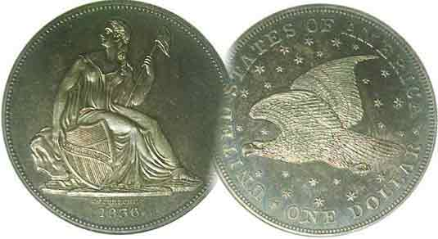
Pres. Willie Simon
V .P. Pat James
Sec. Jim Mullaney
Treas. Chuck Goergen
Sgt. in Arms: Jim Sproull

Programs: Pat James
ANA Representative: Jim Barry
Show Chairman: Steve Kuhl
Photos: Helen Barry
Publicity: Pat James
Newsletter: Arno Safran
E-Mail: arnosafran@comcast.net
Auctioneer: Jim Sproull
Web site: Susie Nulty (see above.)

Volume 13, No. 12 the Stephen James CSRA Coin Club, Founded in 2001 December, 2014
Monthly Newsletter
Club Completes 14th Year in 2014
2014 Club Meeting Schedule
Our pre-X’mas dinner will be held on Thursday, Dec. 4, at the Knights of Columbus

Jan. 2 Apr. 3 July 3 Oct. 2
Feb. 6 May 1 Aug. 7 Nov. 7
Mar. 6 June 5 Sept. 4 Dec. 4

Successful Show and Many Fine programs
Highlight club year

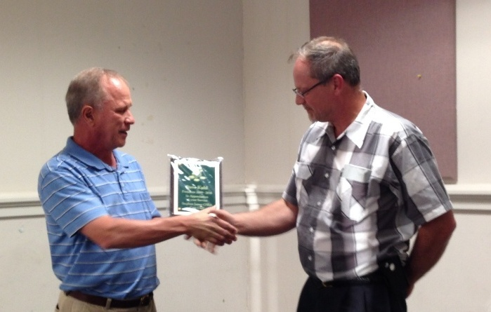

Incoming President Willie Simon Awarding Outgoing President
Steve Kuhl for his service as President and Show Chairman

In 2014, Willie Simon was elected President taking office if April, the start of the club’s fiscal year. Previously, Willie had served as our first President from 2001 through 2008. He replaced Steve Kuhl who served as President for five years, (2009-2013). Steve was also praised by President Simon for his service to the club as Show Chairman during his tenure as President.
VP Pat James and Programs chairperson arranged for many fine speakers that included Chuck Goergen, Garry Naples, Wayne Damron, Mary Faubert, Zack Richardson and Arno Safran. Sec. Jim Mullaney’s technical support helped the presentations run smoothly. Another encouraging aspect of the club’s growth is the continued interest by members contributing to the Show & Tell segment at our monthly meetings. As a result, we were able to view numismatic items dating from classical Greece to the latest offerings from the US Mint such as the 2014 Kennedy gold commemorative coin.
________________________________________________________________________________________________________________________
(Continued on page 3, column 1)

The US Coins of 1934: 80 years ago By Arno Safran

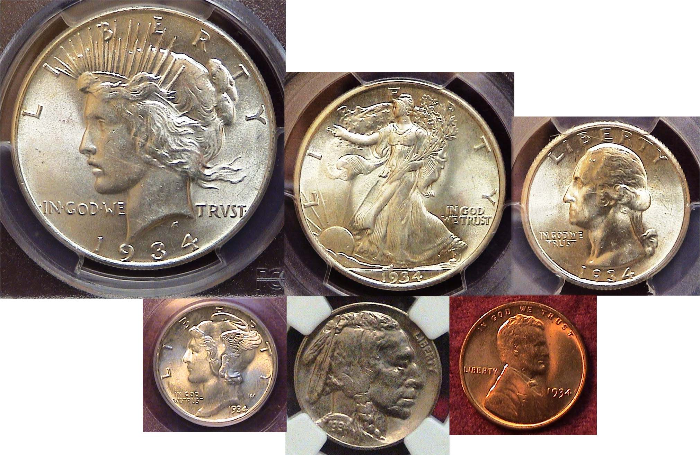

The obverses of a 1934 denomination set
[Magnify to 150% or maximize page to view details.]

In 1934, Franklin D. Roosevelt was in his second year as President of the United States and while the Great Depression still gripped the nation, congressional actions signed into law by FDR were beginning to bring some hope that the worst of the poor economic times were diminishing.

The bad economy affected our coinage program as well. During the depths of the Great Depression, 1931 thru 1933, mintages were low with a number of denominations being suspended altogether. No silver dollars were coined from 1929 thru 1933, and from 1930 thru 1932, no half-dollars were struck for circulation. Quarters were not issued in 1931 or 1933. Nickels and dimes were suspended in 1932 and 1933. Only the lowly cent was produced yearly. By 1934, the economic tide was beginning to improve and the Mint decided to resume the striking of all six denominations including the silver dollar with ample numbers of half dollars, quarters, dimes, nickels and cents. Today, it is possible to assemble a six piece denomination set of 1934 coinage averaging as high as MS-63.
____________________________________________________________________________________________________________
(Continued on page 2, column 1)
Collecting the Coins of 1934: 80 years ago
(Continued from page 1, column 2)

The reverses of a 1934 year set
Top. $1.00, 50c & 25c, Bottom: dime, nickel and cent
[Magnify page to 150% or maximize to view details.]

A coin set looks best when the grades appear closely matched. Ideally, the higher the grades, the more attractive the set. A high-end set could balance with coins graded from AU--55 thru MS-64, a mid-grade set, VF-30 thru XF-45 and a lower grade set, Good-6 thru Fine-15. Obviously, the scarcer the coins of a particular series, the lower will be the grade of the set. Back in 1995, the author attempted to assemble a six piece set of US coins dated 1795, (excluding gold.) The grades of the coins ranged from VG-8 to VF-30.

Two things occurred in 1934 to make it easier for collectors to assemble a high grade denominational year set for that year, First, the output from the Philadelphia and Denver Mints were fairly large for all denominations and second, dealers started to put away rolls of uncirculated coins as soon as the left the mint. In 1934, the San Francisco Mint struck only dollars and half-dollars but high grade examples of both the Walking Liberty half-dollar and especially the Peace dollar are quite scarce and expensive.

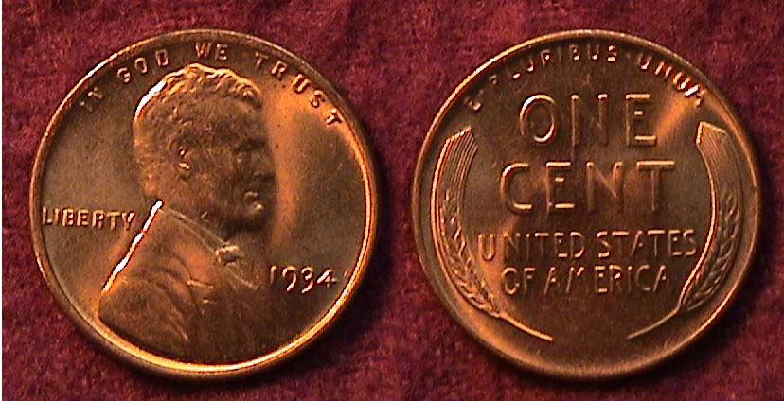

A 1934-P Lincoln Wheat- back cent grading MS-65 Red
[Magnify page to 150% or click maximize square.]

The cent output in 1934 consisted of 219,080,000 struck at the Philadelphia Mint but only 28,446,000 produced at the Denver facility with the result that the 1934-D is likely to cost the collector about one-third more for the Denver issue in the MS-65 Red grade shown in the photo. That said, finding a 1934-D specimen grading full Red MS-65 will be much harder than the price differential suggests. An attractive 1934-P cent will do very nicely.

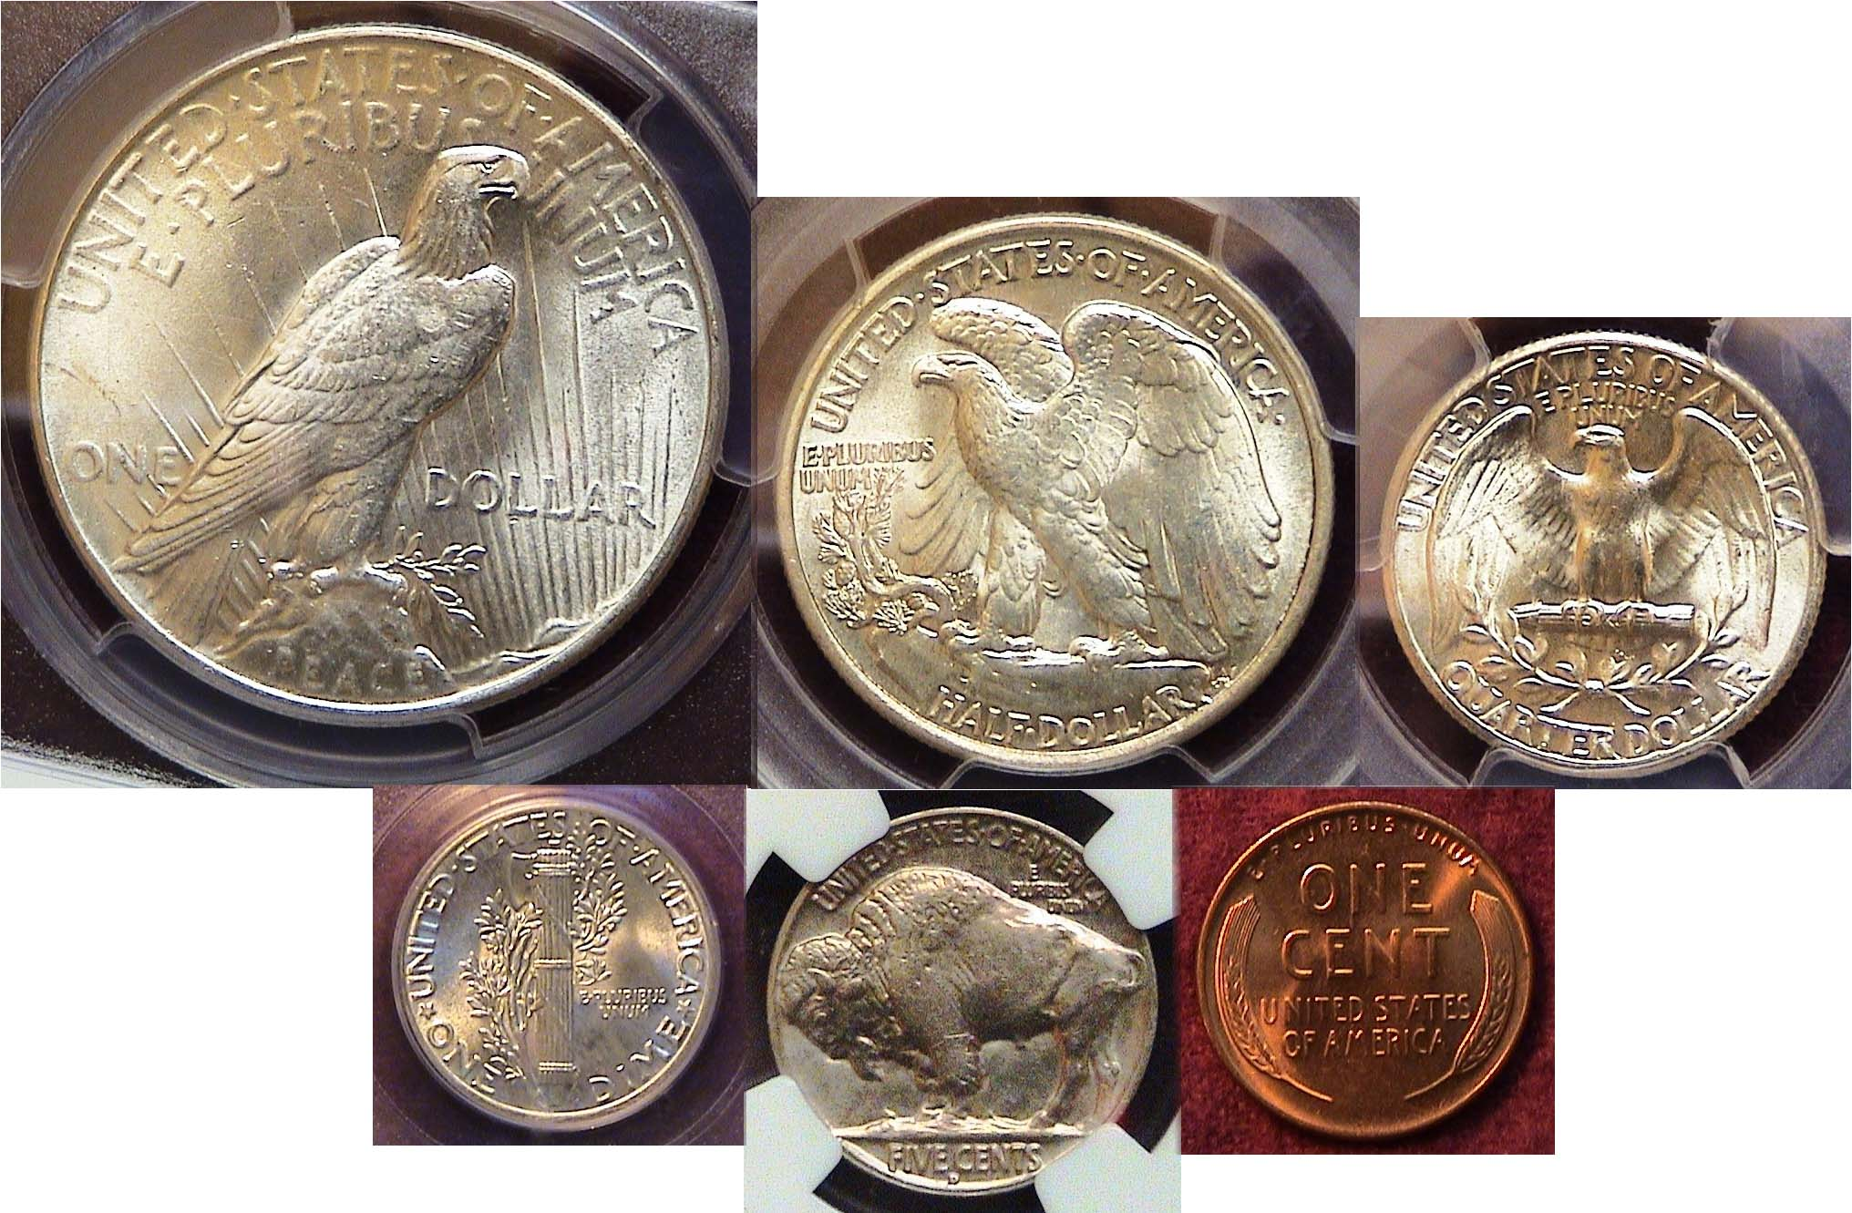
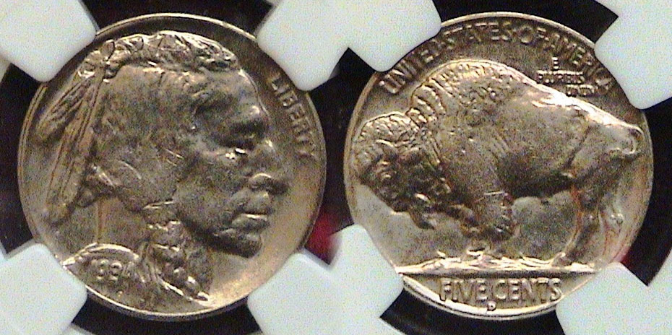

A 1934-D Indian Head/ Buffalo nickel graded MS-64 by NGC
[Magnify page to 150% or click maximize square.]

20,213,003 Indian head/ Buffalo nickels were struck at the Philadelphia Mint in 1934 compared with 2,480,000 at the Denver facility with the result that a certified 1934-D issue grading MS-64 is valued at about twice the price of a 1934-P. Since 1934 represents the first year dealers began stashing rolls of uncirculated US coin in mint state, apparently enough BU 1934-D nickels were saved to keep the date within a more moderate price-range than its smaller mintage suggests. While not as lustrous or as sharply struck as the 1938-D issue, the 1934-D specimen shown above is a pleasing example for a date that usually comes weakly struck.

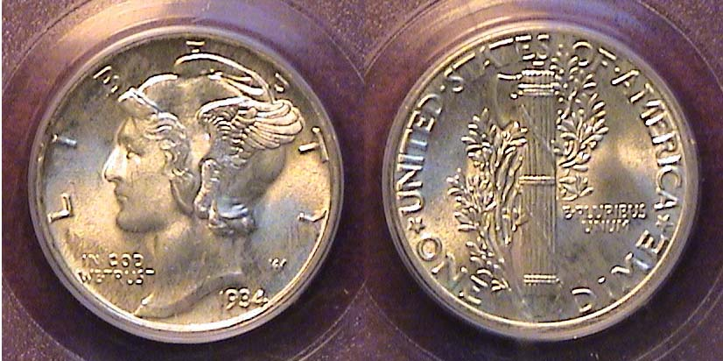

A 1934-P Mercury dime graded MS-66 Full Bands by PCGS
[Magnify page to 150% or click maximize square.]

In 1934, the Philadelphia Mint struck 24,080,000 Mercury dimes compared with just 6,772,000 at Denver. Without full bands on the reverse, the price differential between the two mints is minor with the 1934-D costing almost double that of the 1934-P. Well struck fully split bands on the reverse command a` premium and this is especially so for the 1934-D dime which is priced at nine times higher for a certified MS-66-FB specimen than the 1934-P, shown above. The beautiful Mercury dime type loses much of its eye appeal grading below MS-63 when compared with other US Bust-type obverses such as the Barber Liberty, (1892-1916), Capped Bust (1809-1837) and Draped Bust issues, (1796-1807). As a common date, the 1934 Mercury dime, even grading MS-66 was not all that expensive. However most common date Mercury dimes such as the 1934-P grading MS-64, even without Full Bands display lots of eye appeal and are very moderately priced.
During the Depression prices for most basics were fairly low. The nickel was the workhorse of the economy as it had the purchasing power of 88¢. Public transportation cost a nickel. So did a candy bar, an ice cream cone and a soft drink. In 1934 the purchasing power of the dime was around $1.75. A loaf of bread cost a dime. To a child, ten cents seemed like a lot of money. It could buy a pencil box. Even the cent had value. The mini-candy bars we give out to children on Halloween today cost a penny back in 1934.
_____________________________________________________________________________________________________________________
(Continued on page 3, column 1)
Collecting the Coins of 1934: 80 years ago
(Continued from the previous page)

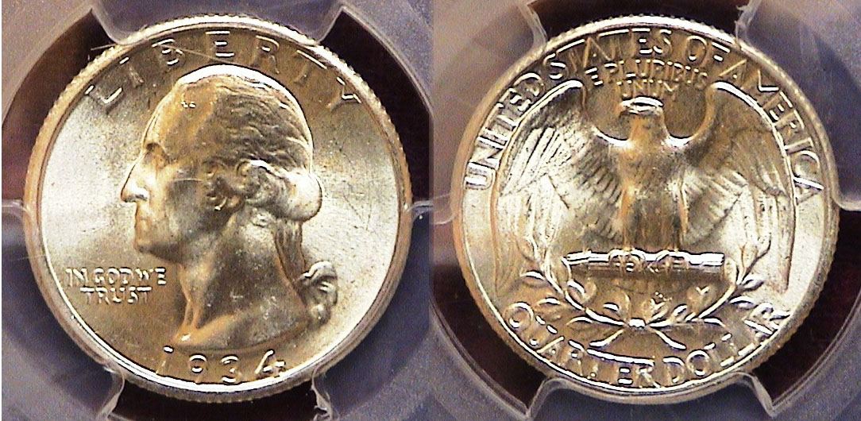

A 1934-P Washington Quarter graded MS-65 by PCGS
[Magnify page to 150% or click maximize square

The Washington quarter was in its second year of production in 1934 as no quarter-dollars were coined in 1933, perhaps the deepest year of the Great Depression. Over 31.9 million were struck at the Philadelphia Mint while only 3.5 million were coined at Denver. Today, a 1934-D grading MS-65 is valued at more than six times that of the 1934-P according to the 2015 Red Book.

In 1932 and part of 1934, the motto, IN GOD WE TRUST was struck lightly. The motto was enhanced later in 1934 with many more heavy motto specimens being struck that year than those bearing the light motto. As a result, a 1934 light motto specimen is worth from 1½ to 2½ times a heavy motto piece from AU-50 to MS-65. There are a number of 1934 quarters designated with a “medium motto” but they are valued similarly to the heavy motto pieces.

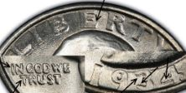
The 1934-P quarter also is known for a scarce double-die variety which appears on various parts of the coin including the motto.

Given the options, the least costly acquisition of a 1934 quarter in any grade would be the 1934-P with heavy motto.

In 1934, a quarter had the purchasing power of $4.35. As a boy, I remember just before we left spending a day with my maternal grandparents, my grandfather would ask, “Have you been behaving yourself?” If we nodded in the affirmative, he would give us a quarter. This was well into the 1940s when 25c still seemed like a great deal of money to a child.

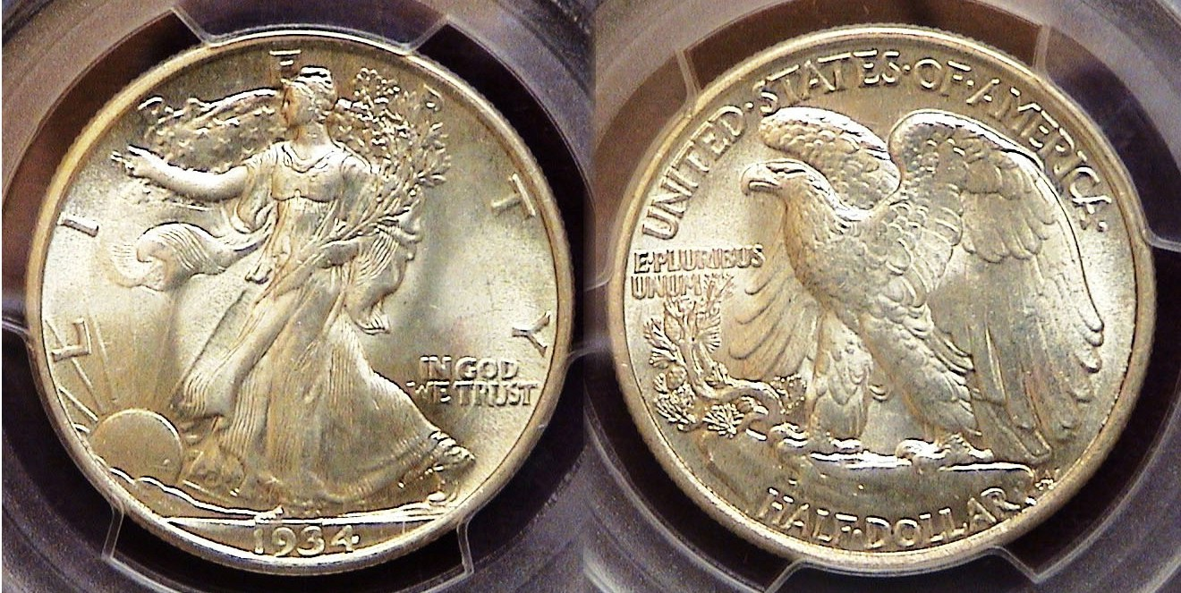

A 1934-P Walking Liberty half-dollar graded mS-64 by PCGS
[Magnify page to 150% or click maximize square.]

With the exception of the 1916-D, 1917-P and 1920-P most of the early dates of the Walking Liberty half-dollar series are scarce to rare grading AU-50 or higher. That situation all began to change 1934.
Many consider the Walking half to be our most beautiful silver coin. Yet from 1916 thru 1933, the 50c denomination intended for circulation had a wobbly existence. It is ironic then that from 1922 thru 1933 no WL halves were struck at the Philadelphia Mint, America’s largest minting facility. At the Denver Mint, after 1921, WL haves were not struck again until 1929; then suspended again until 1934. During this period, only the San Francisco Mint was the most consistent yet there were gaps. No WL halves were produced at all in 1922, 24, 25 & 26, or in 1930 thru 1932. If you wanted to include a 50c piece for your year set in any of those years it would require the acquisition of one of the commemorative half-dollars although no commems were issued in 1930, 1931 or 1932.

In 1934, the WL half was struck at all three mints, 6.9 million at Philadelphia, 2.6 million at Denver and 3.6 million at San Francisco, although examples from the last are scarcer in mint-state and expensive. With dealers now putting away rolls of uncirculated coins beginning in this year, specimens of the 1934-P and D issues are affordable thru MS-63 with the 1934-P being still moderately priced in MS-64. 50c had the purchasing power of $8.75 in 1934.

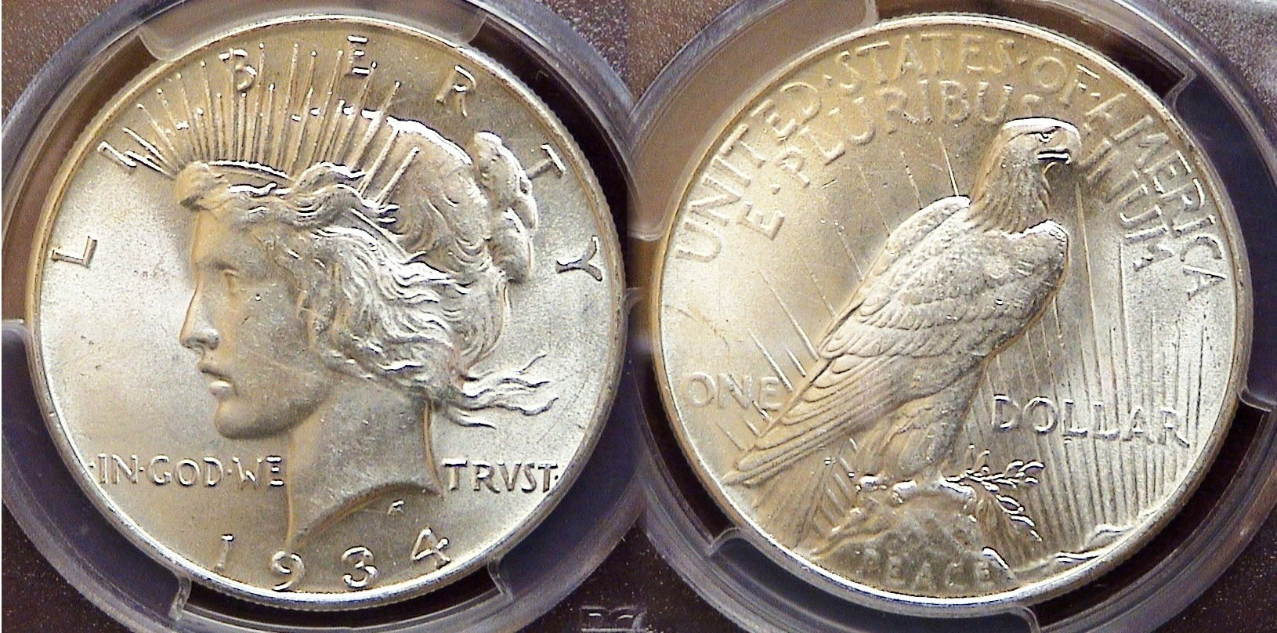

A 1934-P Peace $1.00 graded MS-62 by PCGS
[Magnify page to 150% or click maximize square.]

The 1934 Peace dollar was struck at all three mints but only the 1934-P is moderately priced thru MS-64. Since the open fields surrounding the central devices on both sides of this coin-type allow for more distracting marks compared with the Morgan dollar, retail prices begin to soar above MS-64 for even the common dates. While the 1934-P $1.00 had the smallest mintage of the three Mints, just 954,057, (less that 1 million) as compared with the 1.5 million for the 1934-D and the slightly more than 1 million for the 1934-S, many more survivors exist in mint state than the 1934-D or the 1934-S, the latter being one of the key dates grading AU-50 or higher. This MS-62 example of the 1934-P shown above is as pleasing as some MS-64 examples the writer has seen but cost a lot less.
1934 was a transitional year in the US economy although there was still too much joblessness and poverty which breeds crime. Gangsterism was at its peak in 1934 with the reported shooting deaths of Bonny and Clyde, John Dillinger, Public Enemy No. 1 and Baby Face Nelson taking top headlines of the day. For those celebrating their 80th year of life, a moderately priced attractive set of 1934 US coinage is attainable.
__________________________________________________________________________________________________________

Jim & Helen Barry Receive ANA President’s Award

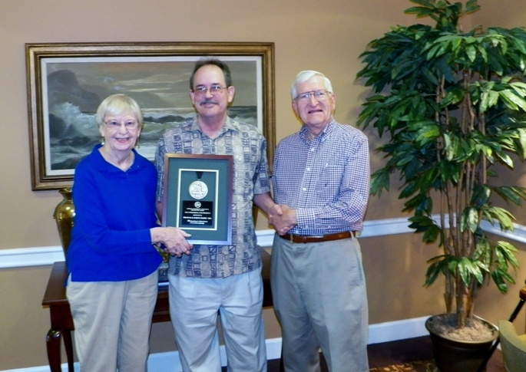

Helen & Jim Barry receiving the ANA President’s Award
Plaque from ANA Governor Mike Ellis
Signed by ANA President Walter Ostromecki, Jr.
]
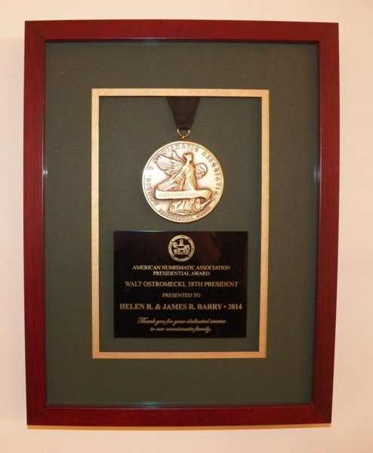
The award was presented to the Barry’s for their service as District Delegates over a long span of years and later as Regional Coordinators for the Carolinas thru 2005. As District Delegates and Coordinators, the Barry’s publicized the ANA to local and state area club meetings and regional shows, helped collectors join the ANA and encouraged education at club meetings. Congratulations!

__________________________________________________________________________________________________________________________

\Highlights from the Nov. 6 Meeting

President Willie Simon called the meeting to order at 6:45 PM. Sgt. In Arms Jim Sproull reported 17 members and 2 guests were in attendance and listed the upcoming regional shows for the month. Treasurer Chuck Goergen n reported a balance of $2,001.40. Chuck also gave us an update on the holiday dinner which will be held on Dec. 4 in lieu of our regular meeting at the Knights of Columbus hall. This year the tab will be $13.00 per member and $25 per non-member.

New Business: Due to New Year’s Day falling on the first Thursday, President Simon has arranged with the library to have our first meeting in 2015 moved back to Jan. 8. Since some members expect to attend the annual FUN Show in Orlando that week, VP Pat James will show a coin video during the program segment. In other new business, President Simon presented the prices from the club T-Shirt Shoppe; long skleeve-$14.54, short sleeve, $11.10 and T-short $8.45.

There was one Show & Tell: Arno Safran showed the two transitional sub-types of the 1917-D WL half dollars, one with the mint-mark on obv. and the other on the rev. explaining that the mint director at the time thought the obv. mm appeared as a die crack.

The Program: Member Garry Naples gave a PP Presentation on Carson City Mint coins highlighting mostly some of the rarer pieces from the Morgan dollar and $20.00 gold double-eagle series, also showing their increase in value over the years,

The prizewinners at the Nov. 6 meeting were Liz Goergen who won a 1961 Franklin half and Jim Sproull who won the 50/50 drawing- $15.00. Congratulations to both winners!
__________________________________________________________________________________________________________________________

Kindly Patronize Our Advertisers
