The Stephen James
CSRA Coin Club of Aiken
P.O. Box 11
New Ellenton, SC 29809
Web site: www.sjcsracc.org
The SJ CSRA CC of Aiken, SC meets on the 1st Thursday of the month at the Aiken Public Library

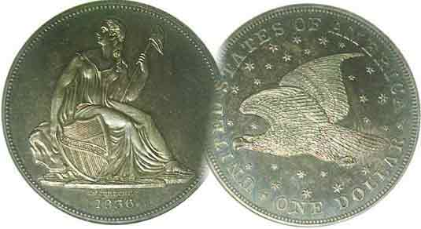
Pres. J.J. Engel
V .P. Pat James
Sec. Jim Mullaney
Treas. Chuck Goergen
Sgt. in Arms: Jim Sproull

Programs: Pat James
ANA Rep.: Glenn Sanders
Show Chair: Board members
Photos: Steve Kuhl
Publicity: Pat James
Newsletter: Arno Safran
E-Mail: arnosafran@comcast.net
Auctioneer: Jim Sproull
Web site: Susie Nulty (see above.)

Our upcoming dinner meeting will not be held on Thursday, Dec. 3 due to the Coronavirus
Happy Holidays to all!

2020 Club “Zoom” Meeting Schedule
Volume 19, No. 12 the Stephen James CSRA Coin Club, Founded in 2001 December, 2020
Monthly Newsletter
Holiday Dinner Meeting scheduled for Dec. 3 cancelled!
Jan. 2 Apr. 2 July 2 Oct. 1
Feb. 6 May 7 Aug. 6 Nov. 5
Mar. 5 June 4 Sept. 3 Dec. 3

An Interesting coin from 140 years ago

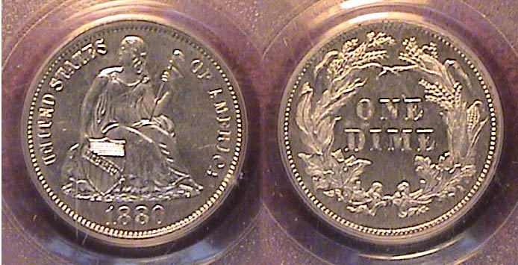

An 1880 Liberty Seated dime graded MS-63 by PCGS
[Enlarge page to fill monitor screen to view details]

In 1878, Congress passed the Bland Allison Act which would have a serious effect on our circulating silver coinage at the expense of producing millions of Morgan dollars which barely circulated. From 1879 thru 1890, the quarter and the half-dollar were struck in small numbers for collectors of that era who preferred business strikes to proof issues, which were coined in even lower numbers. For the first three years of that cycle, (1879 though 1881), Liberty Seated dimes were also produced in very small numbers, just 14,000 in 1879, 36,000 in 1880 and 24,000 in 1881 before the Philadelphia Mint began striking large numbers for circulation in 1882 with the production of 3,9 million. The interesting aspect of the three year dime series is that some of the business strikes appear proof-like, much like the 1880 coin shown above, and while it isn’t as scarce as the quarters or halves, acquiring an attractive mint state example is more challenging than the proofs.

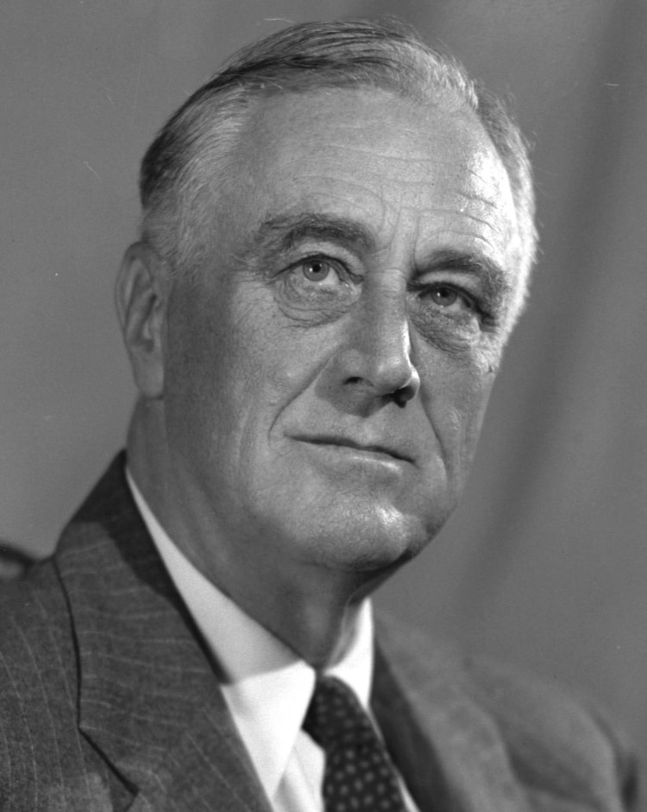
In 1880, only 1,355 proof dimes were struck; the exact same number as the quarters, halves and Morgan dollars, while 3,966 proofs were struck for the 1880 Indian Head cents and Shield nickels. Most collectors of that period retained the proofs. As a result, a far larger number of the proofs may still be available today compared with the business strikes, which is why the 1879-1881 dimes are more challenging to acquire. Apparently, future descendants coming across the business strike issues in their family heirlooms would spend them since the purchasing power of a dime was $2.58 back then.
Collecting the US Coins of 1940, 80 years ago
By Arno Safran

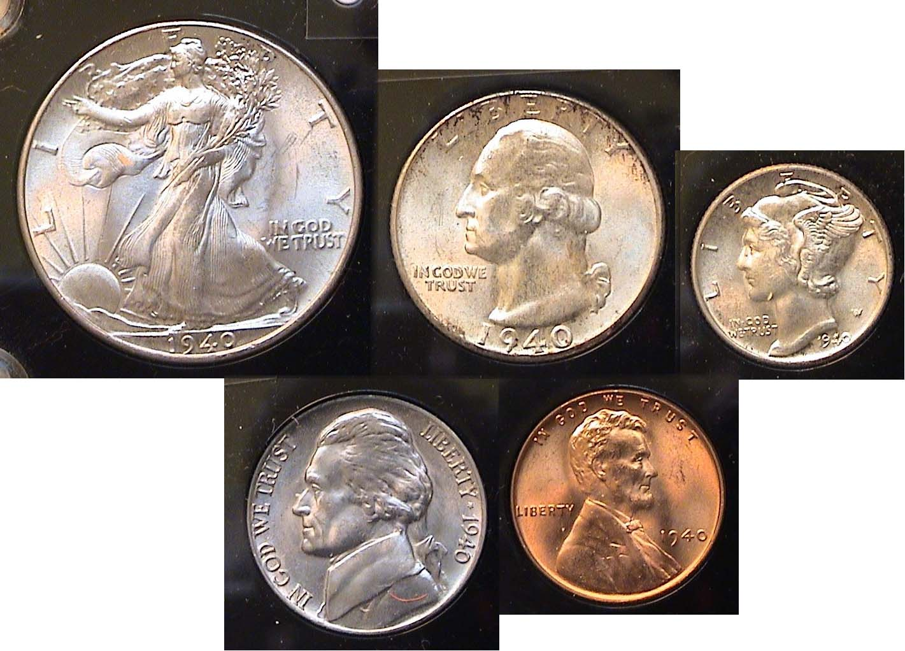

The obverses of the 1940-P BU Year set of U.S. Coins showing atop, the Walking Liberty half, Washington Quarter & the Mercury dime with the Jefferson nickel and Lincoln Wheat-back cent, below.
[Enlarge page to fill monitor screen to view details]

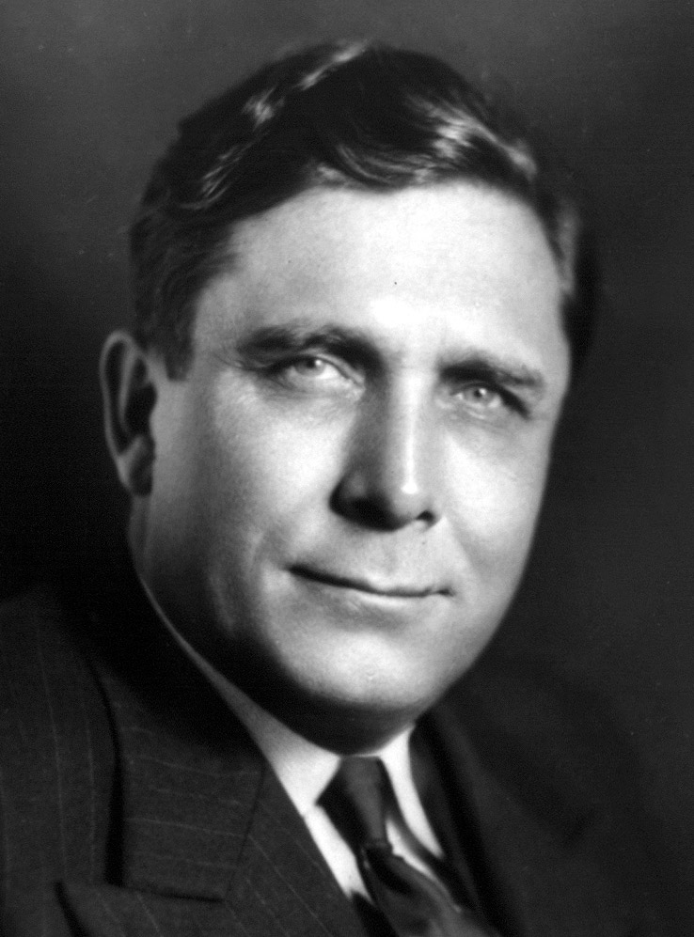
It’s hard to believe that this lovely set of BU coins from 1940 is currently eighty years old, but for members who have recently reached that gilded age, it looks as if we were handling these coins not all that long ago. In 1940, the parents of these newly become octogenarians were living at a time when the nation was beginning to come out of the Great Depression but they were also becoming concerned by the threat of war which had already broken out in Europe due to the invasion of Poland by Nazi Germany on Sept. 2, 1939 and France in 1940. By this time, President Roosevelt decided to run for an unprecedented 3rd term and former Democrat, now turned moderate Republican, Wendell Willkie, ran against him and was later appointed by Roosevelt to an ambassadorial position in the far-east.

Franklin Delano Roosevelt Wendell Willkie
(Continued on page 2, column 1)
Collecting the US Coins of 1940, 80 years ago
(Continue from page 1, column 1)

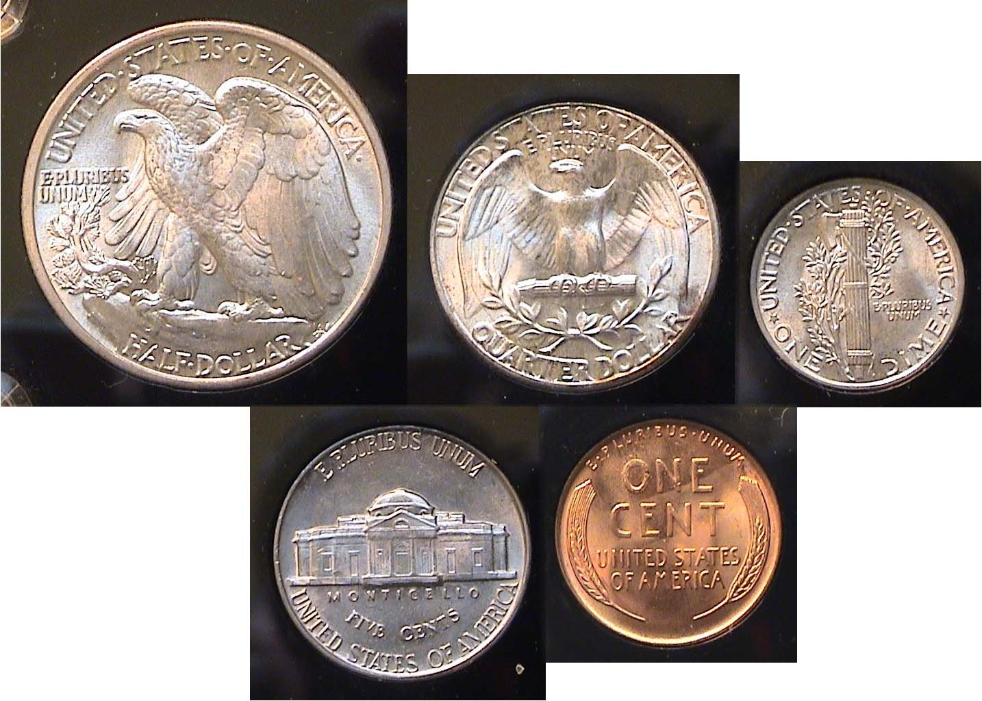

The reverses of the 1940-P BU Year set of U.S. Coins showing atop, the Walking Liberty half, Washington Quarter, Mercury dime and below, the Jefferson nickel and Lincoln Wheat-back cent
[Enlarge page to fill monitor screen to view details]

When it comes to the coinage of 1940, the reverse of the Walking Liberty half dollar startles the eye for it is a supreme masterpiece of artistic design, created by Adolf Weinman, dating from 1916, the first year the Walking Liberty half was struck. The wonderful aspect of our five denominations coined in 1940 is that all are affordable in mint state condition from the three mints then in operation; Philadelphia, San Francisco and Denver although no halves were struck at the Denver Mint that year.

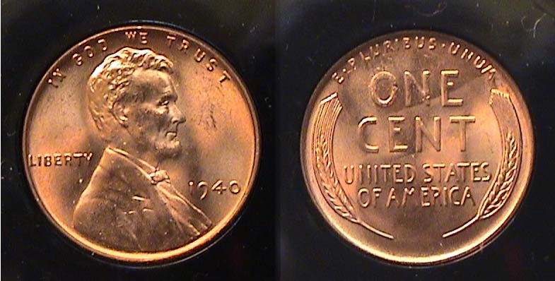

A 1940 Lincoln-Wheat back cent grading MS-64 Red
[Enlarge page to fill monitor screen to view details]

In 1940, 586,810,000 Lincoln Wheat back cents were struck at the Philadelphia Mint, an all time record for the cent denomination that would be broken the following year in 1941 when 887 million were coined. As a result, even a full red specimen certified MS-65 Red is listed at only $22.00, with MS-64’s, just $12,00.

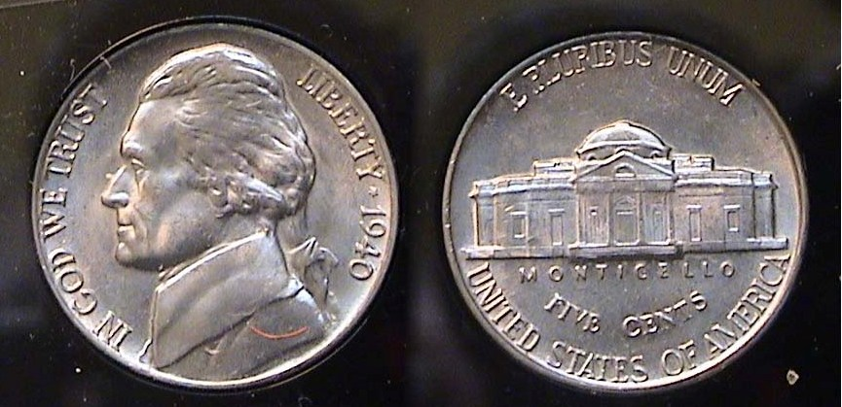

A 1940-P Jefferson nickel with full steps graded MS-65
[Enlarge page to fill monitor screen to view details]

The Jefferson nickel, first coined in 1938 had rounded steps under Monticello on the reverse thru mid 1939 when a second type displaying a more rectangular series of steps replaced it, which is referred to the type of 1940. 176,485,000 nickels were produced by the Philadelphia Mint that year, also a record for the five-cent nickel denomination which would be broken in 1941. The coin is extremely common ranging in price from $5.00 for a MS-63, $10.00 for a MS-64 and $14,00 for one graded MS-65. Full steps examples are slightly higher at $16, for an MS-63, $22, for one graded MS-64 and $28 for one certified MS-65. The coin was designed by Felix Schlag, originally with a sumptuous reverse design featuring a curved Monticello, but questions regarding its striking forced a revision to a flattened and straighter portrayal of Jefferson’s home.

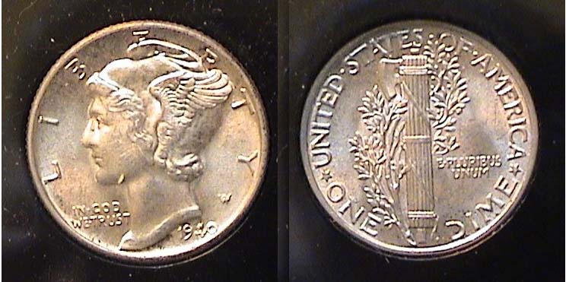

A 1940-P Mercury dime grading MS-64
without full steps on the fasces on the reverse
[Enlarge page to fill monitor screen to view details]

In 1940, 65,350,000 Mercury dimes were struck by the Philadelphia Mint but it wasn’t close to the record of 87,500,00 set in 1936. The date is still considered extremely common ranging in value from $11.00 for a MS-63 example, $15.00 for a MS-64 and to $25.00 for one graded MS-65 according to PCGS’ s COINFACT . With fully split bands on the reverse, it would worth a lot more; $14.00 for an MS-63, $22.00 for one grading MS-64 and $40.00 for a certified MS-65 specimen. This coin was also designed by Adolph Weinman and as with the half-dollar, first appeared in 1916.

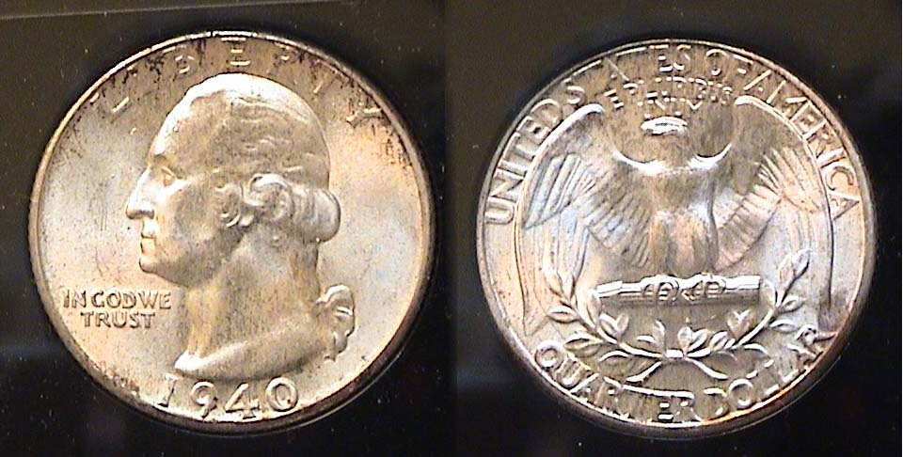

An 1940-P Washington Quarter graded MS-63
[Enlarge page to fill monitor screen to view details]

In 1940, 35,700,000 Washington quarters were struck at the Philadelphia Mint and today, the date is currently valued at $25.00. When the coin was acquired in 1984, it cost $10.00, not especially a very good investment, but then, it is a very common date and an MS-63 is considered merely average in quality for mint-state coin.
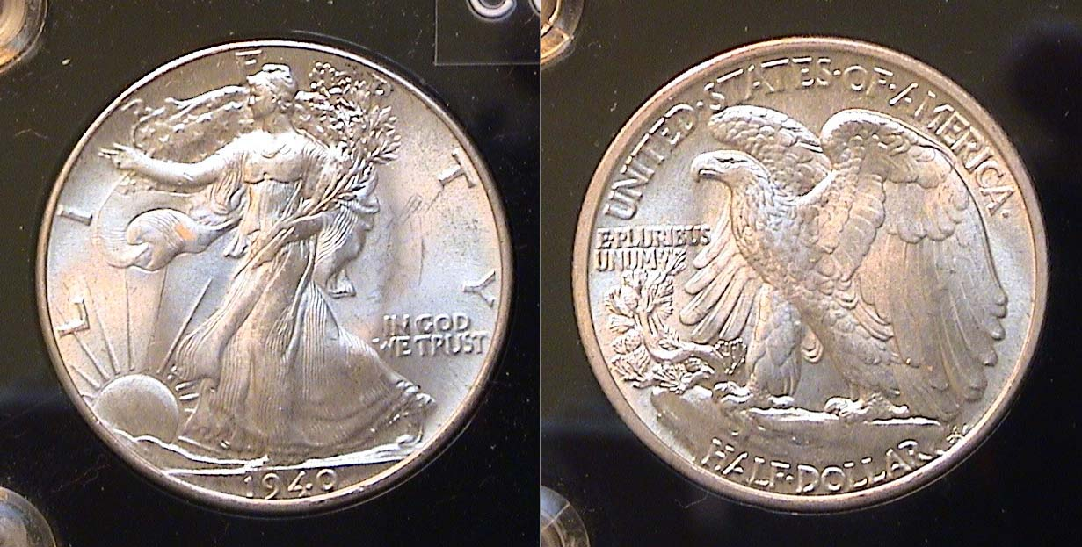

A 1940-P Walking Liberty half-dollar graded MS-65
[Enlarge page to fill monitor screen to view details]

In 1940, the Philadelphia Mint struck 9,596,000 Walking Liberty half dollars and is considered the scarcest of the 1940s yet still fairly easy to acquire in grades as high as MS-65, with a current retail value of just $110. In 1977, it cost just $20.00.
_________________________________________________________________________________________________________________________________
(Continued on page 3,column 1)
Collecting the US Coins of 1940, 80 years ago
(Continue from page 2, column 2)

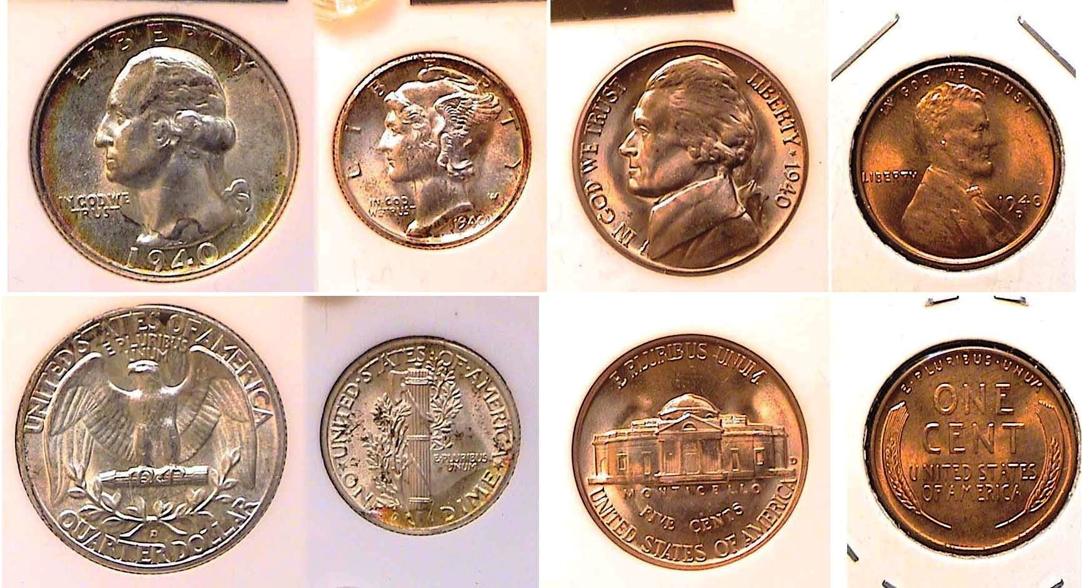

A 1940-D uncirculated Year Set
No Walking Liberty halves were issued at the Denver Mint that year
[Enlarge page to fill monitor screen to view details]

In 1940, the Denver Mint struck only four of the five designated US coin denominations; the cent with a mintage of 81,390,000, the Jefferson nickel, mintage, 43,540,000 ,the Mercury dime, mintage, 21,198,000 and the Washington quarter with 3,797,600. It is possible that there was no need to mint any halves at the Denver Mint that year because the 1939-D with a mintage of over 7 million may have been sufficient.
None of the above 1940 Denver Mint coins shown above are high-end uncirculated examples, with most probably grading between MS-63 and 64. The Jefferson nickel appears to be very well struck with full steps below the Jefferson memorial while the Mercury dime has fully split bands on the reverse. As result, they make-up a nice balanced yet affordable set.

Collecting the 1940-S US Coins

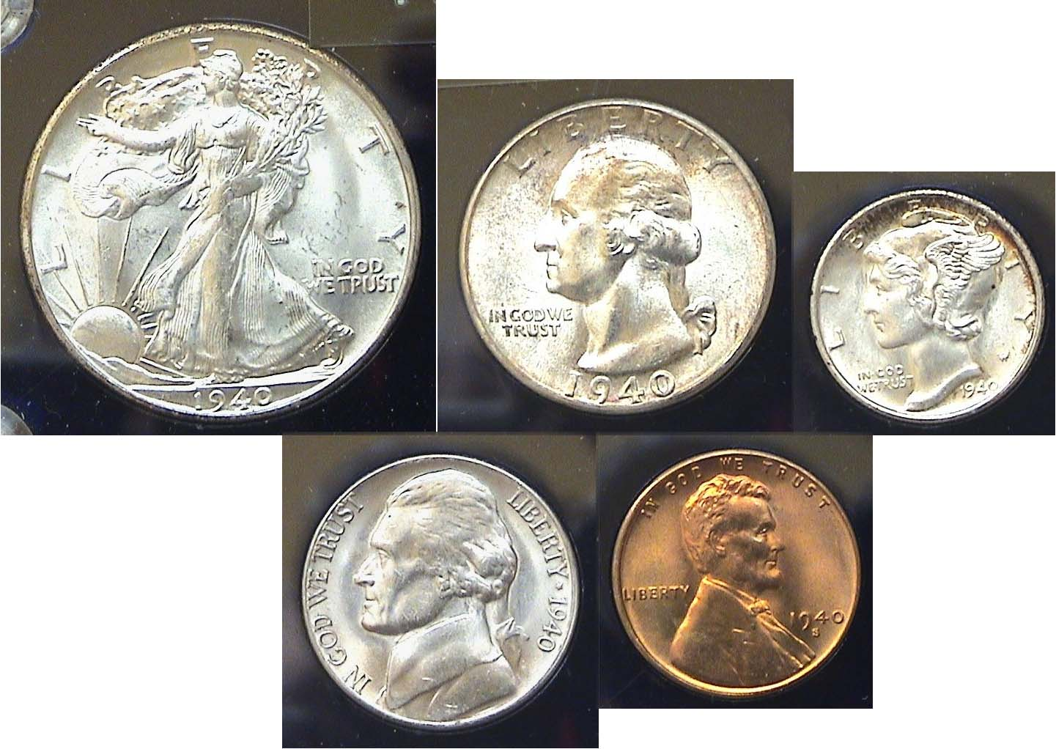

The obverses of the 1940-S BU Year set of U.S. Coins
[Enlarge page to fill monitor screen to view details]

During the late 1970s, the author was still in the throes as a beginning collector and while desirous of being able to collect earlier US coin types, even the so-called commoner dates were arguably quite expensive due to their lower survival rate, compared with later date US coin types, so until he knew how to grade more accurately, he concentrated more on obtaining BU coins from the golden age of our coinage, (1916-1947). In the mid to late 1970s, there were coin shops all over the place, not just in the big cities but also in small towns and in the malls.
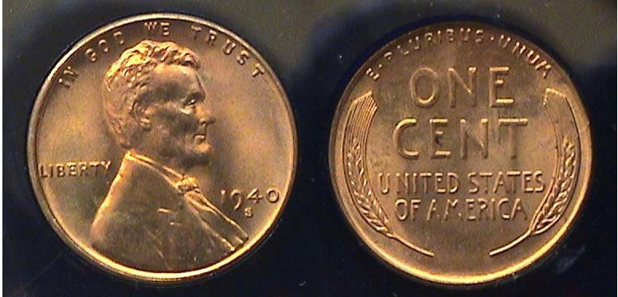

A 1940-S Lincoln-Wheat back cent grading MS-65 Red
[Enlarge page to fill monitor screen to view details]

If the reader can enlarge the digital image of the 1941-S Lincoln Wheat-back cent to see the example more clearly, one will notice a clear S mint mark below the date with a mark-free bronze surface across the field on both sides of the coin. In 1940, the San Francisco Mint produced 112,940,000 Lincoln cents and is considered an extremely common date.

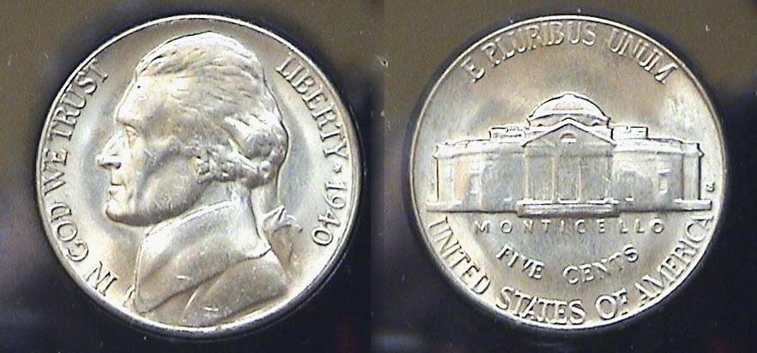

A 1940-S Jefferson nickel with full steps graded MS-65
[Enlarge page to fill monitor screen to view details]

Like the cent above, and upon sufficient magnification, the 1940-S Jefferson nickel appears to be well struck with full steps on the base of Monticello. Only 39,690,000 were coined at the San Francisco Mint that year, but the population of the western cities were far less than they are today and the 1940-S nickel is considered fairly common, even with full steps.

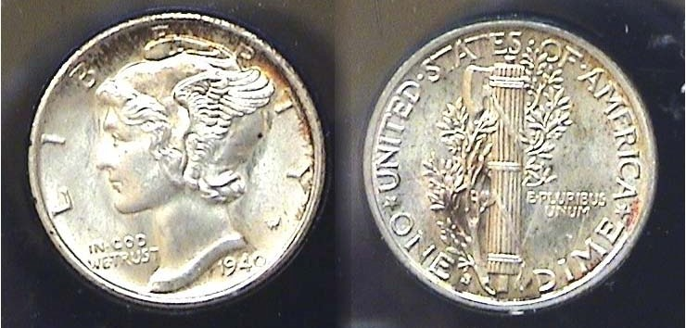

A 1940-S Mercury dime with full bands on the reverse graded MS-64
[Enlarge page to fill monitor screen to view details]

When the 1940-S coins were acquired, upon completing the set, the author inserted all five denominations into a special plastic Capitol holder which was originally intended to store proof or uncirculated sets for display purposes. Over the years, slight toning occurred on the left side of the reverse on the dime which the reader can clearly see without enlarging the page. So, despite the full bands, this type of toning is problematic and tends to deduct from the overall value of the coin.’

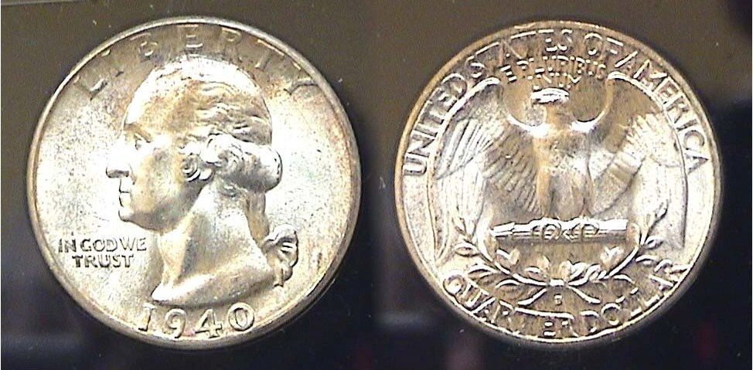.

A 1940-S Washington quarter graded MS-64
[Enlarge page to fill monitor screen to view details]

In 1940, the San Francisco Mint struck 8,244,000 quarters and the coin is common across the grading spectrum. It’s value is around the $60.00 mark today. In 1940, the coin had the purchasing power of $4.56.
(Continued on page 4, column 1)
Collecting the US Coins of 1940, 80 years ago
(Continue from page 3, column 2)

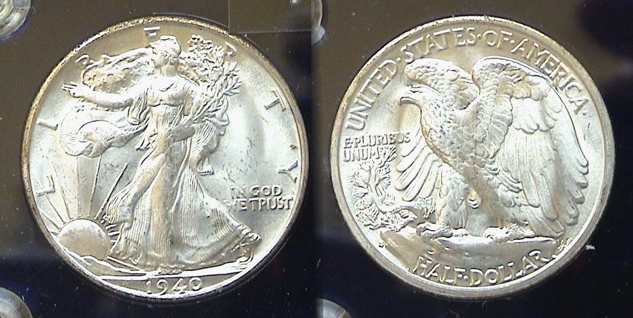

A 1940-S Walking Liberty Half-dollar graded MS-65
[Enlarge page to fill monitor screen to view details]

In 1940, the San Francisco Mint struck 4,550 000 half dollars, slightly less than the 1920-S with 4,624,000 struck but for over half a century, the 1920-S has been considered one of the key dates of the series because continuing over from the Barber type coins era, half-dollars, the denomination still circulated heavily during the roaring twenties and in MS-63, the 2021 Red Book values it’s cost at $3,250.00 today whereas the 1940-S in the same grade, MS-63, is listed at just $80.00. The coin above would probably grade MS-65--even with the weak strike--because in all other respects, it is brilliant. A 1940-S graded MS-65 is currently retailing at $285 while the 1920-S in the same grade would be worth a whopping $15,000.

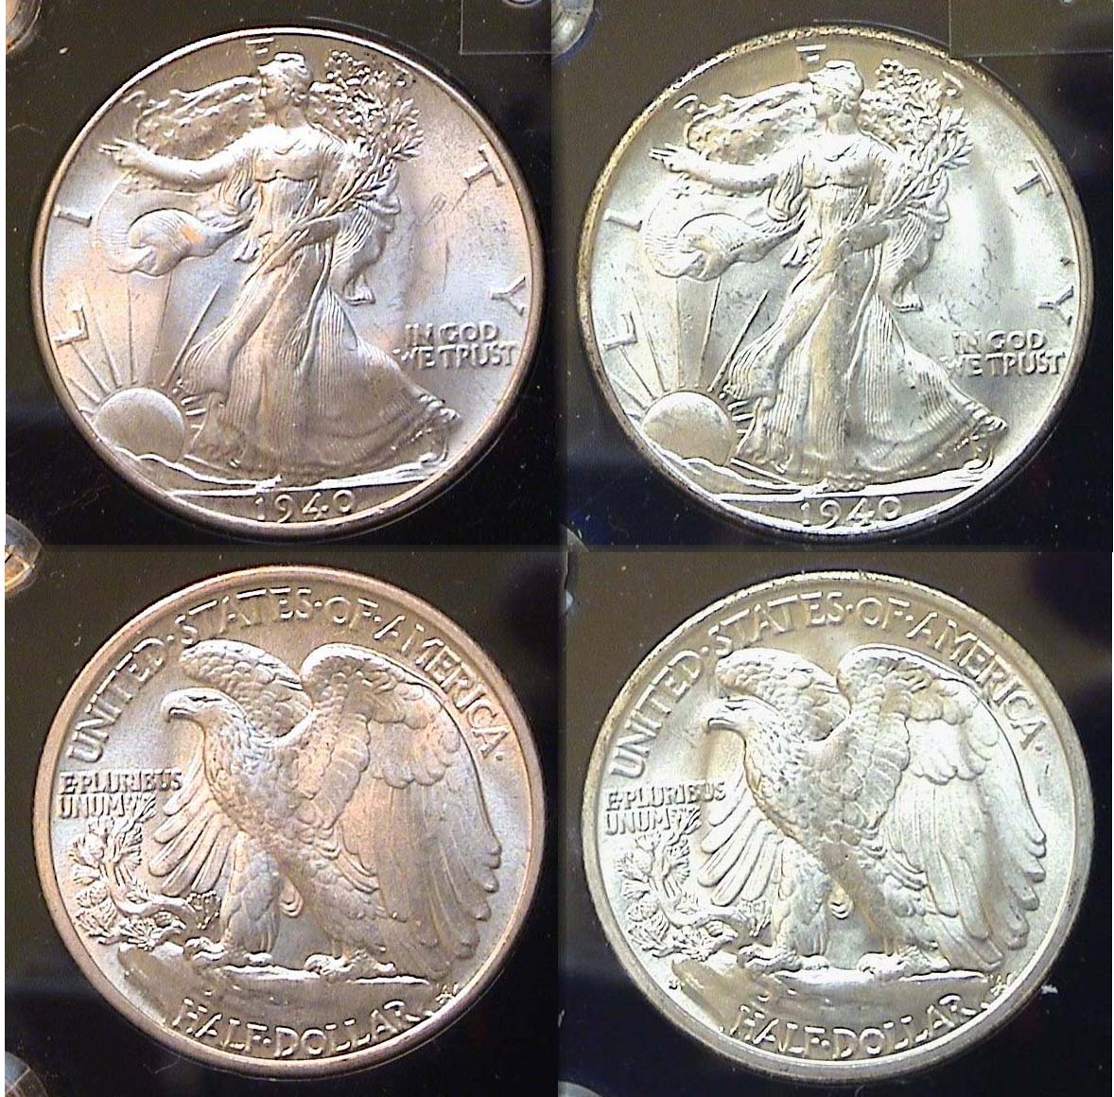

The 1940-P and 1940-S WL halves, both graded MS-65 but compare the strikes between the coin on the left with the one on the right!
[Enlarge page to fill monitor screen to view details]

Upon enlarging the images of the 1940-P and 1940-S halves sufficiently, if the reader looks at Miss Liberty’s hand crisscrossing the center of her gown, on the 1940-P, the details are far sharper than on the 1940-S example at the right. However, the mint-mark S, on the 1940-S half--while tiny---is sharply struck and can be seen on the lower left side of the reverse of the coin in the space between the rim and of the rock in the left of the eagle’s talon.
In 1940, a half-dollar had the purchasing power of $9.11
Virtually all of the 1940 US coins intended for circulation are affordable thru MS-64 possibly, MS-65. However, there is another set worth considering.
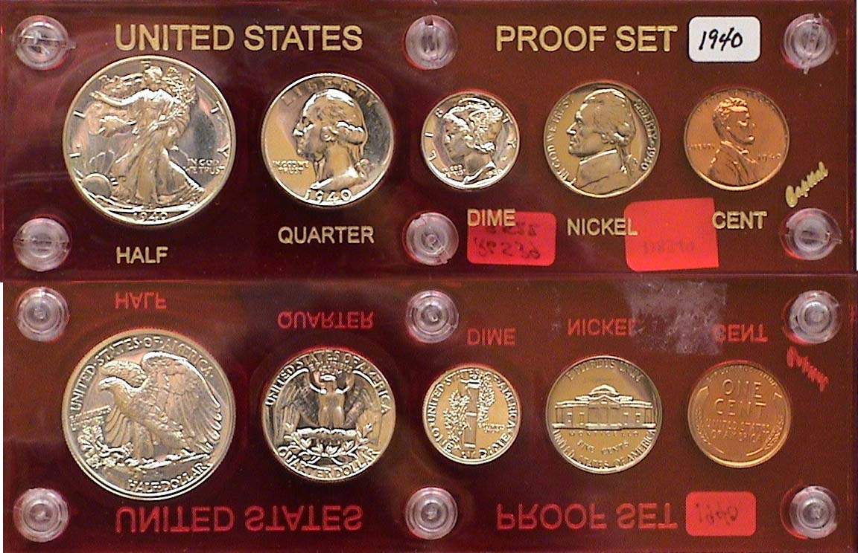

A 1940 Proof Set hosed in a Capital vinyl plastic holder
[Enlarge page to fill monitor screen to view details]

Proof coins were struck of United state coins as year sets for collectors with the last complete set prior to 1936 being 1916 with a partial set issued in 1917. Then nothing!. In 1936, during the administration of Franklin Delano Roosevelt, our 32nd President, proof sets were again resumed. Since there were no silver dollars or gold coins struck for circulation after 1935, a proof set consisted of only five coins, the cent, nickel, dime quarter and half dollar and when first issued, they originally cost $1.89. From 1936 thru 1938, the numbers of US proof sets produced never exceeded four figures ranging from just 3,837 in 1936 thru 8,795 in 1939. In 1940,the US Mint and Philadelphia struck 11,246 proof sets. According to the 2021 Red Book ,the 1940 proof set is valued at $925 today but this is probably for a set certified MS-63 to MS 64.

Before the age of professional certification which began around 1986 when PCGS was founded followed by NGC the following year in 1987, proof sets were packaged in a small cardboard box in tiny cellophane wrappers. For collectors who liked to display their sets, the Capital Coin Company out of Massillon, Ohio started producing hard see through plastic holders in various colors with six plastic screws and nuts to house the five proof coins inside them firmly.

Since the beginning of the 21st Century, due to the increase in the sales of certified coins housed in hermetically sealed holders, the older type proof set holders are no longer viable. As a result, the sales of these Capital holders have diminished, with the upshot that collectors interested in displaying the five hermetically sealed coins together can request a merging of the holders of the individual certified proof coins from PCGS or NGC. Before “slabs“, mint and proof sets looked very attractive in these older Capital holders which cannot be said to be the case today but as mentioned earlier, over the years of storage, these holders weren’t able to prevent unintended harsh toning which corroded some of the coins.
The foregoing said, for members turning 80 years of age this year, 2020, if you don’t own a 1940 proof set, now is the time to go on line and see what’s available and affordable. Some sets are still housed in capital holders.
Happy hunting!
___________________________________________________________________________________________________________________
STEPHEN JAMES CSRA COIN CLUB
Regular Meeting Thursday, November 5, 2020 VIA Zoom

The Club’s regular monthly meeting was held on November 5, 2020, via a Zoom session arranged by Club Secretary, Jim Mullaney. President J.J. Engel called the regular meeting of the club to order at 6:54 p.m.

President Engel recognized and thanked Secretary Jim Mullaney for all his many contributions to the club, including making the continuation of monthly meetings by Zoom sessions possible. There were 14 members who joined the Zoom session, along with one guest, Reilly Hammond.

A motion was made by Willie Simon, seconded by Jim Sproull, and passed, to dispense with the reading of the October 2020 meeting minutes. A copy of the minutes will be on file with the other club records, and a copy will appear in the club newsletter.

Treasurer Chuck Goergen reported that the Club’s bank balance was $ 1,153.49.

New Business:
President Engel informed the members that at a meeting of the Club’s Board of Directors on
November 2, 2020, the consensus was that the holiday party scheduled for Thursday, December 3, 2020, should be cancelled for a number of reasons. The virus situation seems likely to worsen somewhat in the coming weeks. Our club was unlikely to reach the minimum number of dinners necessary to reserve the hall as a number of members had notified him that they would not attend due to the Coronavirus pandemic recommended guidelines for attending indoor gatherings which would have limited the members’ ability to socialize. The Club’s Board will evaluate in January whether it is practical to have a social event in the Spring.
President Engel reported there is no change at this time with the situation with having the use of the Meeting Room at the Aiken Library; however, member Glenn Sanders had informed him that
Glenn’s church was available if the Coin Club wanted to temporarily have monthly coin club meetings there. The church is located in Graniteville, SC. VP Pat James reminded the members that some years ago when it was difficult for the Club to always get the use of the Library’s Meeting Room on the first Thursday of the month, the Club was able
to move its meetings to Cedar Creek which had a great facility with a screen and equipment wonderfully suiting the Club’s needs for a meeting place; however, club membership fell off a lot because a lot of the older members didn’t want to make that five-mile drive at night from Aiken. Pat posed the question whether that might be the case with a drive to Graniteville. At the recent Board meeting several Board members said they would not want to make that drive. However, Glenn also said his church might be a gathering location for those without the ability to join the Zoom meetings in their homes. President Engel said the Board would look into the feasibility of using that remote locale.

When the South Carolina Numismatic Association, commonly referred to as SCNA, announced in August that the State organization was accepting nominations for the outstanding coin club in South Carolina, VP Pat James nominated our coin club. Steve Kuhl, former President of our club, and now a member of the Board of the South Carolina Numismatic Association, gave the members the happy news that our club had again been named South Carolina Coin Club of the Year. The Stephen James CSRA Coin Club and the Augusta, Georgia, Coin Club were named co-winners of the award in 2019. Our club was also named South Carolina Coin Club of the Year early on in 2002.

Our Club’s outstanding wordsmiths, Arno Safran and Steve Kuhl, editors of the SJ CSRA CC Newsletter and the state organization’s SCANNER publication respectively, were also honored this year by the American Numismatic Association. Meanwhile, he Arno Safran ’s Newsletter won the ANA’s 3rd Place award and Steve Kuhl ’s SC ANNER publication won 1st Place in the electronic division.

Old Business:
Past-president Steve Kuhl related that the
SCNA’s annual Convention was held October 30 th –
Nov 1st at the TD Convention Center in Greenville, SC, and there were no issues with the pandemic safety recommendations and requirements. Previously the Bourse Chair, Bill Latour, had checked with the authorities on all levels, including the South Carolina Department of Commerce and the Governors’ Office, to obtain approval to
hold the event and to learn the required safety mandates. There was a temperature check of the patrons upon entering, and anyone with an elevated temperature was not allowed in. Masks were required, and anyone not wearing one was asked to put one on, and if the person failed to comply, he was asked to leave, including one Dealer.
(Minutes continue on page, 6, column 1)
Sec. James Mullaney’s Minutes (Continued from page 5)

Steve Kuhl further reported that the Convention had 170 tables, was well-attended and considered a success by all. Steve added that he thought the Stephen James CSRA Coin Club should consider having a Spring 2021 Coin Show. Dr. David Cashin was scheduled to present Part 2 of his excellent two-part power-point program on the coins of Northeast India; however, due to technical issues, he was not able to do so. Dr. Cashin will instead present Part 2 at the next meeting on December 3, 2020.
Instead, Jim Mullaney continued his mini-grading presentations and put up on the screen two coins for the members to grade, 1844 O slabbed half dollars which had been graded by PCGS. Former coin dealers JJ Engel and Pat James both correctly guessed one as a very nice AU, and that coin was graded AU-53 by PCGS. Pat said she would have put it higher at AU-55 to AU-58. JJ pointed out that the not easily discernable wear on some of the stars likely was the reason for the AU-53 grade when the eye appeal factor may have indicated a higher grade.
Both JJ and Pat guessed the other very attractive half as being XF, but it was revealed to have been graded as VF- 35. There was a general discussion about grading coins, and Steve Kuhl said he thought he could get a speaker to talk about how the grading companies graded coins.
President Engel reminded the members that the Augusta Coin Club had resumed their meetings
some months ago at the Sunset Grill on Washington Road in Augusta, GA. John Kolmar and Jim Sproull reported that that club had 34 members in attendance at the October meeting, and that wearing masks was optional. John said it appeared as if 25% of the members wore masks. John and Jim also reported that the Augusta Coin Club was
proceeding with its plans to hold the club’s annual Fall Coin Show on the weekend of November 20-21, 2020, at the Columbia Exhibition Center located off I-20 at Exit 190.

Bob Sanborn won the members’ attendance door prize, a 2020 Silver Eagle, and Club VP, Pat James, will mail
him the coin.
President Engel reminded the members that the next meeting would be on December 3, 2020, and adjourned the meeting at 8:05 p.m.
Respectfully submitted,
Jim Mullaney, Secretary
___________________________________________________________________________________________________________________

Additional Show and Tell by member John Kolmar

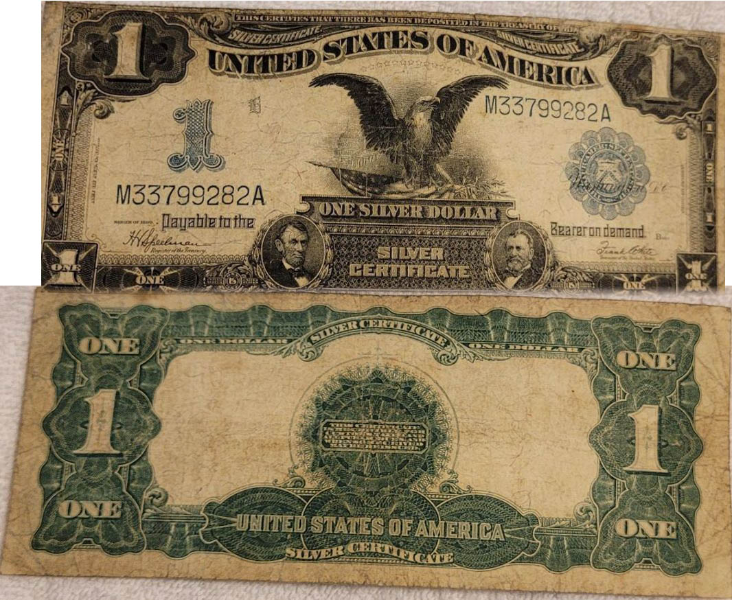

Series of 1899 Silver Certificate graded VG-8
The face of the note portrays an eagle resting on our flag
with the Capitol Building in the background
The portraits of Lincoln and Gen. Ulysses Simpson Grant
appear at the bottom surrounding the note’s title,
SILVER CERTIFICATE printed in a curled manner
John sent this to me via email after acquiring the banknote from Clein’s Rare Coins in Martinez GA. (ED.)
The signatures on John’s note are Speelman and White The back of the note is more traditional. Unlike a Legal tender note, a $1.00 silver certificate could be cashed in for a Morgan dollar back in those days. Thanks, John, for sharing your new acquisition with the members of the club.
_________________________________________________________________________________________________________________________

Report on the November, 20, 21 Augusta Coin Club
Coin and Collectibles Show

On A week before this past Thanksgiving, the Augusta Coin Club held its first show since the Pandemic known as the Coronavirus began. Unlike other regions in our nation where the Coronavirus is raging, the Central Savannah River area (as the Augusta, GA and western South Carolina region is called), has been--at least currently--less effected and the Columbia County Exposition Center located in Grovetown, GA about ten miles due west of the Savannah River along I-20, decided to open their doors to allow conventions once again, only this time they made it mandatory that all entrees, dealers and collectors alike must wear face masks upon entering the building and the large bourse floor further inside. Despite reports that he Show was a sell out with 75 tables sold, when the editor entered the bourse around 11:00 AM, on Friday, Nov. 20 he noticed lots of empty tables scattered around the large hall along with a smaller than expected crowd. On Saturday, it was apparently a little better but compared with past shows, many of the dealers the editor expected to see were no shows this time around and that made the show somewhat disappointing. Fortunately, on the day the editor was there, everyone wore face masks but on Saturday, he heard, that was not entirely the case.
___________________________________________________________________________________________________________________
It’s the Holiday Season so why not
Give a numismatic gift for Christmas or
Hanukkah Gelt for Hanukkah

{Found off the Internet]

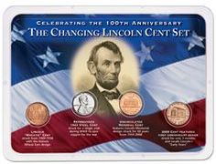
Lincoln cent sub-types
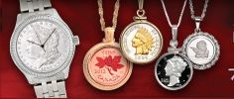

Pendent Jewelry type which could also include a 1/10 or ¼ gold eagle for the woman in your life.?
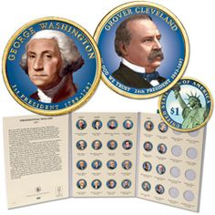
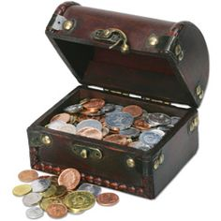
Coins of the World Treasure Chest

Meanwhile, let me use this extra space to wish every member of our club a very Merry Christmas or Chanukah greetings . As editor, I would like to thank Club President, JJ Engle, VP Pat James, Recording Secretary, Jim Mullaney, Treasurer, Chuck Goergen, Sgt. In Arms, Jim Sproull and former club President, Steve Kuhl for all their help on the newsletter throughout the year. To all, stay well and safe!

Respectfully,
Arno Safran, Editor
______________________________________________________________________________________________________________

Kindly Patronize our advertisers

